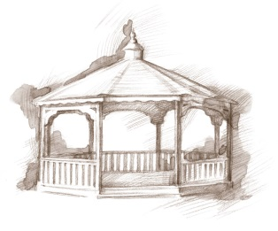 TheVillageVoice

December 2014

After much anticipation, the Christmas season has finally arrived! The day after Thanksgiving is traditionally when the Christmas decorations start to appear throughout Westminster Village. Over 60 Christmas trees will be assembled and beautifully decorated. The new construction going on outside of Westminster has not dampened the holiday spirit inside; in fact, the residents enjoy watching the daily changes that are taking place.

New Construction Update

We thought it would be a good idea to give you a monthly progress report on construction, in our newsletter. The grounds around the building are being prepped for the new Rehab to Home Neighborhood and Event Hall foundations to be laid. If the weather warms up the guys will be laying the foundations before they are forced inside by the cold temperatures. Huge machinery

has been moving dirt to build an additional parking lot. A new wall has been erected to reduce the noise and keep us safe & warm inside. The first floor East Wing apartments are currently being renovated in preparation for new Full Service Assisted Living Neighborhood.

C:\Users\mscoble\AppData\Local\Microsoft\Windows\Temporary Internet Files\Content.IE5\HY793NOJ\MC900388970[1].wmf

Holiday Events at Westminster Village

In December, the Activities Department has scheduled several special Holiday events for the residents. They will be making homemade Christmas cards and attending the Living Christmas Tree Service at Grace Baptist Church. There are two Christmas Parties planned. The first party is the *Resident & Employee Christmas Party* and the second one is the Resident Christmas Party with *Santa and Mrs. Claus*. All parties at Westminster Village are topped off with tasty refreshments. Several residents have volunteered their time to ringing bells for the Salvation Army at the Muncie Mall. One evening residents are going to eat dinner at The Cracker Barrel in Upland, then go look at the lights in Marion in the comfort of the Westminster bus. Many residents will be attending the *MSO Fisher/Shafer Holiday Pops at Emens*. Another evening the residents will be riding the bus over to the *Gresham Center* to tour the Christmas Light Display.

C:\Users\mscoble\AppData\Local\Microsoft\Windows\Temporary Internet Files\Content.IE5\BTIRLN9M\MC900361924[1].wmf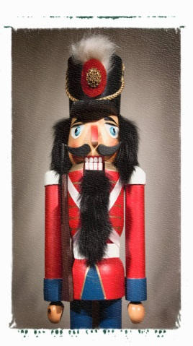Throughout the holiday season Village residents will enjoy regular daily activities as well. In December the Lunch Bunch will be dining at *Osborn’s* and *Our Daily Bread*. They will attend the Theatre of Dance’s *“The Nutcracker”* and also a performance of *“The Best Christmas Pageant Ever”* at the Civic Theatre. The residents have several BSU Women’s Basketball games that they will be going to this month and as always, there will be door-to-door service in the warm bus. There are card games, table games, Wii Bowling, Bible study, and much more to choose from. The final party of the year will be the *New Year’s Eve Pizza Party* and Bingo. This party is a resident favorite and a perfect ending to the Year 2014!

C:\Users\mscoble\AppData\Local\Microsoft\Windows\Temporary Internet Files\Content.IE5\4SX6KI2T\MC900304913[1].wmfIf some of these activities sound like fun, you may want to consider joining us next year as a resident of Westminster Village. We wish you and your family a blessed Christmas Holiday and a Happy & Healthy New Year! 