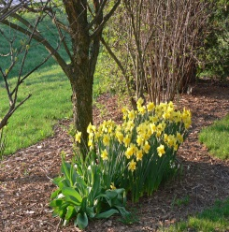
As the saying goes, “April showers bring more flowers.” We certainly look forward to the pretty spring flowers. The cold temperatures of March have given way to warmth and sunshine, melting the snow into spring. The moisture gives the grass much needed nourishment, helping the lawns around Westminster to once again become green and lush. Residents have noted that, “the robins have returned in search of worms and the birds are singing in the trees.” This is the time of year for rebirth!

Westminster is Presented with the Chamber
Chairman’s Award
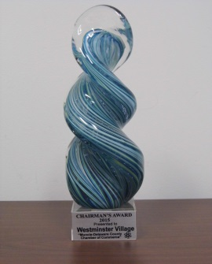
At the Muncie-Delaware County Chamber of Commerce Champion Award Luncheon, at the Horizon Convention Center, on Wednesday, March 18th, the outgoing Chairman, Jeff Daniels, presented Westminster Village with the Chairman’s Award. This
award is presented to a member organization of the Muncie-
Delaware County Chamber of Commerce who exhibits a commitment to their business and the community, and chosen by the outgoing Chamber Chairman based on a list of criteria. In his address, Jeff said, “the criteria for this award includes leadership, thoroughness and community involvement.” Jeff also stated that, “they (Westminster) recognize the value of participating in organizations dedicated to providing resources that allow them to prosper for the benefit of their residents.” The President of Westminster, Dale Lindley, and Vice President, Mary Jo Crutcher, were on hand to accept the award for Westminster Village.

A Feathered Friend

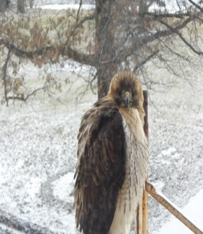
For several months now, a Red Tailed Hawk has been seen perching on the construction scaffolding, in the back of Westminster, facing the pond. Is there a meaning for this grand bird’s vigil? We decided it would be interesting to see what we could find out about the hawk. In the Native American culture hawks are considered symbols of courage and strength, and are thought to be the Guardians of Mother Earth. In some tribes, such as the Cheyenne, hawks are associated with protection from enemies. The red tail of the hawk only appears when the bird reaches maturity. To the human beside whom the Red Tailed Hark flies, this is quite significant, for it indicates that the red feathers are not easily given and must instead be earned over time. Hence, the symbolism of the red tail feathers emerging only with age and experience. How ironic that he is keeping an eye on Westminster’s construction project!

April Resident Activities
Residents at Westminster Village have many activities each month that they can choose to attend, if they wish. In April the residents have several craft classes that will focus on making spring wreaths and floral bouquets. There is a trip to the BSU Planetarium for a program entitled “Saturn and Beyond.” They will be back at BSU for the MSO “Folk Festival” concert at Emens and The Theatre of Dance performance, “All You Need is Love.” The Lunch Bunch will be dining out at Ruby Tuesdays and Chili’s this month. Dietary is introducing some of Westminster’s behind-the-scenes staff with, “Flavors from Your Kitchen,” featuring a different experienced cook each month, as they prepare a new dish for residents to taste and critique. The class “Tips and Tricks for the Smartphone and Tablet” continues with growing interest. Once a month, Westminster’s resident Classic Movie Expert has an evening where he talks about fun and interesting facts pertaining to the making of a particular movie, then the film is featured the following Friday during the weekly Friday afternoon Movie and Popcorn event.

