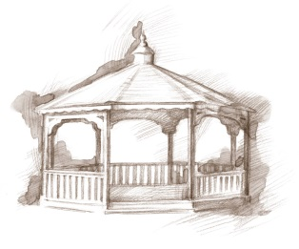
TheVillageVoice
September 2015

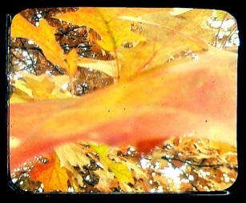
The crisp feel of fall is in the air. The cooler evenings are a welcome return. Residents are anticipating the completion of the new sidewalks. The new walkways will meander around the back lawn and are going to be 6 feet wide, making it easier for residents to walk side-by-side.

Construction Corner

The corridor that had been closed for most of the construction has now been opened. It is exciting to see the new carpet, light fixtures, and wall colors. The new Beauty Shop, Activity Rooms, Fitness Center, mailboxes, and Event Hall are close to completion. Opening of the newly renovated Assisted Living Neighborhood is scheduled for the end of September. All the finishing work is being completed. Construction on the Rehab-to-Home facility on the west side of the building is moving along and should be
totally enclosed before long. The exterior brickwork is now being applied to match the rest of the building. Landscaping has begun around the building where construction is completed and the grounds will soon be seeded for grass.

Flags of Honor at Minnetrista

Meet everyone at Minnetrista for the Westminster sponsored Senior Free Admission Day on Wednesday, September 9th, at 10:00 am and 2:00 pm for the Flags of Honor. This annual event, hosted by Muncie Exchange Club, honors our Veterans by flying American Flags. Each flag is purchased by someone from the community. It is a beautiful sea of red, white and blue, as the flags fill Minnetrista’s entire front lawn! On September 9th, come and listen to Muncie Exchange Club members talk about the project and what it means for our community.

Westminster Village Offers Classes to Residents

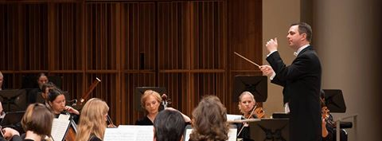
Westminster is a huge proponent for continuing education and with many residents being retired teachers, the education never really ends. There will be a three part class on the Scientific Secrets for a Powerful Memory presented by Charles Gilbert, a retired local minister, who has facilitated this class, along with others, at Ball State’s E.B. Ball and Bertha C. Ball Center over the last few years. Westminster’s Activity Director teaches a monthly class on the Tricks and Tips for Smartphones and Tablets. Residents are having fun learning new things that their devices can do.

September Activities

Westminster residents enjoy the many choices of activities in which they can participate if they desire. This month, residents will be going to the Civic Theatre comedic performance of, “You Can’t Take it With You”, and residents will attend the MSO Concert, “Wow.” The Lunch bunch will be dining at Johnny Carinos and McCallisters. Residents will be visiting the Academy of Model Aeronautics for a tour. Another experienced staff cook will be presenting Flavors from the Kitchen. Residents are invited to sample a possible future menu item, prepared right in front of them. Let the critique begin!

Several, One Bedroom / Full Kitchen Apartments, are now available. This includes Basic TV, Utilities, Housekeeping, Linen Laundry, Meal Plans, and Social, Education, Physical Fitness and Entertainment Programs.
For more information, call Judi or Melody at 288-2155.

