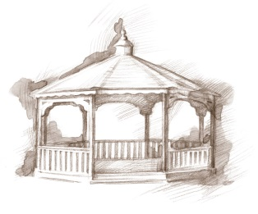
TheVillageVoice
October 2015

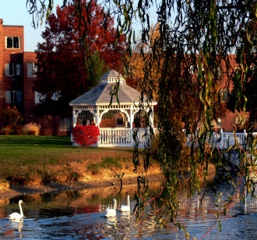
The Season of Fall is beginning to make an appearance at Westminster Village, with its beautiful colors of reds, yellows and oranges. The trees and bushes around the pond are beginning to turn pretty autumn hues. Landscapers are working around the grounds planting colorful mums and foliage in new sidewalk and courtyard bedding areas.

Construction Corner

This week has brought many moves onto the newly remodeled areas, as well as moves so other remodeling can begin. The Beauty Shop and Fitness Center have moved into their new homes, while the Village Store and Library were moved into temporary areas so construction can begin on the new Café and Bank. Remodeling of the Residential halls has begun. Hallways will get a makeover with new carpet, light fixtures, doors, hand rails, and paint colors. Remodeling of the Main Dining Room and Main Lounge will begin soon. It is exciting to see this enormous project begin to come together.

The Final Senior Free Admission Day at Minnetrista

The Westminster Sponsored Senior Free Admission Day at Minnetrista for October will be the final one for the year. If you haven’t had an opportunity to visit Minnetrista then this will be the perfect time to experience a Muncie treasure. On Wednesday, October 21st, at 10:00 am and 2:00 pm, you are invited to visit the Orchard Shop and Cider Room. Attendees will get a back stage look at the cider process, pressing apples grown in Minnetrista’s own orchard. Apples and their delicious cider will be available for purchase.

Classes Offered at Westminster for Residents

The desire for learning never ends and Westminster is very aware of that fact so classes and programs are offered for residents’ continuing education. Art Workshops with Ann Johnson and a trip to the BSU Planetarium for “Halloween Astronomy” are on the calendar in October. The Tips and Tricks for Your Smart Phone and Tablets class will return soon.

BSU Women’s Basketball Team to Visit Residents
For many years, Westminster residents have been in the stands at all of the BSU Women’s Basketball home games. It has been a tradition, that before the basketball season begins, the team visits Westminster to get acquainted with the residents that attend their games. As the season progresses, the girls develop close relationships with residents. At the end of the season Westminster hosts a banquet for the team and their beloved fans.

October Activities

Westminster schedules many monthly programs and activities in which residents may participate if they choose. In October, residents will be attending the Artist Series “Bullets over Broadway” at Emens, Muncie Symphony’s “Heavenly” at Sursa Hall, and The Farmers Market at Minnetrista. This month the Lunch Bunch will be dining out at Outback and Mill Street Inn. For the fall season, residents will be painting pumpkins and gathering together for a Halloween Party & Costume Parade.

Now that fall has arrived, your thoughts may turn to the many challenges of winter weather. This could be a good time to talk with Judi or Melody, at 288-2155, about how you can enjoy being safe and warm at Westminster Village.

