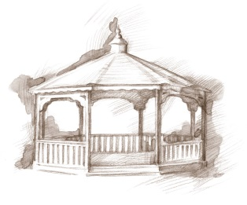
TheVillageVoice
November 2015

Around Westminster, the brilliant colors of fall are giving way as the leaves have begun falling to the ground. With the familiar smell of fall in the air, and leaves crunching under foot, one is reminded of the words to the Thanksgiving song, “Over the river and through the woods to Grandmother’s house we go!” Families will experience a special time with their parents and grandparents as they enjoy a delicious Thanksgiving dinner together as they bring in the Holiday Season at Westminster Village.

Construction Corner

The Event Hall has been completed and is now serving as a temporary dining hall where the white chandeliers cast a bright and cheery ambiance upon the unique blend of classic and modern décor. The front wall of windows ushers in the sunlight and provides the diners with a great view of the new landscaping in progress. Before we know it, the two new dining rooms will be completed and the Event Hall will begin to serve its intended purpose. The New Assisted Living Neighborhood is almost full. Residents are enjoying the convenience of services available through their Neighborhood Care Station and are pleased to entertain visitors in their Fireside Lounge overlooking an outside garden patio and path leading to the pond. The Rehab-to-Home center is taking shape and interior renovations are proceeding as planned. As each step of the project is completed, we see an almost magical transformation. Like the butterfly emerging from its cocoon, we are reassured that the result has been worth the wait.

Muncie Public Library Reads to Residents

Muncie Public Library employees are bringing the printed word back to Westminster residents who can no longer see to read the paper for themselves. Every Sunday afternoon, a Muncie Public Library employee brings the week’s Muncie Star/Press newspapers and reads the news to residents. This wonderful project was set up by a former Westminster resident who had lost part of her vision and she missed reading the daily newspaper.

Fall and Thanksgiving Craft Classes Offered
There are several classes in November for the artistic minded Westminster resident. During Ann Johnson’s Art Workshop, residents will continue working on their fall watercolor landscapes. The Activity Department has planned a fun Thanksgiving craft project.

Residential Activities during November

Westminster schedules many activities and events. Residents will be attending the Women’s Basketball Games at BSU. The Lunch Bunch will be dining out at Merks and Concannons, Residents will be going to Emens for the Department of Theatre and Dance, “As You Like It”, the MSO concert, “The Magical Music of Disney.” And The Artist Series “Flashdance.” The Delaware County Historical Society will be at Westminster to talk about,” Muncie’s 150 Years of History.” Westminster residents volunteer to ring the Salvation Army bell by MCL in the Muncie Mall. Residents ride to and from events comfortably on our Westminster buses.

Thank you!

We enjoy sending you news each month on the new development at Westminster Village. Now we would like you to join us for a sneak peak at what we have accomplished so far. To schedule a personal tour to see the areas we have completed, call Judi or Melody at 288-2155.

