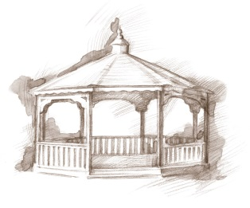
TheVillageVoice
December 2015

The last of the Thanksgiving turkey has been polished off and the anticipation of the Christmas season has begun. Although some areas of Westminster Village continue to be under renovation, Christmas decorating shall not be deterred! Many of the Christmas trees and decorations will be going in areas where construction has already been completed. The 12ft. Christmas tree that for years stood in the Main Lounge, will this Christmas grace the beautiful, new Event Hall.

Construction Corner

The rain and snow that fell the last few weeks encouraged the newly planted grass seeds to burst, transforming the bare soil into a soft green blanket that highlights the newly landscaped grounds. Inside, remodeling continues as each floor undergoes a complete redesign with new lighting fixtures, doors, colors and carpeting. Construction continues on the new dining venues, library, bank and store. On the west side of the building, the new Rehab Center is shaping up nicely and interior work has begun. When we say goodbye to this winter season, we expect to be ready to present the new face of Westminster Village.

Cards for Military Soldiers

Many soldiers won’t be able to go home this year for Christmas to be with their families so Westminster residents will be gathering to make special cards and notes, sending greetings and appreciation to the soldiers for all they do to keep our country safe.

Westminster Residents Will Party in December

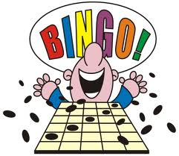
Westminster residents will have several parties to attend in December. Santa and Mrs. Claus make the long trek from the North Pole to join in singing Christmas carols, dine on tasty holiday goodies, and residents will get their pictures taken on Santa’s lap. The Resident & Employee Christmas Party is a special time that residents and employees can share together, singing and eating delicious treats. For residents, the highlight of the year is the New Year’s Eve Pizza and Bingo Party. Residents ring out the old year and ring in the new, playing Bingo while munching on Pizza King pizza.

Resident Activities in December

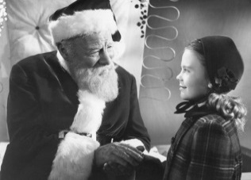
Throughout the year, Westminster schedules activities and events for residents to participate in if they so desire. In December, residents will be attending the BSU Women’s Basketball Games and ringing the bell for The Salvation Army at MCL, in the Muncie Mall. Residents will be attending The Artist Series production of “Rudolph the Red Nosed Reindeer,” and “Miracle on 34th Street” at Muncie Civic Theatre.

If staying alone in your home during the long, cold winter doesn’t sound like something you want to do this year; Westminster has an idea for you! Come and spend the winter in a comfortable furnished apartment. You can participate in any of the activities, exercise in the new Fitness Center, and join in all the reindeer games! “Safe & Warm for the Winter” includes meals, cleaning, linen laundry, utilities and basic TV, with monthly rates beginning at $2,045. If you would like to schedule a tour or just ask a question, call Judi or Melody at 288-2155.

