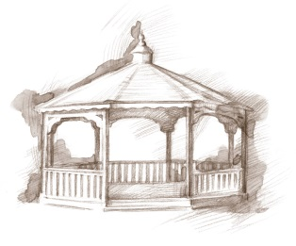
TheVillageVoice
February 2016
Each year on February 14th, many people exchange cards, candy, gifts or flowers with their special “valentine.” This day of romance, we call Valentine’s Day, is named for the Christian martyr, Saint Valentine or Valentinus, and dates back to the 5th century, but has origins in the Roman holiday Lupercalia. Westminster residents will celebrate Valentine’s Day with music and special treats. It is quite certain that there will be many exchanges of cards and flowers!

Construction Corner
The new changes will soon greet you as you walk through the front door and they are amazing! Picture yourself sipping on hot chocolate as you sit by the cozy fireplace in the café or shopping for supplies the sparkling new store. In the main lounge, the new carpet is accented by the newly painted brick walls, while the white chandelier and new light fixtures hang above. The beautiful new Rehab-to-Home Neighborhood, CooperVista, will be opening soon.

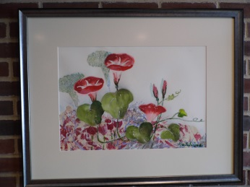
Westminster Treasures

In 1979, Westminster was blessed when a tiny lady, with a big personality, moved into The Village. It didn’t take long for Betty Hutchins to become known as the “local artist”. Betty was schooled as an English teacher but when an art teacher position became available, she decided to spread her wings in a different direction. Betty was in her 50’s when she took a class in watercolor and fell in love with the medium. At Westminster she had her own studio where she painted her canvases. Her joy in painting was not for monetary gain for she often gave away many of her paintings to employees and friends. When Betty passed, her paintings were given to Westminster and they were displayed for everyone’s enjoyment. Today, with the remodel, over 100 watercolors and her paintings, have been re-matted and reframed. Each painting is now being placed with love and care in just the perfect spot, complementing the different wall color of each floor.

Resident Activities
in February
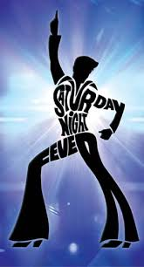
Westminster residents are offered many activities during the month in which they can choose to participate. In February, residents will be getting into a disco dance mood at the Artist Series titled, “Saturday Night Fever,” and also will attend the BSU Theatre of Dance production of “Jungle Book”, all on the BSU campus. This month, The Lunch Bunch will be dining at Ruby Tuesdays and Olive Garden. Many of our basketball enthusiasts will be courtside for the BSU Women’s basketball games in February. Residents will be going to Civic Theatre to see, “The Producers.” We will also be going out for a Masterworks Chorale concert, “Love in Full Flight”, as well presenting a special concert here at Westminster Village. A new class, “How To Use Your Tablet and Smartphone” will help residents with their technical questions.

Westminster Village is
a Voting Precinct
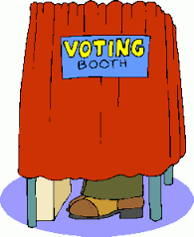
Did you know that Westminster Village is a Voting Precinct? Residents that have changed their Voter Registration, to this Precinct, may vote here in the building. For many years, Westminster Village has been pleased to provide residents the convenience of voting at home!

If you are planning a spring or summer move, now is the time to contact Judi or Melody at 765-288-2155.

