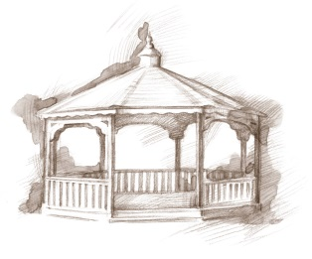
TheVillageVoice
January 2016

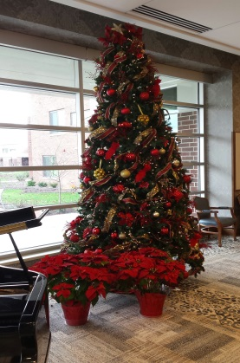
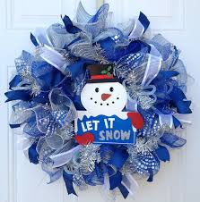
Garland and bulbs of green, red, and gold have been packed away for another year. Pretty winter themed door decorations have replaced the Christmas wreaths and Santa has returned to the North Pole. With the Christmas Season behind us, we look forward to what adventures the New Year will hold. Certainly, completion of the construction and renovation will be very exciting.

Construction Corner

As each week passes, we can see the transformation come to completion in another area of the Village. When the painters take over, we know that the finishing touches are not far behind. It’s hard to believe, but by the end of next month, most of the major renovation is expected to be substantially complete. That means we will be down to details. It won’t be long until we are inviting you to join us for a Grand Opening.

New Event Hall

We have just finished celebrating our first Christmas in the Event Hall. Our first Christmas party featured vocalist Barbara Frost, and her piano accompanist, presenting a traditional musical performance. Santa and Mrs. Claus made a grand entrance. It is a long standing tradition at Westminster for residents to be photographed with Santa, if they choose. Many a grandchild has been amazed to receive a picture of Grandma or Grandpa sitting on Santa’s lap. About 400 residents, staff and family members attended the Residents/Staff Christmas party. Everyone sang Christmas Carols and enjoyed delicious snacks prepared by Westminster’s two chefs and the entire dietary department. This is a special time for staff and residents to wish a Merry Christmas to each other. The New Year’s Eve Celebration with Pizza King pizza, door prizes & a Bingo Party was so much fun! Over 120 residents, and staff, toasted the New Year with sparkling grape juice.

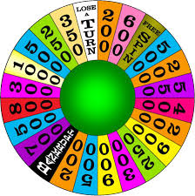
January Resident Activities

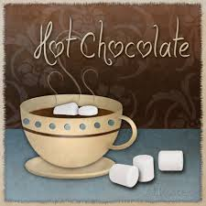
Residents are invited to attend activities throughout the year. In January, the residents will be attending the BSU Women’s Basketball games, sitting in stands, cheering on the team. This month, the Lunch Bunch will be dining out at Red Lobster in Muncie and Pizza King in Yorktown. A Hot Chocolate Party is scheduled and there will be a class in making snow globes. Many residents love to play Hand & Foot cards, and other card games, as well as Dominoes. There are Marsh, Meijer and Walmart shopping trips scheduled. The Activities Department has added several new choices to the weekly schedule. Residents can join in playing Wheel of Fortune and Winter Bingo, in addition to the regular Thursday night bingo. Spiritual programs include Bible studies, Prayer & Share, Sunday Vespers, and open communion. Westminster has many different kinds of activities available to enhance Mind, Body, and Spirit. As with any trips, residents receive door-to-door service!

Safe & Warm for The Winter

Winter has been kind to us so far. December has delivered record breaking warmth, making it safe to be outdoors. But as we know, Indiana weather can change in the blink of an eye and the next two months are not likely to be so kind. It’s not too late to book a winter vacation at Westminster Village where you may find yourself renewing an old friendship and making new ones. For more information or to schedule a tour, call Judi or Melody at 288-2155.

