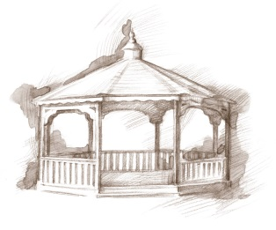
TheVillageVoice
August 2016

August, for many, signifies the end of summer. Families will be heading home from summer vacations and children will soon be returning to school. Maybe that is why August is the “Back to School Month.” August is also the “Peach Month,” the “National Goat Cheese Month” and
“American Adventures Month,” to name a few!

“Expanding Your Horizons” in August

For the Expanding Your Horizons presentation in August, Westminster Village Foundation, in association with the E.B. Ball and Bertha C. Ball Center, will present Indiana’s Bicentennial, Wednesday, August 3rd, at 2:00 pm in the Legacy Commons Event Hall at Westminster. Nancy Carlson, as Delaware County’s Coordinator of Indiana Bicentennial Events, will highlight upcoming festivities, and share some interesting tidbits about our state. Those attending may help us wish Indiana a Happy 200th Birthday in a 15 second video that will be part of the official Bicentennial Celebration on www.Indiana2016.org. This event is free and open to the public.

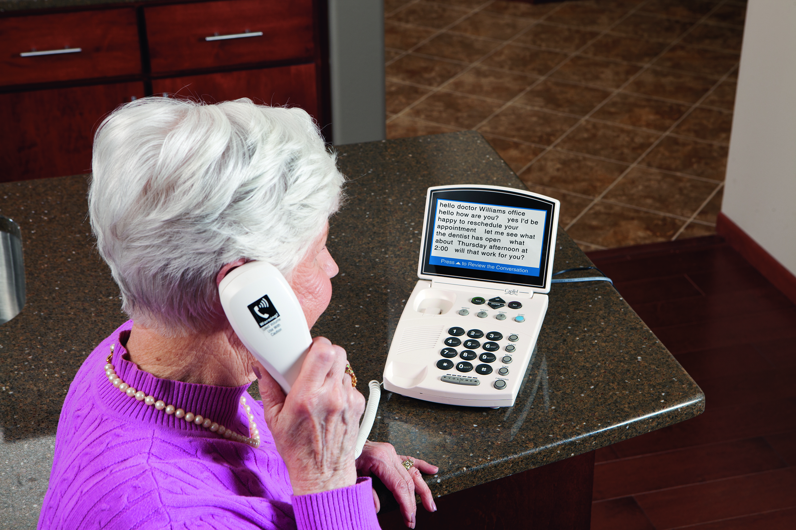
Taking Charge of Your Health
Taking Charge of Your Health in August, we have invited Stephanie Morriset, the Outreach Representative from CapTel, to present facts about the Captioned Telephone to our residents and visitors. Stephanie will be in Legacy Commons on Tuesday, August 9th, at 2:00 pm. The CapTel Captioned Telephones allow people with hearing loss to listen to their caller and read everything the caller says. Like captions on TV – for your phone! Free with verified hearing loss, you get the phone plus installation, providing you with better phone conversations. This includes free captioning service with no monthly fees or contracts required. For those in attendance that cannot hear the presentation, Stephanie will be meeting with them personally. The public is invited to attend.

Don Bell and His Horses Return to Westminster!!
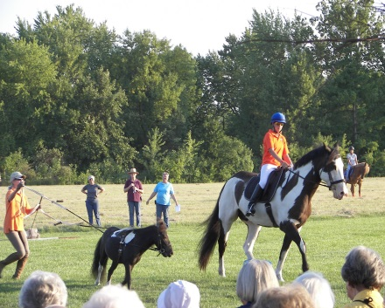
We are proud to announce that Don Bell and his horses will appear at Westminster Village again this summer. On August 10th, at 7:00 pm, Don’s trained European Friesian and Arabian horses will entertain residents, their families and our newsletter friends, weather permitting. The show will be held in the meadow, off Benton Road, east of Westminster. Don’t forget to bring your chair and bottled water!

Senior Free Admission Day

Westminster Village is pleased to sponsor the Senior Free Admission Days at Minnetrista. In August, visit with the Minnetrista Collection staff for a tour of the Heritage Gallery. You will be guided though an exploration of local utilitarian and artistic glass works. Come join us on Wednesday, August 17th, at 10:00 am and 2:00 pm.

Resident August Activities

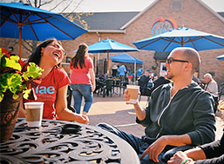
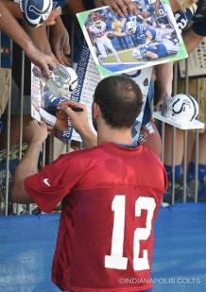
In August, residents will have the opportunity to participate in various activities and events. Our Colts Fans will be attending Colt City and Practice in Anderson, to get a good look at the team. There are afternoon games to play and evening musical programs to enjoy. Many residents will be making a Saturday trip to the Farmers Market at Minnetrista.

