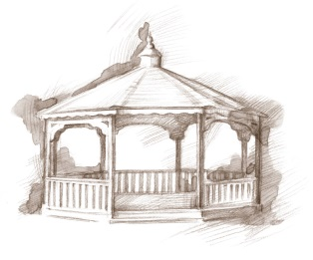
TheVillageVoice
July 2016
July is a favorite time of year for most folks. It is not only a time for being out of doors, enjoying the sunny days with family and friends, but it is also a time to celebrate our nation’s birthday. As we reflect on those that settled our country, as well as those that fought for our freedom, we realize the sacrifices that were made to give us this wonderful country that we live in today.

Danny Russel Presents Honest Abe
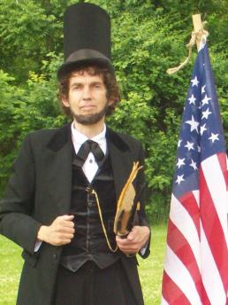
Expanding Your Horizons in July will be the story of Honest Abe, as performed by Danny Russel. Danny’s enduring appeal is evident in this portrayal, which covers all notable aspects of Lincoln’s life, from his Hoosier boyhood years (7 – 21 years old) to his extraordinary accomplishments in the White House. Alternate hilarious and heartbreaking, Danny’s performance includes stirring renditions of “A House Divided”, the “Gettysburg Address” and portions of Lincoln’s Second Inaugural. We encourage you to join us on Tuesday, July 19th, at 2:00 pm, in Legacy Commons.

Senior Free Admission Day

Westminster sponsored Senior Free Admission Day at Minnetrista in July will feature, “Behind the Booth at the Farmer’s Market.” What does it mean to Grow Local? Staff and local vendors will give a behind the scene look at what it takes to present a weekly Farmer’s Market. Join us at Minnetrista on Wednesday, July 20th at 10:00 am or 2:00 pm.

Pianist to Perform at Westminster

Westminster has invited Allyn Ehlert, an accomplished pianist, to perform various classical selections, on Friday, July 29th, at 2:00 pm. She will be playing for residents and the public is invited to attend as well.

Resident Activities in July

In July, residents will have many activities in which they can choose to participate in. On July 4th, residents will be at Minnetrista for America’s Hometown Band performance and fireworks. Minnetrista is especially attentive to Westminster residents by providing comfortable chairs in a special seating area. As usual, Village Activities will include playing Hand & Foot, Dominoes, Pictionary and other games. For those that enjoy art, there is a Summer Craft scheduled. In a celebration of summer, we will host a Watermelon Social out on the patio. Lunch Bunch will be dining out for lunch at the Chocolate Moose in Farmland and Wick’s in Winchester.

A Move-in Before Winter

It is not too early to be planning where you are going to spend this winter. It is warm now but, unfortunately, winter is inevitable. Westminster has welcomed a number of new residents already this summer but there are still apartments available in all the different floor plans. Come and experience the new dining rooms and activities. We will do the shoveling for you! To schedule a tour, call Judi or Melody at 288-2155.

