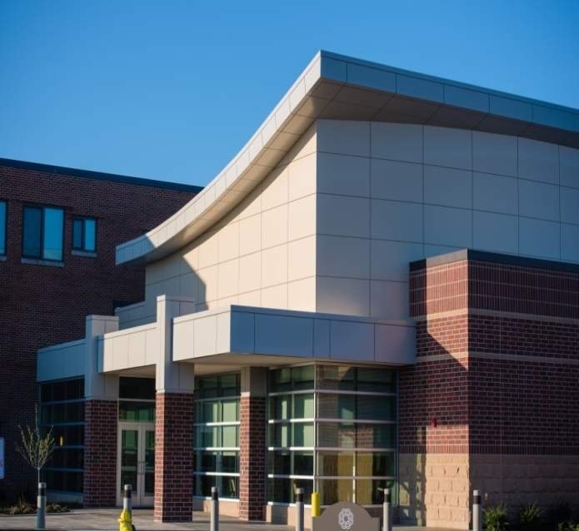
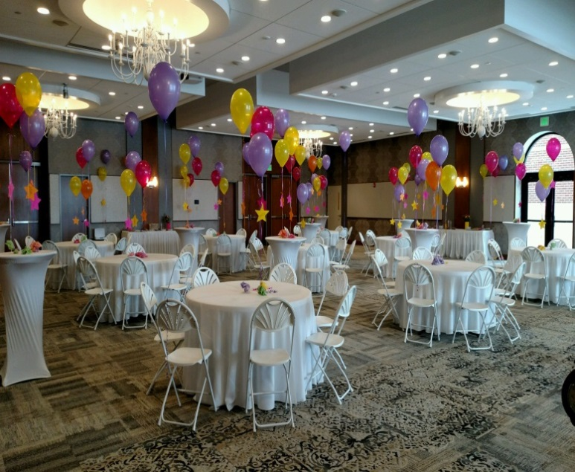

Legacy Commons Event Hall
UPCOMING EVENTS
- September 14, 2016 @ 3:00 p.m. – Robert Warrner on “Frontier Indiana”
- September 21, 2016 @ 2:00 p.m. – Danny Russel as “Daniel Boone”
- October 11, 2016 @ 2:00 p.m. – Alan & Bev Wilson on “Cuba”
- October 18, 2016 @ 2:00 p.m. – IU Health-BMH - “State of the Hospital”
- October 19, 2016 @ 3:00 p.m. – Robert Warrner on “Pioneer Indiana”
- October 26, 2016 @ 2:00 p.m. – Danny Russel as “James Whitcomb Riley”
- November 5, 2016 @ 7:00 p.m. – Magic City Music Men
- November 11, 2016 @ 7:00 p.m. – Veteran’s Day “Officer’s Club” Dance
- November 16, 2016 @ 3:00 p.m. – Robert Warrner on “19th Century Indiana”
- November 18, 2016 @ 7:00 p.m. – Lori Borgman, Author and Humorist
- November 19, 2016 @ 7:00 p.m. – Muncie Civic “Honk” (like Ugly Duckling)
- November 30, 2016 @ 2:00 p.m. – John Disher– Healthy Community Alliance

Westminster Village Muncie
5801 West Bethel Avenue
Muncie, IN 47304
(765) 288-2155
WVMuncie.com

