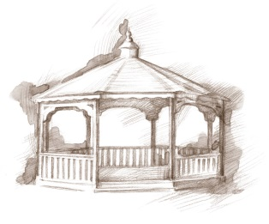
TheVillageVoice
September 2016

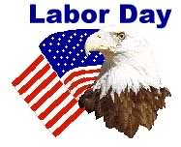
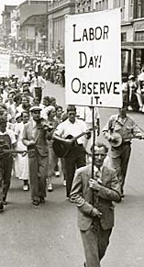
On September 5th, we will celebrate Labor Day, which is a National holiday that honors the American labor force and the contributions that workers have made to the strength, prosperity, and well-being of our country. In 1887, Oregon became the first state to make it an official holiday. By 1894, it became an official federal holiday, with thirty U.S. states officially celebrating Labor Day. We would like to take this opportunity to thank all of the Westminster employees, and their labor of love, to make Westminster Village such a great place to live!

Senior Free Admission Day at Minnetrista

Join us at Minnetrista for the Westminster sponsored Senior Free Admission Day. On Wednesday, September 7th, at 10:00 am and 2:00 pm, Minnetrista will host the Delaware County
Master Gardeners Association. Come and listen to members of the club discuss how their volunteer work has kept the plantings beautiful through the hot summer, and what it means to our community.

Expanding Your Horizons

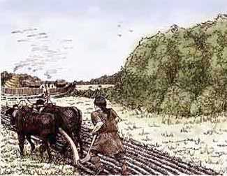
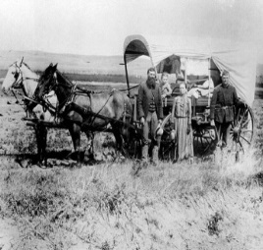
As part of the Bicentennial Celebration, Westminster Village has invited Muncie Community Schools Board Member and Historian, Robert Warrner to present a three part series about the settlement of Indiana through statehood. On Wednesday, September 14th, at 2:00pm, Robert will be showing a 30 minute film about “Frontier Indiana (1700-1800)” and then he will be talking more about this time period. Robert taught history in the Muncie Community Schools for 38 years and he has been teaching in the BSU History Department for the last 8 years, after retiring from MCS. Next month, Robert will be discussing “Pioneer Indiana (1800-1851).” The public is invited to attend.

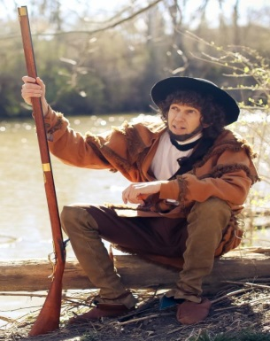
Danny Russel Presents “Daniel Boone”

Another September Expanding Your Horizons at Westminster! Those who attended Danny’s wonderful performance of “Lincoln,” in July, will want to come back and see his rendition of Daniel Boone. In this compelling portrayal, we find our favorite frontiersman reliving years filled with adventure, hardship and danger. The program will be on Wednesday, September 21st, at 2:00pm. The public is invited to attend.

Resident Activities in September
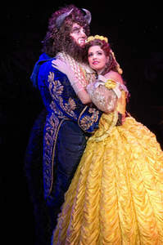
In September, residents may choose from a variety of activities. Some will be making crafts to Welcome Fall. The Lunch Bunch will be dining at Johnny Carinos and Merks. Activities will be starting a new class on, “Helpful Tips and Tricks for Your Phone and Tablet.” Residents will be going to Civic Theatre to see “Beauty and the Beast” and attending MSO’s “Organ Celebration” at Emens. Did you know National Strawberry Cream Pie Day is celebrated this month? Westminster residents do and they will be enjoying delicious Strawberry Cream Pie!

Senior Moments,
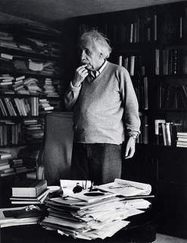
Been There…Done That!

Photographer Ernst Haas took a famous picture of Albert Einstein, which shows the great physicist thoughtfully rubbing his chin, as if he were pondering the mysteries of the universe. In fact, the picture was taken right after Haas asked Einstein where on the shelf he had put a particular book.

A Fall Move to Westminster?
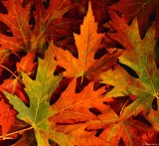
The winter months are quickly approaching. Are you prepared? Consider moving into Westminster before the first snow flies. We have several floor plans to choose from and apartments are move-in ready. We are just waiting for you!

