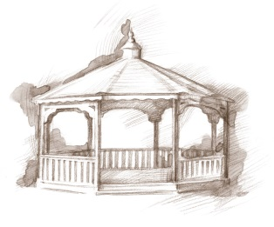
TheVillageVoice
December 2016

ecember, the month that most people wait all year for, is finally here! The weeks leading up to Christmas are a magical time with the sights and sounds of the holiday season. Around Westminster, the Christmas decorations abound. There are over sixty, beautifully decorated Christmas trees, throughout the building. Each Christmas tree has been lovingly decorated with its own special theme. Outside of Westminster, the building and trees have been strung with Christmas lights.

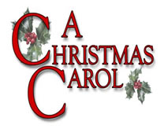
Charles Dickens and “A Christmas Carol”

Charles Dickens was born on February 7, 1812, in Portsmouth, England, the second of 8 children. Dickens’ literary success began with the 1836 serial publication of The Pickwick Papers. A Christmas Carol, was published in 1843, not long after the
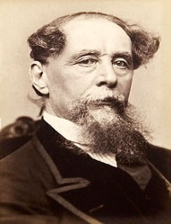
widespread use of Christmas trees (1841) and the first Christmas card (1843). The original title of the book was: A Christmas Carol in Prose: Being a Ghost Story of Christmas. While best known for A Christmas Carol, Charles Dickens penned four other books about Christmas: The Chimes, The Cricket on the Hearth, The Battle of Life, and The Haunted Man and the Ghost’s Bargain. These five Christmas books were published between 1843-1848. Charles Dickens passed away June 9, 1870. He wished to be buried, without fanfare, in a small cemetery in Rochester, but the British nation would not allow it. He was laid to rest in Poet’s Corner, Westminster Abbey. A Christmas Carol remains popular today and continues to inspire adaptations in every artistic genre.

Resident Activities In December
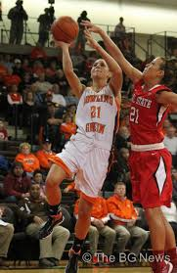
In December, residents have many activities to choose from. Many residents will be attending the BSU Women’s Basketball Games to cheer on the ladies. There will be a Holiday Dessert Walk, which is similar to a “cake walk” and a group of crafters will be making Christmas wreaths. In December, the Lunch Bunch will be dining at IHOP and Applebee’s. Residents will be attending the Artists Series: The Ten Tenors and the MSO concert Fisher Shafer Holiday Pops at Emens. Many residents will be going to Civic Theatre for Joseph and the Amazing Technicolor Dreamcoat. Residents will be going to BSU to attend the Theatre of Dance – A Christmas Carol. Residents receive door-to-door service.

Holiday Traditions at
Westminster Village
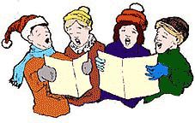
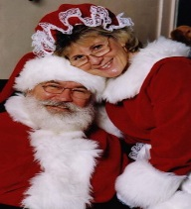
The Employee and Resident Christmas Party is a special tradition at Westminster. Everyone gathers together to sing Christmas carols and enjoy delicious treats. Another tradition is a visit from Mr. and Mrs. Santa Claus. Residents will have their pictures taken with the couple in red! The
Holiday Season culminates with a New Year’s Eve
Bingo and Pizza Party.

Safe and Warm For The Winter

If staying alone in your home during the long, cold winter doesn’t sound like something you want to do this year; Westminster has an idea for you! Come and spend the winter in a comfortable furnished apartment. You can participate in any of the activities, exercise in the Fitness Center, do your banking, get your hair done in the Beauty Salon, and join in all the reindeer games! “Safe & Warm for the Winter” includes meals, cleaning, linen laundry, utilities and basic TV, with monthly rates beginning at $2,131. If you would like to schedule a tour or just ask a question, call Judi or Melody at 288-2155.

