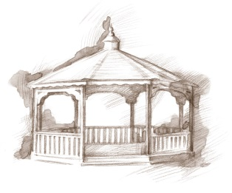
TheVillageVoice
November 2016
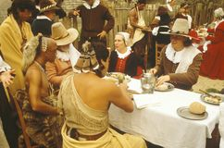
As we celebrate Thanksgiving, with family and friends, our thoughts often wander to that first Thanksgiving, in 1621. Over 90 Wampanoag Indians came to the Plymouth Settlement to celebrate the “good harvest” with the Pilgrims. For three days, they feasted on venison, turkey, as well as, seafood, fruits, grains, vegetables and nuts. This was the first, and last time, that the Pilgrims celebrated “Thanksgiving”. Then, in 1827, Mrs. Sarah Josepha Hale began lobbying several Presidents for the creation of Thanksgiving as a national holiday. It wasn’t until 1863, in the midst of the Civil War, that President Abraham Lincoln made it a national holiday.

Single Seniors USO Dance at Westminster
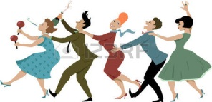
Do the sounds of Benny Goodman or the Dorsey Brothers make you want to get up and dance? On Veteran’s Day, Friday, November 11th, from 7:00 pm to 10:00 pm, Westminster Village will be hosting a USO Dance for single seniors. Come to Jitterbug or Swing the evening away as DJ, Matt Howell, plays the hits of the 1940’s. The public is invited to attend and yes, couples are welcome.

19th Century Indiana
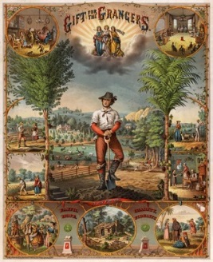
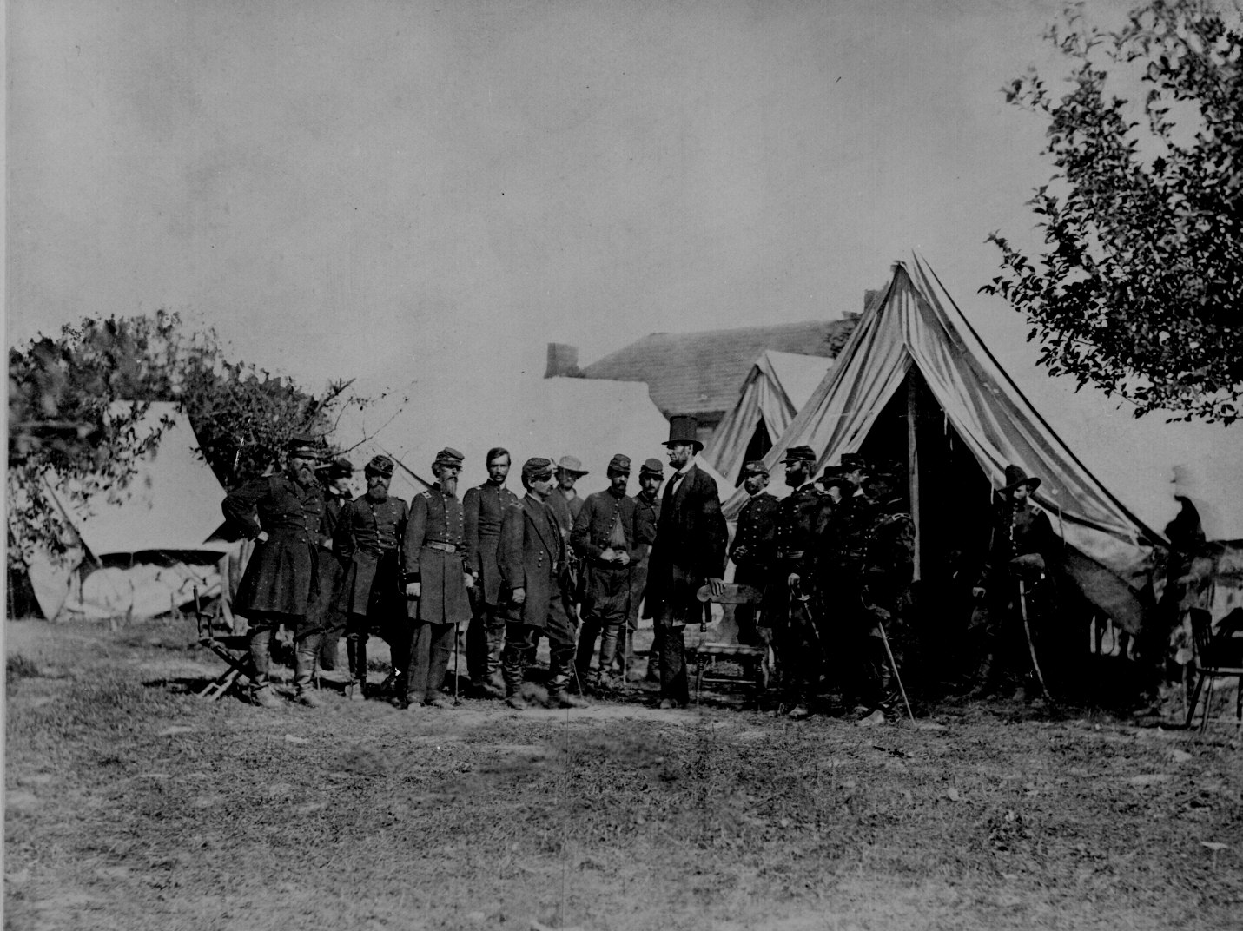
Westminster continues the celebration of Indiana’s 200th Birthday with the November Expanding Your Horizons, featuring Robert Warrner’s presentation entitled, “19th Century Indiana.” This is the third in a three part series, focusing on Indiana in the Civil War, Indiana’s role in national politics and more. Residents and guests have tremendously enjoyed learning about Indiana’s early history in the first two programs. The public is welcome to attend.

Red Carpet Event Featuring Lori Borgman
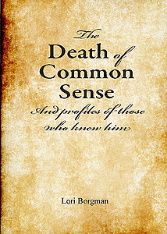
We are pleased to announce that author/humorist Lori Borgman has been invited to Westminster for a special Red Carpet Event. Lori is a nationally-distributed columnist, author of four books and speaker, addressing family matters from a humorous point of view. One of her most popular essays, “The Death of Common Sense & Profiles of Those Who Knew Him”, written in 1998, continues to be circulated around the world. Lori will be at Westminster, Friday, November 18th, at 7:00 pm. The public is invited to attend this FREE event! Due to the popularity of Lori Borgman, seating will be by Reservation Only, so call the Front Desk at 288-2155 today to reserve your tickets. All attendees’ names will go into a drawing for special door prizes.

Civic Theatre brings Honk! to Westminster

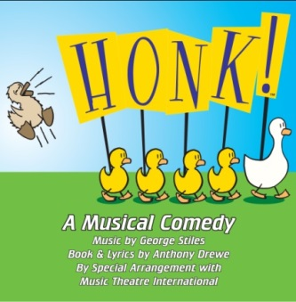
Based on one of Hans Christian Andersen’s most beloved tales, Honk! is a high-energy musical comedy that tells the story of Ugly, the duckling who is born into ridicule and loneliness because he is different. The Civic Theatre cast will perform at Westminster on Saturday, November 19th, at 2:00 pm. With its exuberant music and steady stream of hilarious characters, Honk! promises to delight those of every age. “A fowl play has never been quite as much fun!” The event is FREE and open to the public.

Delaware County
Historical Society’s Traveling Display

The Delaware County Historical Society has set up their Traveling Display at Westminster Village in the Legacy Commons and it will be on display through November. It is available for visitors and residents to enjoy.

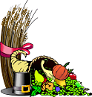
Happy Thanksgiving
From Westminster Village

