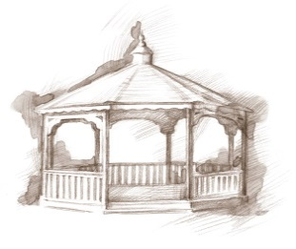
TheVillageVoice
January 2017

Another New Year is upon us, full of new hopes and
dreams. Around Westminster, all the Christmas trees,
lights, wreaths and other decorations, that took weeks to
put up, are being carefully packed away for another year.
Residents are ready to spend winter at Westminster, where
they know they will be safe from whatever winter can dish
out. With all the amenities that Westminster offers right inside our building, residents can relax in knowing that they don’t have to step a toe outside unless they want to!

Presidential Inauguration
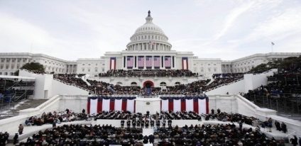
On Friday, January 20th, our new President will be inaugurated, in Washington, DC. The inauguration itself is steeped in tradition but the only element mandated by the US Constitution is that the President make an oath or affirmation before that person can “enter on the Execution” of the office of the presidency. The first inauguration for George Washington was held on April 30, 1789, at the Federal Hall in New York City. In 1801, Thomas Jefferson became the first to be sworn in as President in Washington, D.C., which officially became the federal capital on June 11, 1800. Inauguration day was originally on March 4, four months after Election Day, but this was changed to noon on January 20 by the Twentieth Amendment, in 1933. Coming February 8th, Danny Russel will be here to reprise his performance as President Abe Lincoln. Look for more details in the February newsletter.

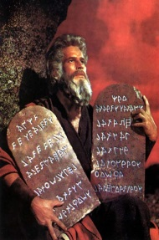
Senior Moments Been There…Done That!
Bill Harback, one of the first executive producers of The Tonight Show, once attempted to ask his secretary to telephone future guest Charlton Heston to arrange a rehearsal. “Get me…uh…Charleston Huston!” Harback barked. “Wait – I, uh, mean Charlton Hudson!” Suddenly recalling that the actor had starred as Moses in the movie The Ten Commandments, he corrected himself. “You know who I mean!” he told his secretary, “Chester Moses.”

January Resident Activities
Residents always have a variety of activities to attend if they choose. Here is a small selection of what the residents will be doing in January. Residents will be attending several BSU Women’s Basketball games, while The Lunch Bunch will be dining out at Red Lobster and Olive Garden. Several residents will be attending the Artist Series production “Once: The Musical,” at Emens. During the winter, door-to-door service, in a warm van or car, is always a plus!

YMCA Silver Sneakers
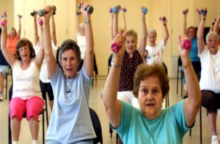
Through a partnership with the YMCA, Westminster residents have been enjoying Silver Sneakers Exercise Classes in the Village for several years. Beginning January 3rd, Silver Sneakers at Westminster Village will be open to the public. Classes will be offered in Legacy Commons Event Hall on Tuesdays and Thursdays from 1:15 to 2:00 pm. Join us in this fitness program tailored to the health and wellness of older adults. You do not have to be a member of the Y and there is no charge to participate in Silver Sneakers at Westminster Village.

Westminster IS Affordable!

Some people have the opinion that Westminster is “just too expensive!” Actually, living at Westminster is affordable. Where else can you live in a One Bedroom Apartment with a Full Kitchen, that includes one meal per day in the dining room, all utilities, Housekeeping, flat linen laundry, basic TV, Maintenance, daily wellness checks, many activities, while living in a safe, secure, beautifully decorated building, all for only $2,029.00 per month?

For more details, or to learn about other apartment options, contact Judi or Melody at 288-2155.

