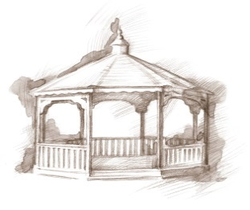
TheVillageVoice
February 2017

The calendar says it is winter but the warmer temperatures and rain of January, say different…but February could be another story! The majority of residents chose to stay active throughout the winter months with activities and exercise. Many join in the daily exercise classes or work out on the equipment in the Wellness Center. The Silver Sneakers classes offer a slightly more intense workout and are taught by trainers from the YMCA. Staying active helps many to breeze through the dreary winter days, whatever the precipitation.

Pianist Frederick Moyer To Give Concert

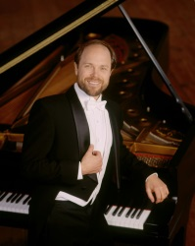
Pianist Frederick Moyer, will be making his third appearance at Westminster Village to perform for residents and guests. Fred first appeared with the Boston Symphony at age 14 and performed with The Boston Pops as a teenager. Fred attended the Curtis Institute of Music in Philadelphia while in high school and graduated from Indiana University. Frederick will be performing in Legacy Commons Event Hall on Tuesday, February 7th, at 2:00 pm, performing selections of classical and jazz, as well as a few special pieces. Our newsletter friends are invited to attend. Please arrive to be seated by 1:50 pm.
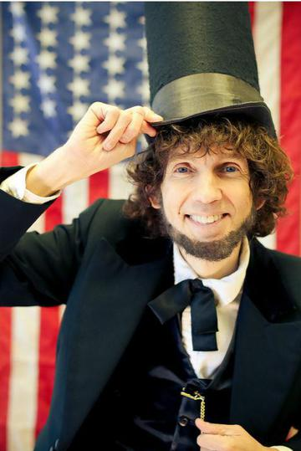
Danny Russel Presents: Abe Lincoln

Expanding Your Horizons in February, Westminster has invited Danny Russel for an encore performance of Abe Lincoln. Danny’s enduring appeal is evident in the portrayal, which covers all notable aspects of Lincoln’s life, from his Hoosier boyhood years (7-21 years old) to his extraordinary accomplishments in the White House. Alternately hilarious and heartbreaking, Danny’s performance includes stirring renditions of “A House Divided”, the “Gettysburg Address” and portions of Lincoln’s Second Inaugural. Please join us for this wonderful performance on Wednesday, February 8th, at 2:00 pm., in Legacy Commons. The public is welcome to attend.

Sweetheart Ball

In Celebration of Valentine’s Day, Westminster invites you to attend a Sweetheart Ball on Friday, February 10th, 7:00 pm – 9:00 pm, in Legacy Commons Event Hall. Matt Howell will be the DJ, playing romantic music from the 1940’s through the 60’s. Spin your favorite sweetheart around the dance floor, or just come to listen. All are welcome!

Steve Bell – Educator, Broadcast Journalist

Expanding Your Horizons in February will feature Steve Bell, ABC News Anchorman, War Correspondent for ABC and Emmy Award Winner, as he shares his life’s experiences in the ABC studios, Vietnam and Indo-china. Steve will screen a 30 minute portion of a documentary that has been produced about his distinguished career. Steve’s presentation will be on Wednesday, February 15th, at 2:00 pm, in Legacy Commons Event Hall. The public is welcome to attend this interesting event.

Taking Charge of Your Health

In February, Westminster will present Taking Charge of Your Health, featuring Alexis Neal, MA, RN, Cardiovascular Service Leader, IU Health Ball Memorial Hospital. On Wednesday, February 22nd, at 2:00 pm, in Legacy Commons, learn about the cardiac and sleep services that are now available through IU Health Ball Memorial Hospital. Know how to recognize the warning signs of heart issues and when to seek medical assistance. Light refreshments will be served. The public is welcome to attend.

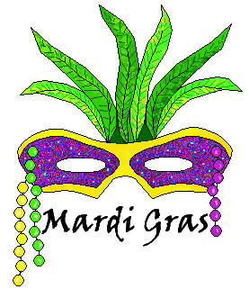
The Real Mardi Gras

We hear all the stories of Mardi Gras, but did you know that it is steeped in tradition and history? What is the story behind King Cakes or the colors of gold, green and purple? To find out the answers to these questions, and indulge in some decadent treats, join us on Fat Tuesday, February 28th, at 2:00 pm, in Legacy Commons, as Judi Harris, Westminster Village’s Marketing Director, presents, “The Real Mardi Gras.” The public is invited to attend.

