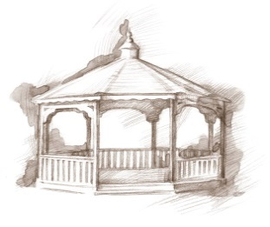
TheVillageVoice
May 2017

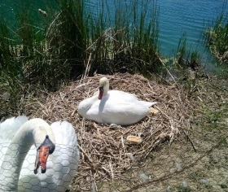
Spring time has finally arrived! Around Westminster, tulips and daffodils are in bloom, trees are again sporting their green foliage, while many ornamental trees are covered in a variety of colorful flowers. Now that the days are feeling warmer, Westminster residents and visitors love to stroll out to the deck, maybe to enjoy the sunshine or watch the swans sitting on their nest.

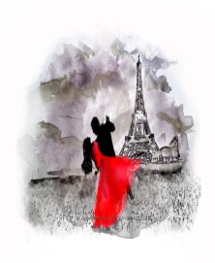
An Evening in Paris

On May 5th, 7:00 pm - 9:00 pm, Westminster Village will host
an Adult Formal Prom; An Evening in Paris. Dance as if you
were in the shadow of the Eifel Tower or walking hand-in-hand
along the Seine, under the soft glow of street lamps, DJ, Matt Howell,
plays many romantic tunes. There will be door prizes and light
refreshments will be served. The public is invited. Formal attire is optional.

Expanding Your Horizons: Life of Eleanor Roosevelt

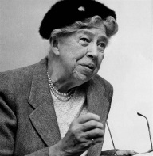
Westminster Village offers many diverse topics for its Expanding Your Horizons programs and in May, Sue Templin, will present “The Life of Eleanor Roosevelt.” Sue is a retired elementary school teacher who became interested in the life of the nation’s most iconic first lady when she portrayed Eleanor in a play. Join us for Part 1, as Sue follows Eleanor’s life from birth to the death of Franklin in 1945. Part 2 of Eleanor’s life, “After Franklin” will be scheduled at a later date. The program will be on Wednesday, May 3rd, at 2:00 pm., in the Legacy Commons Event Hall. The public is welcome to attend.

MSO: Friends of the Symphony at Westminster
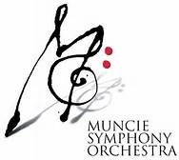
Westminster will host a Wood Quintet Concert on Wednesday, May 10th, at 2:00 pm as part of Friends of the Symphony at Westminster. The musicians will be playing works by Scott Joplin, August Klughardt, George Gershwin and more. The public is invited to attend.

Rick Garrett Presents: Burl Ives

If you are a fan of Burl Ives and enjoy his music, you will be interested in this program. On Wednesday, May 17th, at 2:00 pm, in Westminster’s Legacy Commons Event Hall, comedian Rick Garrett will present “An Afternoon with Burl Ives.” Rick, who lives in Indy, is a native of Cowan. During Rick’s show, he appears as Mr. Burl Ives himself, telling Burl’s life story through spoken word, songs, and sing-a-longs. The public is
welcome to attend.

Senior Free Admissions Day at Minnetrista

The Westminster sponsored Senior Free Admission Day at Minnetrista begins in May and runs through October. Seniors are welcome to visit Minnetrista, at no cost, for programs and tours, one Wednesday a month. On Wednesday, May 24th, Minnetrista’s Heritage is on display in the Minnetrista Heritage Gallery. Collections staff will talk about the objects and purpose of their collection. The programs will be at 10:00 am and 2:00 pm
and admission is free all day for seniors.

A Moment in Time: Muncie’s Rivoli Theater
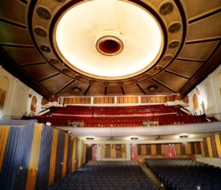
For another interesting Expanding Your Horizons in May, please join local photographer, John Disher, for a view of Muncie’s historic Rivoli Theater in 1987. John will present his photos of the last days of the Rivoli and share his experiences as he toured rarely seen areas of the theater shortly before its demise. The program will be on Wednesday, May 31st, at 2:00 pm., in the Legacy Commons Event Hall. The public is invited to attend.

Resident Activities in May

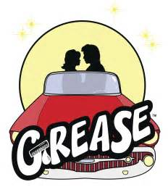
In May, many of the residents will be dining out with the Lunch Bunch at Montana Mike’s in Anderson and Ivanhoes in Upland. Some residents will be attending the performance of “Grease” at Civic Theatre and the Artist Series production of “Mama Mia” at Ball State. Residents will be celebrating Mother’s Day with a Mother’s Day Tea.

Happy Mother’s Day!

