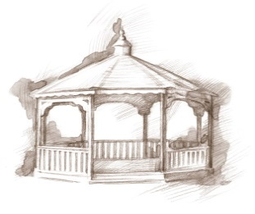
TheVillageVoice
June 2017

With the warmer, sunny days of June, residents and visitors enjoy a stroll out to the pond. Many are now going out to see the new Cygnets that hatched on April 28th, while others like to relax in one of the deck chairs to look at the water and fountain. You will often see residents sitting in the shade of the gazebo to read a good book or visit with each other. A special stop on the way to the pond is the Memory Garden with its beautiful flowers and artistic sculptures. Whatever the reason, going out to the pond is worth the short walk!

Annual Gazebo Picnic

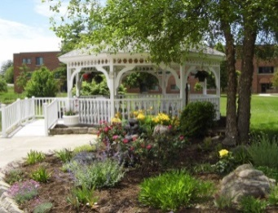
On a day each June, residents enjoy a picnic lunch on the deck and in the gazebo. They are served a KFC
dinner with all the fixings and the kitchen prepares a delicious summer dessert that will beautifully complement the meal. We all hope it is a lovely sunny day so residents can enjoy the afternoon sitting at the tables, under the umbrellas. However, if the weather decides not to cooperate, the picnic will be moved indoors to The Legacy Commons Event Hall and it will still be a picnic!

Resident June Activities
Westminster plans many different events and activities that residents may attend if they wish. In June, residents will be attending the Strawberry Festival at Garden of Gethsemane. The Lunch Bunch will be dining at Mulligans. Many will be visiting the BSU planetarium for the program entitled “Eclipse: The Sun Revealed.” Residents will also be attending the MSO Concert Festival on The Green.

“Any man can be a father. It takes someone special to be a dad.” – Anne Geddes. Westminster Village will be celebrating Father’s Day and our resident fathers with a Root Beer Float Party. We want to show these wonderful men how much they mean to us and what a positive influence they are in our lives! On Father’s Day, Westminster Village also honors all men who have guided a child through their journey to adulthood.

Senior Moments:
Been There…Done That!
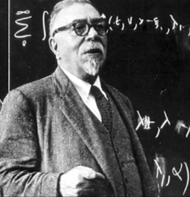
When the family of MIT mathematician, Norbert Wiener, moved from Cambridge, Massachusetts, to the nearby suburb of Newton, his wife knew the famously absentminded professor would never be able to find his way to their new home on his own. So she wrote down the Newton address on a piece of paper and gave it to him before he left that first morning. A few hours later, when an idea struck him, he found the piece of paper in his pocket and scribbled some notes on the back. After he looked the idea over, however, he decided it was worthless, and threw the paper away. With no note to remind him he had moved, he returned to his old house in Cambridge to be met by his daughter, waiting there for him. “Hi, Daddy,” she said. “Mommy thought you would forget!”

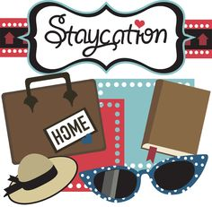
Summer Vacation At Westminster

Any plans for your summer vacation? Why not come and spend several months through the summer at Westminster on a “Stay-cation!” You can vacation right here in Muncie, experiencing our dining rooms, many different activities, and events. So, call Judi or Melody at 288-2155, and get ready for a summer of fun!

