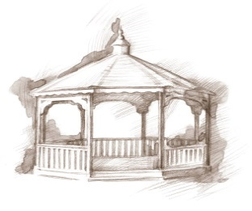
TheVillageVoice
July 2017

Summer is here with it’s warm temperatures and sunshine. This is the perfect time for sharing those special moments with family and friends. Many Westminster residents have been traveling on their summer vacations or have plans to visit family out of town. On the evening of July 4th, Westminster residents will be enjoying the warm summer evening listening to a patriotic concert by America’s Hometown Band and watching the fireworks display at Minnetrista. Residents will be sitting in their special reserved seating that Minnetrista provides.

Senior Free Admission Days at Minnetrista
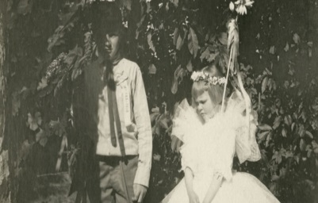
The Westminster Village sponsored Senior Free Admission Days at Minnetrista will be on Wednesday, July 19th, at 10:00 am and 2:00 pm. The program, entitled “Childhood on the Boulevard,” will be presented by Jessica Jenkins, Minnetrista Heritage Collections staff, on the imaginative play of the Ball children on the boulevard enjoyed during the time the houses were occupied. Grandparents, this would be a perfect opportunity to share the fun stories of the Ball children with your grandchildren, in air conditioned comfort, on a hot summer afternoon!

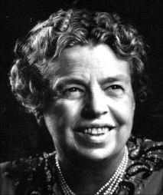
Eleanor Roosevelt- Part II

After her interesting talk about one of our First Ladies’, Eleanor Roosevelt, Sue Templin returns to Westminster for Eleanor Roosevelt Part II. In this discussion, Sue will talk about Eleanor’s life after the death of her husband, Franklin. The program will be on Wednesday, July 26th, at 2:00 pm in the Legacy Commons Event Hall. Please join us.

Westminster Village to Host Recitals
Westminster Village is often asked to host recitals in the Legacy Commons Event Hall. The amateur performers enjoy entertaining our residents and it gives them a chance to perform in front of an audience. On Wednesday, July 12th, at 2:00 pm, Jonathan Daughtery will be giving a jazz recital and on Friday, July 28th, at 2:00 Allyn Ehlert will be performing on the piano. The public is welcome to attend the recitals of these young performers.

Resident Activities For July

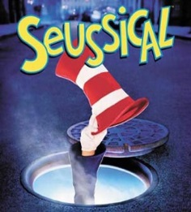
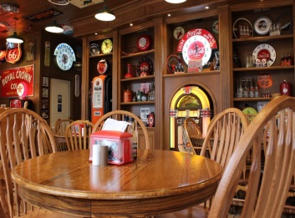
In July, residents have the choice of activities from which they may participate in if they choose. Many residents will be going to Cornerstone Center for the Arts to watch Civic Theatre’s performance of Seussical the Musical. (Civic Theatre’s remodel project is currently underway.) The Lunch Bunch will be dining out at Cammack Station and The Chocolate Moose in Farmland. There will be various card games, Wii Bowling, Dominoes, and other activities to choose from.

Senior Moments: Been There...Done That!

On July 28, 1962, the Mariner 1 space probe was launched from Cape Canaveral. Its scientific mission: to reach Venus after 100 days in space, go into orbit, and then send back valuable data. But four minutes after the launch, the $18 million rocket veered dangerously off course and had to be destroyed by remote control. The cause? Someone had forgotten to put the one symbol into the computer’s program.

