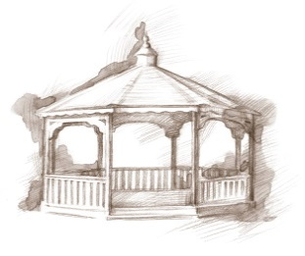
TheVillageVoice
August 2017

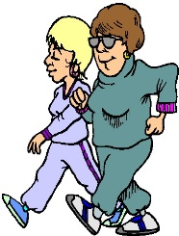
For many, August signals that summer is coming to a close. Families take their final summer vacations and kids begin to prepare for the first day of school. Early mornings at Westminster, while the temperatures are still cooler, the “Westminster Walkers” stroll along the sidewalk and trails that winds around the building. On their walks, they enjoy the flowers and bushes that have been so lovely this summer, knowing that very soon those beautiful summer colors will turn the shades of fall. So while we can, let’s enjoy the colors of summer!

Two Expanding Your Horizons in August

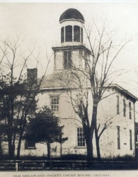
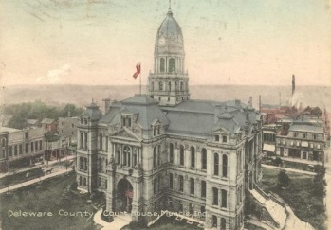
There will be two Expanding Your Horizons events in August. On Wednesday, August 9th, at 2:00 pm, Jim Kouns will present, “My Experiences with Genealogy”. Jim will discuss the tools in researching your genealogy and what you might find. Before retiring, Jim was in real estate for 28 years. He is a member of the Delaware County Master Gardeners and the Exchange Club. On Monday, August 14th, at 2:00 pm, Westminster will feature Chris Flook, Vice President of the Delaware County Historical Society. Chris will be at Westminster to present Indiana’s Court House Squares. Courthouse squares bring back the days when downtowns were the hub of the city. People would gather at the courthouse square to visit with friends or shop in the local stores that surrounded them. The public is welcome to attend both events.

Don Bell and His Horses To Perform at Westminster
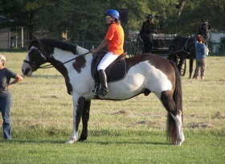
The annual event at Westminster Village, a highlight of the summer, is Don Bell and his trained European Friesian and Arabian horses. Sitting outside on a lovely summer evening watching Don’s beautifully trained horses, as they dance with precision to music, is an experience you won’t want to miss. The performance will be Thursday, August 10th, at 7:00 pm, in the meadow, off Benton Road, weather permitting. Our special Village Voice friends are welcome to attend. Don’t forget to bring water and your chair!

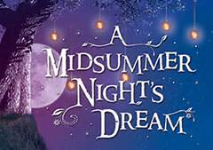
Senior Free Admission Day at Minnetrista

The Westminster sponsored Senior Free Admission Day at Minnetrista in August will be presented by Muncie Civic Theatre’s Laura Williamson. This summer, Muncie Civic Theatre will be bringing Oakhurst Gardens to life with their production of A Midsummer Night’s Dream. On Wednesday, August 16th at 10:00 am and 2:00 pm, join Laura, along with the theatre staff, as they explore the historic connections between the Minnetrista Boulevard and Community Theatre.

Country Kickers to Perform at Westminster

On Thursday, August 17th, at 2:00 pm, The Country Kickers will be at Westminster to perform a Line Dancing Show. The public is welcome to attend!

Classic Car Review & Sock Hop at Westminster
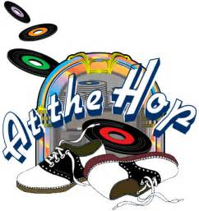
Favorite songs like, “Rock Around The Clock” and “The Stroll” bring back memories of bobbysocks, saddle shoes and muscle cars. On August 18th, Westminster invites you to step back in time with a Classic Car Review followed by a Sock Hop! The Classic Car Review starts at 5:00 pm – 7:00 pm, in our front parking lot. There will even be an antique fire truck and don’t forget to sample the Root Beer Floats! The Sock Hop begins at 7:00 pm – 9:00 pm, in the Legacy Commons Event Hall. DJ Matt Howell will be playing all the great tunes from the 50’s and 60’s. Refreshments will be served throughout the evening.

