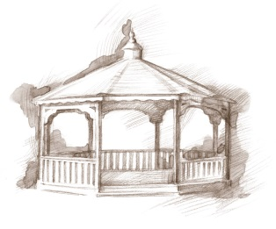
TheVillageVoice
October 2016
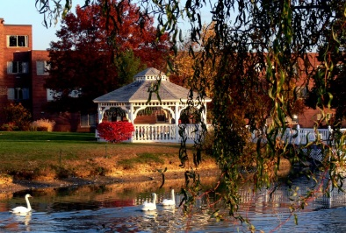

The calendar says its fall but it seems like summer doesn’t want to loosen its grip. Soon the cooler temperatures will be upon us and the leaves will begin to turn their brilliant hues of gold, red, and orange. Typically in Indiana, leaves turn the second and third week of October. At Westminster the fall mums have been carefully planted, which will add more beautiful colors to what will be a lovely fall landscape. With the changing of the season, we know that the holidays are just around the corner!

Lunch & Learn
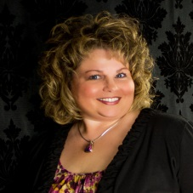
Westminster will host a Lunch & Learn, with special guest speaker, Sherry Brown, on Tuesday, October 4th, Noon to 1:30 pm. Sherry is a Professional Organizer and Senior Move Manager, specializing in Assisting older adults & their families with all or any part of the downsizing and moving process.
We will be meeting in the Village Meeting Room. RSVP is required to Judi or Melody at 765-288-2155, by 10:00 am, October 3rd. Call now because seating is limited.

Travel to Cuba
Join Alan and Beverly Wilson at Westminster Village as they share their fascinating trip to Cuba. Learn about Cuba’s past and present, as the Wilson’s photos take you there. Alan and Bev will be here on October 11th, at 2:00 pm. The public is welcome to attend.

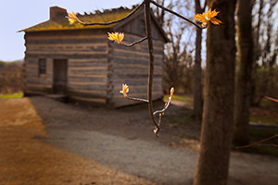
Pioneer Indiana

Westminster’s Expanding Your Horizons program in October, will feature history teacher, Ball State University instructor, and member of the Muncie Community School Board, Robert Warrner, as he presents the second, of the three part series on Indiana, entitled “Pioneer Indiana.” Please join us on October 19th, at 3:00 pm, as we continue our celebration of Indiana’s 200th Birthday. The public is invited to attend.

The Final Senior Free Admission Day
The Westminster Sponsored Senior Free Admission Day at Minnetrista for October will be the final one for the year. On Wednesday, October 19th, at 10:00 am and 2:00 pm, you are invited to visit the Orchard Shop and Cider Room. Attendees will get a back stage look at the cider process, pressing apples grown in Minnetrista’s own orchard. Apples and their delicious cider will be available for purchase.

Danny Russel as James Whitcomb Riley

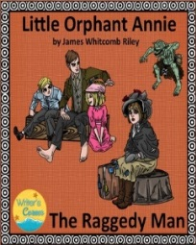
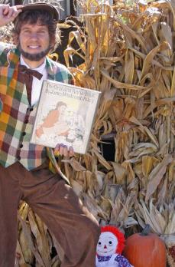
Following his remarkable performances as “Lincoln” and “Daniel Boone”, Danny Russel returns to Westminster as Indiana’s own humorist and poet, James Whitcomb Riley. In this sentimental, fast-paced and humorous portrayal, Russel, as Riley, recites and performs “simple sentiments that come directly from the heart” – The Raggedy Man, When the Frost is on the Punkin, his most beloved piece, Little Orphant Annie, and more. The performance will be October 26th, at 2:00 pm. The public is welcome to attend.
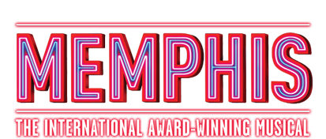
Resident Activities in October

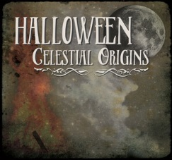
Residents have many activities that are scheduled throughout each month that they can choose to do. Some of the special events that the residents will be choosing from include attending MSO for their performance of Revelry and the Artist Series of Legends in Concert at Emens. There is a visit planned to the BSU Planetarium for the presentation of Halloween Celestial Originals. Several residents will be going to Civic Theatre to see Memphis: The Musical. The Lunch Bunch will be dining out at Outback and Bob Evans.

We are now taking reservations for “Safe & Warm For The Winter.” For more information, please call 765-288-2155 and ask for Judi or Melody.

