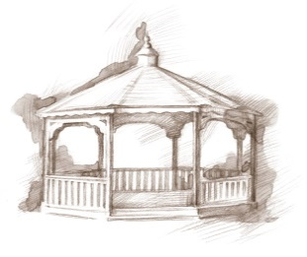
TheVillageVoice
November 2017
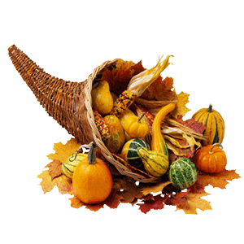
For many, the month of November marks the beginning of the Holiday Season. Preparations for Thanksgiving will soon commence. During Thanksgiving many Westminster residents invite family members to join them as they celebrated with a traditional Thanksgiving meal, while other residents travel to go visit friends and family. During this special time, let us give thanks for all our blessings!

Expanding Your Horizons In November
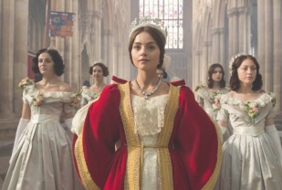
In anticipation of the second season of the PBS Masterpiece production, “Victoria”, Expanding Your Horizons at Westminster Village in November will feature WIPB screening of “Victoria”, from the season’s first episode. Watch as a young Victoria becomes Queen in 1837 at the age of 18, through her relationship with Lord Melbourne, and marriage to Prince Albert. The screening will be Wednesday, November 1st, at 2:00 pm. The public is invited to attend.

Passport to Wellness Health Fair
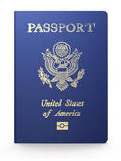
On Wednesday, November 8th, Westminster Village will host a Free Health Fair, in the Legacy Commons Event Hall. Health screenings including glaucoma, hearing, diabetes, health/stroke, skin cancer, balance, neck/joint and cardiovascular will be offered. Over twenty five participating business will be on hand to answer your questions. The Passport to Wellness Health Fair will start at 10 am until 2 pm. Westminster residents and the public is encouraged to
attend.

Senior Singles USO Dance
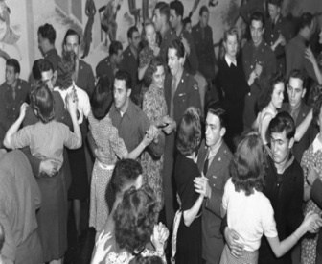
You are invited to join us at Westminster Village to celebrate Veteran’s Day with our Second Annual Senior Singles USO Dance, on Friday, November 10th, from 7:00 pm – 9:00 pm, in the Legacy Commons Event Hall. Come and dance to the music of the 1940’s Big Bands sounds of Tommy Dorsey, Glenn Miller and more. For your listening pleasure, the music will be provided by DJ Matt Howell. And yes, couples are welcome!

Lunch & Learn with Sherry Brown

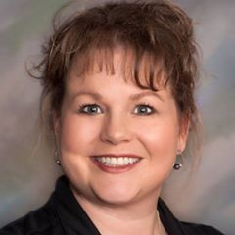
For anyone who is considering a move, or just needing to down size, consider attending the Lunch & Learn with Sherry Brown at Westminster Village on Monday, November 13th, from noon until 1:30 pm. Sherry Brown, a Professional Organizer and owner of Organize This!, will be presenting “Preparing for a Winter Stay at Westminster.” Even if you aren’t planning a move to Westminster at this time, Sherry’s helpful ideas will prove beneficial to you now or in the future. Seating is limited so an “RSVP” is required by noon Friday, November 10th, to Melody at 288-2155.

Red Carpet Event! Old Time Radio Show

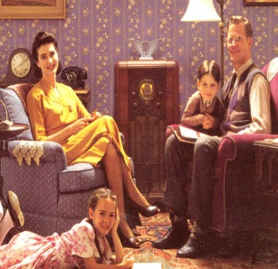
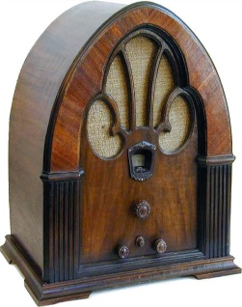
On Friday, November 17th, at 7:00 pm, Westminster will be hosting a Red Carpet Event in the Legacy Commons Event Hall, featuring Tom Cherry’s Old Time Radio Show! Join us as we relive the Golden Age of Radio. Remember when families gathered in front of their radios to listen to Fibber McGee & Molly, The Shadow, and more? Come and watch as the actors and sound specialists create their magic! The public is welcome to attend this free event.

Now that fall has arrived, your thoughts may turn to the many challenges of winter weather. This could be a good time to talk with Melody, at 288-2155, about how you can enjoy being safe and warm at Westminster Village.

