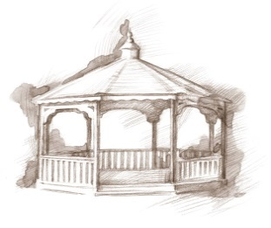
TheVillageVoice
December 2017

The Holiday Season is upon us with the lovely sights and sounds of Christmas. Here at Westminster Village, it is going to be a virtual Winter Wonderland, with over 70 beautifully decorated trees throughout the entire building and wreaths adorning many a door. Christmas goes beyond the inside walls as the trees and building outside are draped in lights and wreaths. At Westminster Village it is tradition that the Friday following Thanksgiving is when the Christmas decorations are beginning to be assembled. Everyone can feel excitement!

Expand Your Horizons In December
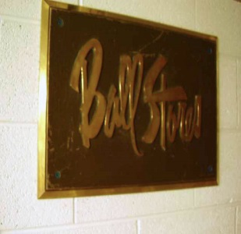
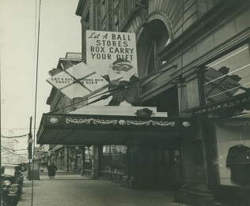
For those of us who grew up in Muncie, a highlight of the Christmas Season was a trip downtown to Ball Stores. The entire store was decked out in all its Christmas splendor, and for wide-eyed children, Santa’s workshop was magical. Come and relive those special Christmas days at Muncie’s Ball Stores on Wednesday, December 13th, at 2:00 pm. Karen Vincent, the Historian from Minnetrista, will be at Westminster to take us down memory lane with stories and photos. The public is welcome.

Holiday Violin Recital

On Saturday, December 9th, at 2:00 pm, in the Legacy Commons Event Hall, Westminster, will host The Tiffany Arnold Studio Holiday Violin Recital. Twenty violin students will perform for residents and guests. The public is invited to attend
The Bells Are Ringing At Westminster Village

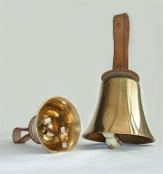
The Holiday Chimers will bring their beautiful Christmas sounds to Westminster Village in the Legacy Commons Event Hall on Sunday, December 10th, at 6:30 pm. The Holiday Chimers will certainly get everyone in the holiday spirit! The public is welcome.

“It’s a Wonderful Life!”

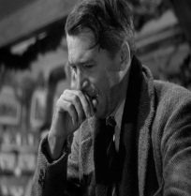
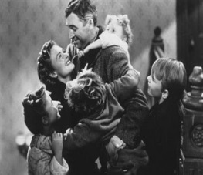
The movie, “It’s a Wonderful Life” was ranked as the #1 Most Inspirational Movie of All Time by the American Film Institute in 2006. The film was Jimmy Stewart’s first picture after 20 months on the front lines of WW II. He was suffering from Post Traumatic Stress Disorder while filming. He said that while filming the scene in which George prays while sitting at the bar, he began to sob, so the Director, Frank Capra, re-framed the now much closer shot to capture his expression. That is why the shot appears grainy compared to the rest of the film. “It’s a Wonderful Life” has been a Classic Christmas Holiday favorite for more than 75 years.

Resident Activities for December
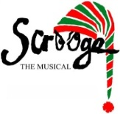
Many activities are planned each month for Westminster residents to participate in, if they wish to. In December, some residents will be going to Civic Theatre for the production of Scrooge: The Musical. Residents riding to events outside of Westminster, have door-to-door service in one of our warm buses.

Safe and Warm For The Winter

If staying alone in your home during the long, cold winter doesn’t sound like something you want to do this year; Westminster has an idea for you! Come and spend the winter in a comfortable furnished apartment. You can participate in any of the activities, exercise in the Fitness Center, do your banking, get your hair done in the Beauty Salon, and join in all the reindeer games! “Safe & Warm for the Winter” includes meals, cleaning, linen laundry, utilities and basic TV, with monthly rates beginning at $2,072. If you would like to schedule a tour or just ask a question, call Melody at 288-2155.

