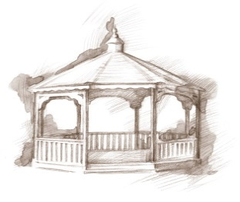 TheVillageVoice

**January 2018**

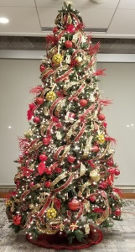Westminster Village had over 30 beautifully decorated Christmas trees throughout the building this year. If you weren’t able to view all of them, come to Westminster on Thursday, January 4th, from 2:00 pm to 6:00 pm for our *Enchanted Tree Celebration*, to view 25 of our celebrated Christmas trees, before they go back into storage for another year. Enjoy a cup of hot cocoa and cookies as you stroll through our Mall area and Legacy Commons Event Hall, to view the trees. There will be an opportunity to win a variety of great door prizes. Whoever schedules a tour for January, and moves in before June 30th, will receive $1,000 off their third month’s fee.

**Meet Westminster’s New Marketing Director!**

[](https://www.facebook.com/profile/picture/view/?profile_id=1504414667)

In December, Alice Gay Nation became the Marketing Director at Westminster Village. Gay joins the Westminster Marketing Team with over 40 years

of sales and marketing experience - New York City’s Garment District, Paws, Inc. - Jim Davis’ Garfield studio, and NASH FM 102.5. She has a strong commitment to non-profit and is actively involved in volunteering with various organizations - member of the Rotary Noon Club of Muncie for over 10 years, WIBU (Women In Business Unlimited) 2008 Athena recipient, AWAKEN and currently serves on the board of Masterworks Chorale, to name a few. Gay is originally from Perry, GA but is a die-hard Munsonian and Cardinals fan. Welcome Gay!!

***Rhatatat* at Westminster**



On Wednesday, January 9th, at 2:00 pm, in our Legacy Commons Event Hall, Michael B. will present *Rhatatat*, a musical performance the whole family can enjoy, from golden oldies to popular hits of today. With a passion for music, Michael B. has been singing and playing the saxophone for over 30 years, and brings that passion to his performances. The public is welcome to attend.

**Expanding Your Horizons for January**



April 6, 1917, the United States officially entered World War 1, under the command of Major General John J. Pershing. This global conflict claimed 116,516 American lives and wounded another 200,000. Join us for the *Expanding Your Horizons* on Wednesday, January 10th, at 2:00 pm, as Jim Waechter, Executive Director of the Delaware County Historical Society, will be in the Legacy Commons Event Hall, to discuss the war’s impact 100 years later and share statistics as they relate to Delaware County. The public is invited to attend this interesting program.

**Chords of Friendship Folk Music**

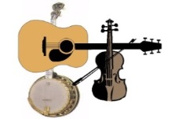Did you know that January is Folk Music Month? In celebration of Folk Music Month, Westminster has invited the *Chords of Friendship* to perform at Westminster on Wednesday, January 23rd, at 2:00 pm in the Legacy Commons Event Hall. The *Chords of Friendship* musicians describe their music as “*front porch music*!” The public is welcome to attend this toe tapping performance.

**Westminster IS Affordable!**

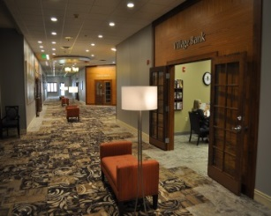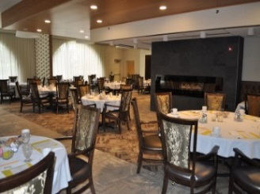Some people have the opinion that Westminster is “*just* *too expensive!”* Actually, living at Westminster is very affordable. Where else can you live in a One Bedroom Apartment with a Full Kitchen, that includes one meal per day in one of the dining rooms, all utilities, housekeeping, flat linen laundry, basic TV, maintenance, daily wellness checks, many activities, while living in a safe, secure, beautifully decorated building, all for only $2,072 per month? For more details, or to learn about other apartment options, contact Tyler or Melody at 288-2155.