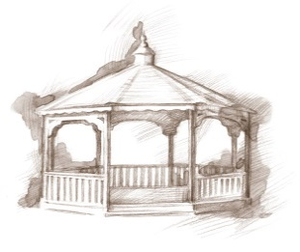
TheVillageVoice
February 2018
Each year on February 14th, it is customary to exchange cards, candy, gifts or flowers with a special “valentine.” Westminster wishes everyone a very sweet Valentine’s Day!

Meet Westminster’s New Sales Consultant

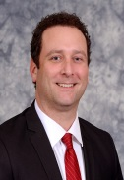
In December, Tyler Ewing became the Sales Consultant at Westminster Village. Tyler joins the Westminster Marketing Team with over 17 years of sales and marketing experience in the medical field – Work Comp related injuries, Hospice Services and Assisted Living. He has a strong community connection. He was born and raised in Eaton/Muncie. He graduated from Delta High School and Ball State University. He is married to his wife Mary and they have three wonderful kids. He enjoys attending his son’s soccer games and daughter’s dance recitals. He also likes cheering on the Cardinals. Welcome to the Marketing Team, Tyler!!

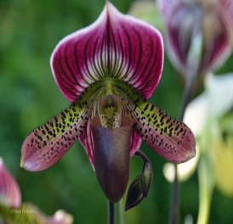
The Beauty and Mystic of Orchids

On Thursday, February 8th, at 2:00 pm, the curator of the Dr. Joe and Alice Rinard Orchid Greenhouse at Ball State University, Cheryl LeBlanc, will be at Westminster in the Legacy Commons to present “The Beauty and Mystic of Orchids” including the Betty Kendall Lady Slipper Orchid Collection.

Expanding Your Horizons In February
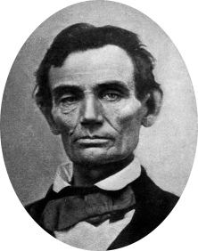
On Monday, February 12th, at 2:00 pm, Jack Buckles, a retired Muncie Attorney, will be presenting “Abe Lincoln – A Conversation.” Jack believes that, “no one was like Lincoln. Lincoln came from such humble circumstances, with less than one year of formal education and to be so well spoken, was just amazing.” Jack will be discussing Lincoln’s early years in
Kentucky and the family’s move to Indiana. The public is
welcome to attend.
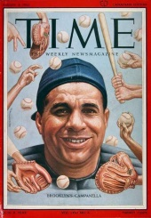
A Collection of “Time” Magazines

We have scheduled another “Expanding Your Horizons” in February. Woody Noblitt will be at Westminster to share his presentation entitled “Review of Time Magazine Through The Years.” Join us in the Legacy Commons Event Hall on Wednesday, February 14th, at 2:00 pm, to see Woody’s interesting collection of the iconic magazines. This program is free and open to the public

The Ball Family of Muncie Leave Their Mark
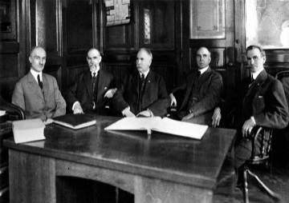
Westminster Village welcomes Minnetrista and E. B. and Bertha C. Ball Center as they present Visiting Nurses, Tuberculosis Assailants, and their Ball Family Champions. Come and learn how the Ball Family continually worked to improve public health in the region, and personally invested time and energy in improving sanitation, hygiene, and medical access in Muncie. The program, presented by Ms. Jessica Jenkins, Curator at Minnetrista, will be on Tuesday, February 20th, at 2:00 pm, in the Legacy Commons Event Hall. The public is welcome to attend.

MSO Friends Of The Symphony Concert

Westminster Village presents the Friends of the Orchestra with Guest Artist, Noelle Tretick Gosling, on Wednesday, February 21st, at 2:00 pm. Noelle is the Concertmaster of the Muncie Symphony Orchestra. She will be playing a mix of classical and beloved classic oldies from the “American Songbook”. Noelle will bring two different violins – acoustic and electric. The public is invited to join us for this wonderful program.

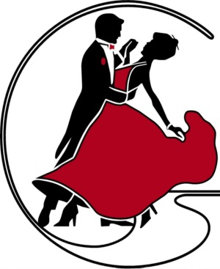
Sweetheart Ball

In Celebration of The Month of Love, Westminster Village invites you to attend a Sweetheart Ball on Friday, February 23rd, 7:00 pm – 9:00 pm, in Legacy Commons Event Hall. Matt Howell will be the DJ, playing romantic tunes from the 1940’s through the 60’s. Join us as you spin your favorite sweetheart around the dance floor, or just come to listen. Senior couples and singles are welcome to attend this free event!

