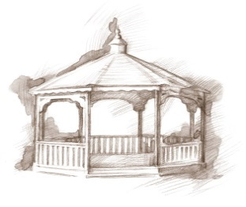 TheVillageVoice

**March 2018**

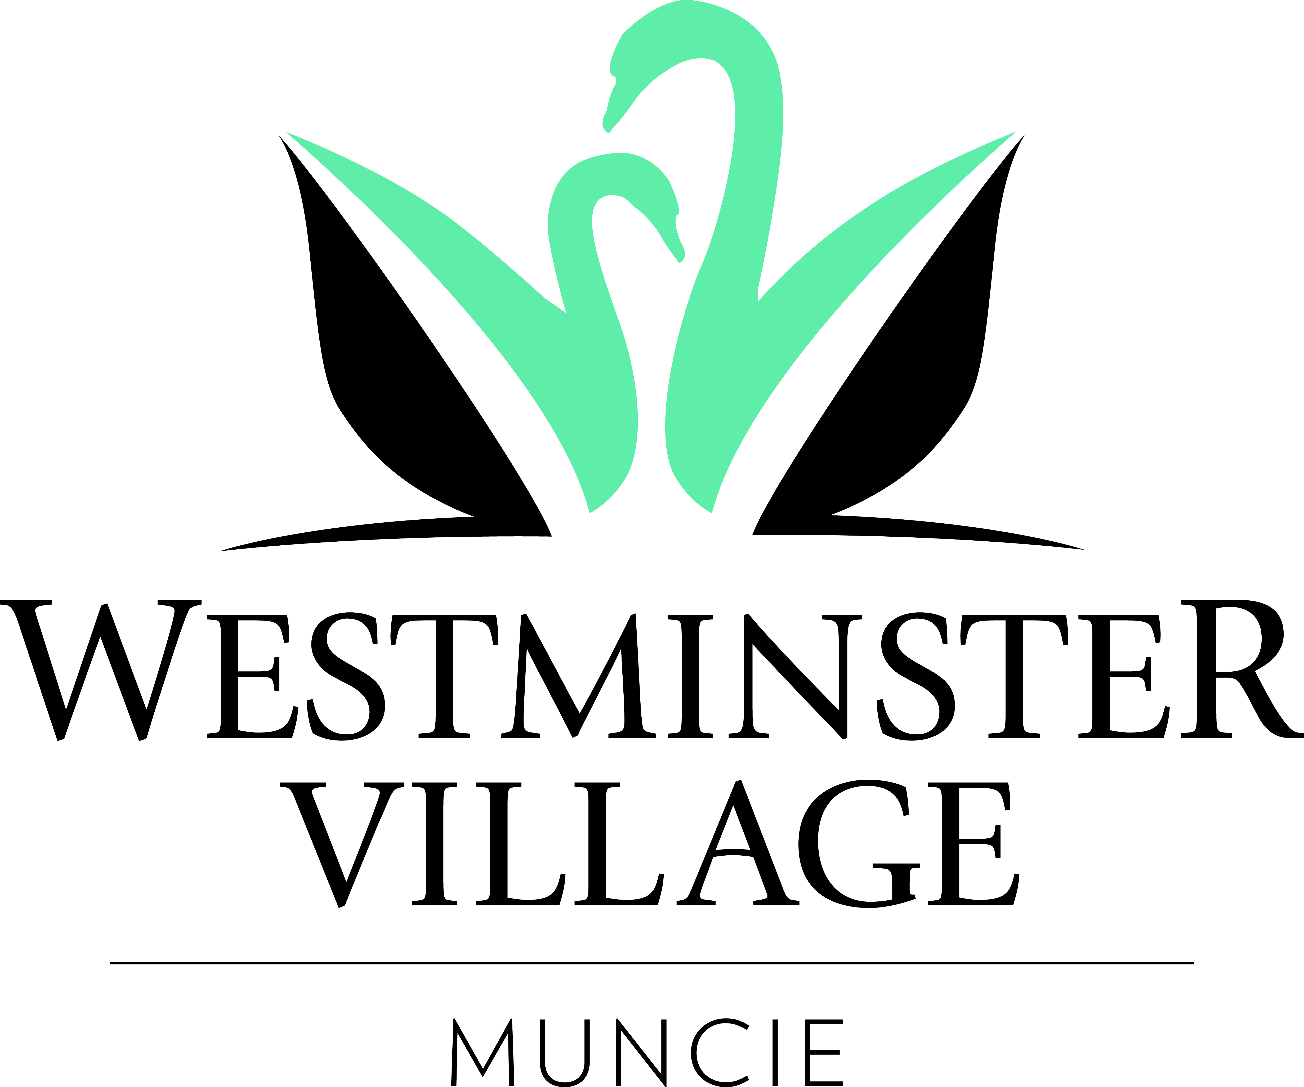

This month will mark the 44th Anniversary of Westminster Village in Muncie. Since we first opened our doors in 1974, Westminster Village has become a premier Continuing Care Retirement Community in Central Indiana. Westminster offers excellent care in Assisted Living, Memory Care, Skilled Nursing Care, Rehab-to-Home, and we have Retirement Apartments in a variety of floorplans. Residents enjoy many top notch events, including concerts, guest speakers, and other entertainment in our Legacy Commons Event Hall. Residents dine in one of seven dining rooms, or our café for a quick meal. Life at Westminster Village is inspiring for Mind, Body, and Spirit.

**Reception for Westminster’s Chaplain**

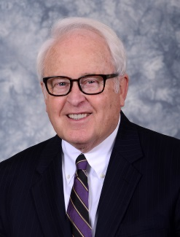Westminster Village will host a reception for Rev. Dr. Ronald Naylor, our first Chaplain, on Thursday, March 1st, from 2:00 pm – 4:00 pm. Ron has lived in Muncie for over 30 years, serving as Senior Pastor at First Presbyterian Church for 28 years. Ron will be welcoming new residents in their transition to Westminster, as well as conducting “Grief Share”, a support group for residents and open to the Muncie community. Ron is married to Susan, and they have two sons and two

granddaughters. The public is invited to attend.

**History of the Eaton Canning Factory**

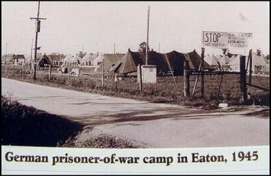On Tuesday, March 6th, at 2:00 pm, Karen Good, Ancestry and Genealogy Chair, Delaware County Historical Society, will be at Westminster, in the Legacy Commons Event Hall, to present the *History of the Eaton Canning Factory*. During WWI, farmers started to feel the pressure of producing more crops with less labor as men left their farm jobs to serve their country. Then a new pool of laborers emerged to alleviate the problem – prisoners of war. These POW’s helped to harvest and can tomatoes at the Eaton Canning Factory. The public is welcome to attend.

**Comedian and Enthusiast to Perform at Westminster**



On Wednesday, March 21st, at 2:00 pm, Jeff Ryker, *Comedian and Enthusiast*, will be performing at Westminster in the Legacy Commons Event Hall. The public is invited to attend what is sure to be a fun event.

**Danny Russel Presents Daniel Boone**

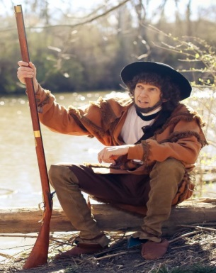*Expanding Your Horizons* for March at Westminster features one of our favorite performers, Danny Russel, who has previously performed at Westminster, telling the stories in the characters of Abe Lincoln and James Whitcomb Riley. In March, Danny, will reprise his rendition of Daniel Boone. In this compelling portrayal, we find our favorite frontiersman reliving years filled with adventure, hardship and danger. The performance will be on Tuesday, March 27th at 2:00 pm. The public is welcome to attend.

**Friends of the Orchestra Concert**

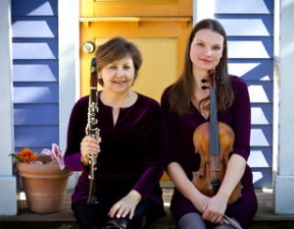The Friends of the Orchestra Series at Westminster, in association with the MSO, will present a concert featuring Elizabeth Crawford on the clarinet and Katrin Meidell on the viola in the Legacy Commons Event Hall. They performed together for the first time in 2015 and enjoyed playing together so much they contacted a composer, Shawn Head, to write a duo piece for them. They now have a catalogue of upwards of 100 new pieces. Elizabeth, a DM Associate Professor of Music at Ball State. Katrin, DMA, has distinguished herself as a violist, teacher, and scholar. The performance will be on Wednesday, March 28th, at 2:00 pm. The public is invited to join us.

If you are thinking about making a spring or summer move into Westminster Village and would like to schedule a tour, call Tyler or Melody at 288-2155.

