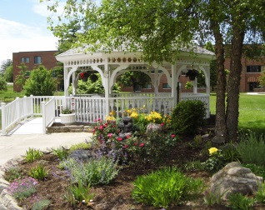
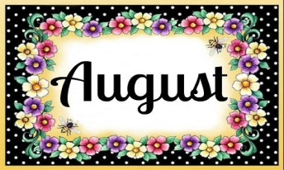
August is the perfect time to do all the things that you have been dreaming of doing all winter long and before fall rolls around again. Westminster’s residents have been out and about Muncie attending many of the events around town. The grounds that surround Westminster are kept beautifully manicured, so it is not unusual to see residents and visitors strolling, observing nature in its splendor, or enjoying a comfortable seat in the cool shade that the gazebo offers.

Singing and Searching
The Scripture

On Wednesday mornings, at 10:00 am Robert Fair will be hosting “Singing and Searching The Scripture” in the Legacy Commons Event Hall. The public is welcome to attend.

August Expanding
Your Horizons

Expanding Your Horizons at Westminster Village in August presents the Alloy Horn Quartet. The Quartet is composed of four professional French horn players and they play classical, light jazz and old favorites, as they talk about the French horn. Their music is to showcase the French horn and its abilities as a musical instrument. The concert will be on Friday, August 3rd, at 2:00 in the Legacy Commons. The public is invited to attend.

Mapping Historic Lives

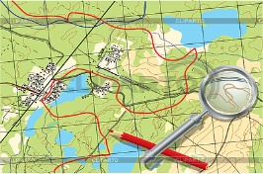
The E.B. and Bertha C. Ball Center will present Mapping Historic Lives at Westminster on Wednesday, August 15th, at 2:00 pm. The guest speaker will be Melissa Gentry, a Map Collections Assistant, GIS Research and Map Collection, University Libraries, at Ball State. She will discuss the maps created by GRMC that identify important places in the lives of historic figures from around the world. The maps include well known subjects like JFK, Anne Frank, Martin Luther King Jr., Princess Diana, and Outlaw John Dillinger. Also some of Muncie figures will also be featured such as Thomas Neely, Hurley Goodall, Hattie Mitchell Anthony, and Ruth Chin. The public is welcome to attend.

August Entertainment
at Westminster Village

8/01 – 7pm, Music by Don Carmer
8/03 – 2pm, Alloy Horn Quartet
8/07 – 7pm, Music w/ Gene Sherfy
8/14 – 7pm, Music of Jimmy Priest
8/15 – 2pm, “Mapping Historic Lives” with Melissa Gentry
8/21 – 7pm, Music with Paul White 8/29 – 7pm, Music by Fred Walker
*All programs will be in the Legacy Commons Event Hall. Free! The public is invited. Additional events to be announced, visit and “like” our Facebook page, Westminster Village Muncie and our website wvmuncie.com for updates.
Safe & Warm

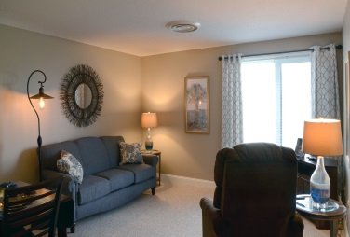
Ready to make a move? Does the thought of spending another winter at home alone, concern you? Consider spending those cold winter months at Westminster Village! You may be able to live for less at Westminster, enjoying a Life in Balance. Then pack your bags and move into one of our furnished apartments. Enjoy meals in one of our beautiful dining rooms, attend a variety of events and programs. Shop in our Village Shoppe, get your hair done or do your banking, all under one roof. Come try one of our studio ($2,184 a month) or one bedroom ($2,426 a month) single occupancy kitchenette apartments, allowing you to live a stress-free life. We also offer a variety of additional size apartments. If you decide that you are having too much fun and want to stay, we will move our furniture out so you can move yours in! For more information, or to schedule a tour, call Tyler or Melody at
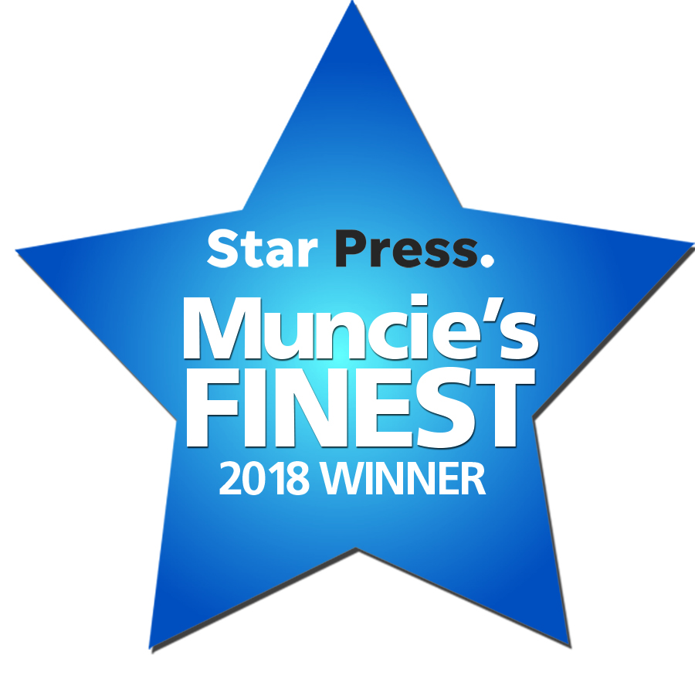
288-2155

“Voted Muncie
Area’s Finest
2018”

