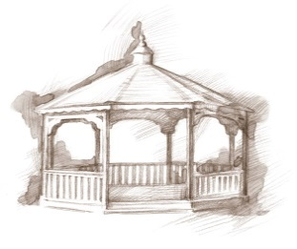
TheVillageVoice
February 2019
Each year on February 14th, many people exchange cards, candy, gifts or flowers with their special “valentine.” This day of romance, we call Valentine’s Day, is named for the Christian martyr, Saint Valentine or Valentinus, and dates back to the 5th century, but has origins in the Roman holiday Lupercalia. Westminster residents will celebrate Valentine’s Day with music and special treats. It is quite certain that there will be many exchanges of cards and flowers!

In My Hands, In My Heart

On Tuesday, February 5th, at 2:00 pm, Minnetrista Theatre will be at Westminster to present the production of In My Hands, In My Heart. This production reflects on two young men working at the Ball Canning Jar Factory and experiencing 1928 in completely different ways. Sam Conger works to send his brother through school because of their father’s back injury. Emmett Ray Davis works to give his brother a better life away from Jim Crow laws. They each make a terrifying discovery as they clean the factory floor: a jar molded with the crest of the Ku Klux Klan. Join us and learn how they handled their discovery.

Rhatatat at Westminster

Rhatatat, a musical production the whole family can enjoy, from golden oldies to popular hits of today. With a passion for music, Michael B. has been singing and playing the saxophone for over 30 years, and brings that passion to his performances. Join us on Wednesday, February 6th, at 7:00 pm.

Third Age Theatre

Come and enjoy Third Age Theatre as a troupe of singers celebrate Valentine’s Day with their version of Love Café. Sing along with familiar love songs or just sit back and let the music take you back. Third Age Theatre will be performing at Westminster on Wednesday, February 13th, at 2:00 pm.

Lunch & Learn with Sherry Brown
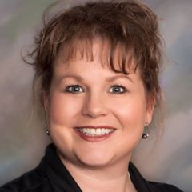
Westminster will host a Lunch & Learn with special guest speaker, Sherry Brown, on Tuesday, February 19th, from noon – 1:30 pm. Sherry is a Professional Organizer and Senior Move Manager, specializing in assisting older adults & their families with all or any part of the downsizing, moving process or “just what to do with all that stuff!” Seating is limited, so RSVP is required to Melody Scoble at
288-2155, by noon, February 14th.

The Wayside Mission
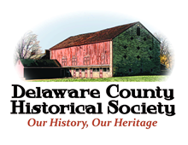
E.B. and Bertha C. Ball Center presents “Lucille Sanders and the Wayside Mission”, at Westminster Village, on Thursday, February 21st, at 2:00 pm. Lucille, along with her husband Lawrence, started the Wayside Mission, on September 14, 1946, at 2428 South Walnut Street to provide a shelter for homeless women and children, and temporarily assisted the unfortunate, destitute, and handicapped. Mrs. Karen Good, Delaware County Historical Society board member, started researching Mrs. Sanders as part of a project to identify Delaware County’s 100+ most influential women.

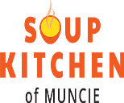
Art & Chocolate
The Soup Kitchen of Muncie presents “Art & Chocolate; An Evening to Meet the Artists.” at Westminster Village. On Thursday, February 21st, from 6:00 pm – 8:00 pm, visit with the artists, Ann Johnson, Susie Burns, Kevin Campbell, Sarojini Johnson, Jean McCauley, Alan Patrick, Carol Strock-Wasson, Dan Woodson and others. Enjoy chocolate treats, music and the art to be auctioned off March 16th at the annual Soup Kitchen of Muncie Dinner.

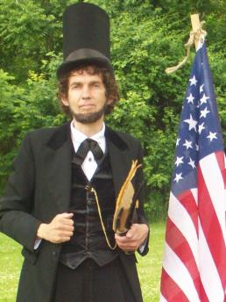
Danny Russel Presents Abraham Lincoln

Expanding Your Horizons in February will be the story of Abraham Lincoln, as performed by Danny Russel. Hilarity, heartbreak, humanity, and brilliant speeches abound as “Abraham Lincoln” traces his amazing journey from a log cabin to the White House. Learn about his Indiana Youth (age 7 – 21) where frontier life was precarious, disease a constant companion, and death, a hovering presence. Danny’s performance includes stirring renditions of “A House Divided”, the “Gettysburg Address” and portions of Lincoln’s Second Inaugural Speech. We encourage you to join us on Monday, February 25th, at 2:00 pm.

