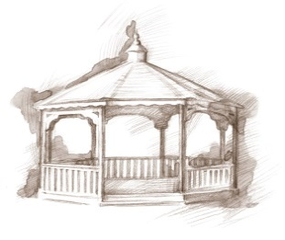
TheVillageVoice
May 2018

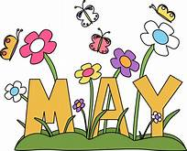
The showers of April brought a bounty of flowers and foliage to the landscape around Westminster. Everything is in bloom with a variety of spring colors. Now that the weather is warmer, residents are taking the opportunity to walk to the pond to get a glimpse of the swan’s new cygnets.

The public is welcome to attend all of our featured events!

The Jacksons to Entertain at Westminster Village
Join us on Saturday, May 5th, at 3:00 pm, for Naomi Jackson and her husband, Bradley, as they sing a variety of songs with a little comedy thrown in for good measure! The program is reminiscent of an old radio show.

Christian Ministries Community Choir
We are happy to announce that we have rescheduled the Christian Ministries Community Choir, featuring Doug Ammon. The concert
will be on Sunday, May 6th, at 7:00 pm, for an evening performance.

Speaker to talk about 1950’s Downtown Muncie
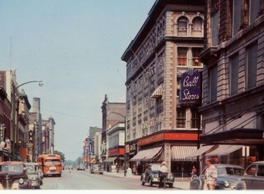
Remember what Downtown Muncie was like in the 1950’s? Norma Lasley, who is retired from the Muncie Public Library and volunteers at the Delaware County Historical Society, will be at Westminster on Wednesday, May 9th, at 2:00 pm, to feature Downtown Muncie from the 1950’s era. Come out and enjoy this program and reminisce with us.

Tiffany Arnold Studio Violin Recital
On Friday, May 11th, the Legacy Commons Event Hall at Westminster Village will be filled with the beautiful music of the Tiffany Arnold Studio violin students, as they perform their violin recitals. The program begins at 7:00 pm.

Muncie Through the Eyes of Geoffrey and Jennifer Mearns
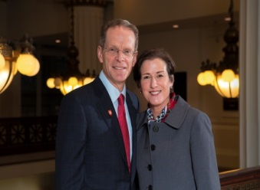
Westminster Village has invited Ball State University President Geoffrey S. Mearns and his wife, Mrs. Jennifer Mearns, to speak at 2 p.m. on Tuesday, May 15, at Legacy Commons Event Hall. They will discuss their pledge to partner with the community through Ball State’s Better Together initiative, and their impressions of Muncie since arriving here a year ago.

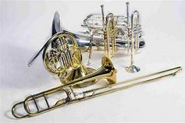
Friends of the Orchestra
Westminster Village, in partnership with Muncie Symphony Orchestra, presents Friends of the Orchestra Music Series. On Tuesday, May 22nd, at 2:00 pm, we will feature brass music with five members of the Muncie Symphony Orchestra as they present “Brilliant Brass”. From Bach to Broadway, this upbeat concert is certain to have something for everyone!

Evening Musical Programs
Westminster Village has many evening musical programs scheduled throughout May. All the evening programs begin at 7:00 pm and will be held in the Legacy Commons Event Hall. The public is invited to attend.
Laurel Blue Grass Music on Wednesday, May 2nd.
Singer Larry Davis will be performing on Tuesday, May 8th.
On Tuesday, May 15th will be Distaff Group.
Nola Nottingham will be playing the piano and singing on May 24th.
John Walker will perform on Tuesday, May 29th.
Fred Walker, singer and musician will be performing on,
Wednesday, May 30th.

Summer or Fall Move to Westminster Village?

It is not too early to start to think about a summer or fall move into Westminster Village. We have a variety of apartments ranging from a lovely studio to a spacious Deluxe Suite. If you would like to schedule a tour, or simply ask a question, please contact Tyler or Melody at 288-2155.

