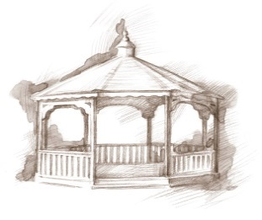 TheVillageVoice

**July 2018**

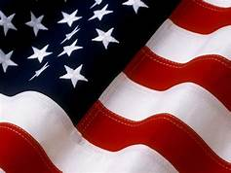July is a favorite time of year for most. It is not only a time for being outdoors, enjoying the sunny days with family and friends, but it is also a time to celebrate our nation’s birthday. As we reflect on those that settled our country, as well as those that fought for our freedom, we realize the sacrifices that were made to give us this wonderful country that we live in today. God Bless the USA!

**Danny Russel Presents *Abraham Lincoln***

**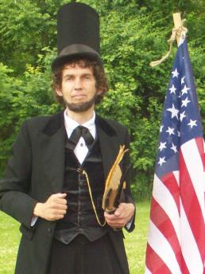***Expanding Your Horizons* in July will be the story of *Abraham Lincoln*, as performed by Danny Russel. Hilarity, heartbreak, humanity, and brilliant speeches abound as “Abraham Lincoln” traces his amazing journey from a log cabin to the White House. Learn about his Indiana Youth (age 7 – 21) where frontier life was precarious, disease a constant companion, and death, a hovering presence. Danny’s performance includes stirring renditions of “A House Divided”, the “Gettysburg Address” and portions of Lincoln’s Second Inaugural Speech. We encourage you to join us on

Tuesday, July 3rd, at 2:00 pm.

**Muncie Murder & Mayhem**

The E.B. and Bertha C. Ball Center presents Keith Roysdon and Douglas Walker, the authors of *Muncie Murder & Mayhem*. These long-time journalists will share true-crime stories from Muncie’s past. As a continuation of their first book, *Wicked Muncie*, the duo will introduce a new cast of characters from the city’s notorious past. The event will be on Wednesday, July 18th, at 2:00 pm.

**Steve Bell – Educator, Broadcast Journalist**

[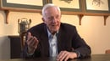](https://vimeo.com/86392285)Westminster Village welcomes Steve Bell, former ABC News Anchorman, War Correspondent for ABC and Emmy Award Winner, as he shares his life’s experiences in the ABC studios, Vietnam and Indo-China. Steve will screen a 30 minute portion of a documentary that has been produced about his distinguished career. Steve’s presentation will be on Wednesday, July 18th, at 7:00 pm.

**Ice Cream Social with Sherry Brown**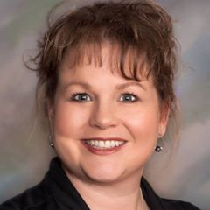

Westminster will host an *Ice Cream Social* with special guest speaker, *Sherry Brown*, on Thursday, July 19th, from 2:00 – 4:00pm. Sherry is a Professional Organizer and Senior Move Manager, specializing in assisting older adults & their families with all or any part of the downsizing, moving process or just what to do with all

that stuff! Seating is limited, so RSVP is required to Tyler Ewing or

Melody Scoble at 288-2155, by noon, July 18th.

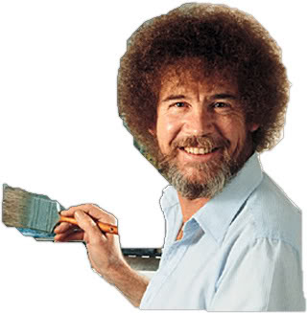**Jim Needham Presents Bob Ross**

On Wednesday, July 25th, at 2:00 p.m., Jim Needham, retired General Manager from WIPB-TV, will present, “The Real Story” of Bob Ross and “The Joy of Painting.” Learn why this show was perfect for WIPB, and how it was the right place for the show to be produced for all of the programs that continued to play on PBS stations nationwide and in 18 countries around the world.

**Events at Westminster Village in July**

**7/03 – 2:00pm** – “Expending Your Horizons” presents Danny Russel as Abraham Lincoln

**7/11 – 7:00pm** – Mountain Laurel – Bluegrass Band

**7/16 – 2:00pm** – Robert McHenry – Singer/Whistler – Oldies

**7/18 – 2:00pm** – E.B. and Bertha C. Ball Center Presents Muncie Murder Mayhem by

Walker & Roysden

**7/18 – 7:00pm** – Steve Bell: Storyteller – Spanning 30 years in broadcasting

**7/19 – 2:00pm** – Ice Cream Social with presentation by Sherry Brown – “Organize

This”

**7/24 – 7:00pm** – Ric Dwenger – Folk Music

**7/25 – 2:00pm** –The Art of Bob Ross presented by Jim Needham

**7/26 – 7:00pm** – Nola Nottingham - Singer & Pianist

**7/31 – 7:00pm** – John Walker Folk Music – Guitar

**\***All of the programs will be held in the Legacy Commons Event Hall and the public is welcome to attend these interesting events.

It is not too early to think about where you are going to spend this winter. With our *Safe & Warm Program* you can move into a furnished apartment to spend 3-4 months with us, safe and warm, inside Westminster Village. Let us do the shoveling for you! To schedule a tour, or to ask questions, call Tyler or Melody at 288-2155.