 TheVillageVoice

**September 2018**

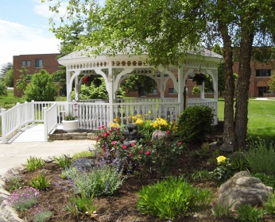

As summer begins to wind down, residents at Westminster have been out and about enjoying the warm summer sun or visiting with family and friends. You will find them strolling out to the pond to see what the swans are up to or just cruising around, enjoying all the beautiful landscaping. Residents have had many activities to participate in all summer long but they know that many exciting things will be planned for them during the fall and winter too. Come and experience the Change of Seasons at Westminster Village!

**Comedian and Enthusiast to Perform at Westminster**

After popular demand, we are happy to announce that *Comedian and Enthusiast*, Jeff Riker, will return to Westminster for another performance on Wednesday, September 12th, at 2:00 pm. The

public is invited to attend this fun event!

***The Aging Eye* with Dr. Makris**

The health series, *Taking Charge of Your Health* is back at Westminster Village. In September, Dr. Vasilis Makris, with Makris Vision Group, will be presenting, “*The Aging Eye”*, on Tuesday, September 18th, at 2:00 pm, in Legacy Commons. The public is invited to attend this informative program.

*******Classic Car Review* & *Sock Hop***

Polish up your saddle shoes, grease back your hair, and *Cruise-On-In* to Westminster Village for our Second Annual *Classic Car Review* & *Sock Hop* on Friday, September 21st. The *Classic* *Car Review* starts at 5:00 pm – 7:00 pm, in our front parking lot and be sure to sample the Root Beer Floats! The *Sock Hop* begins at 7:00 pm – 9:00 pm, in Legacy Commons. DJ Matt Howell will be “spinning” all the great tunes from the 50’s and 60’s. Refreshments will be served throughout the evening.

**WIPB Premiere at Westminster**

The fourth season of PBS’s *Poldark* onMasterpiece airs on WIPB on September 30th at 9:00 pm. You are invited to preview the first episode of the fourth season before it comes to the big screen on Wednesday, September 19th, at 7:00 pm, at Westminster in Legacy Commons.

**Lunch with the MSO Visiting Artist**

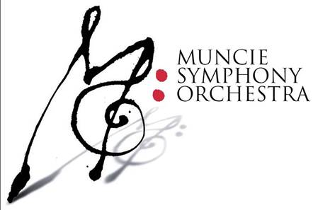The Muncie Symphony Orchestra will host a *Lunch with the Artist*- *Meet and Greet,* at Westminster Village. Have lunch with MSO Artistic Director & Conductor, Douglas Droste, who has been called “The People’s Maestro” because of his rapport with MSO; and Violinist, Steven Greenman, a multi-talented musical artist who is equally adept at performing stunning solo violin works with symphony orchestras. The luncheon will be on Friday, September 28th, from 11:30 am – 1:30 pm. in Legacy Commons. The cost is $15.00 per person. To make reservations, please call Carol at the MSO office at 765-285-5531, [CBradshaw@MuncieSymphony.org](mailto:CBradshaw@MuncieSymphony.org). Reservations will be taken no later than Monday, September 24th.

***What Is It Really Like To Live At Westminster?***

If you are considering a move to Westminster, but you want answers to your questions, please join us on Wednesday, October 3rd, at 11:30 am, for a free *Lunch and Learn Q & A Discussion on,* “*The Ins and Outs of Living at Westminster Village*.” The panel, with Westminster’s Dale Lindley, President, Mary Jo Crutcher, Vice President, Rev. Dr. Ron Naylor, Chaplain,

Sherry Brown of Organize This, and four of Westminster’s residents, will be on hand to talk with you and answer your questions. For reservations, please call Melody or Tyler at 288-2155.

Reservations must be made by noon on Tuesday October 2nd.

Where are you planning to spend the winter? Why not spend the winter *Safe & Warm* at Westminster Village! For more information, or to schedule a tour, call Tyler or Melody at 288-2155.