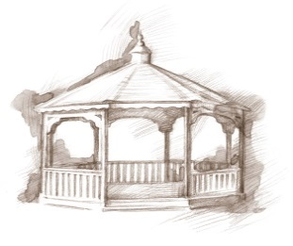
TheVillageVoice
October 2018

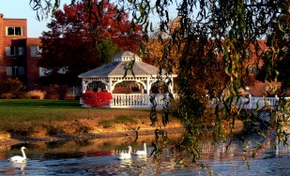
Another summer comes to a close as fall begins to make its presence known, with shorter days and cooler temperatures. The maintenance crew, who has been diligently working outside all summer, will now begin preparing the grounds for winter. Soon the trees will be covered with the beautiful shades of orange, red, and yellow and the summer flowers will have their last hurrah before the first frost. That could only mean that the holidays are just around the corner!

History of Mystery!

E.B. and Bertha C. Ball Center, Ball State University, will present History of Mystery on October 11th, at 2:00 pm, in Legacy Commons. Mrs. Kathryn Kennison will be the presenter. Mystery, often referred to as crime fiction, usually involves a mysterious death or a crime to be solved. Edgar Allen Poe’s short story, The Murders in the Rue Morgue (1841), is generally considered the first modern crime fiction story in the US. However, the Bible, Oedipus Rex, and Macbeth could also be considered mysteries by that definition. Mrs. Kennison will discuss the many elements that make this genre a favorite. The public is welcome to attend.

Second Annual Health Fair at Westminster
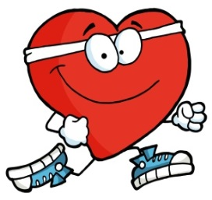
Westminster Village will host its Second Annual Health Fair, “Keeping Your Life In Balance,” on October 17th, 10:00 am – 2:00 pm, in Legacy Commons. There will be over 30 vendors ready to answer your questions and give you information to help you stay healthy. Several of the vendors will be offering free screenings for Hearing, Dermatology, Bone Density, Vision, Blood Pressure, Glucose, and Heart/Stroke. The Delaware County Sheriff’s Department will also be here for a prescription medicine drop. Please come to this informative fair to help live a “Life in Balance!”

“In The Pink Day” At Westminster Village
October is Breast Cancer Awareness Month. On Friday, October 26th it will be In the Pink Day at Westminster, as we remember those who lost their battle to Breast Cancer and celebrate others who won their fight. At Westminster, we will be decorating in pink and encouraging everyone who can, to wear pink on this special day. At 2:00 pm, there will be an In the Pink Social in Legacy Commons. Beverly Wilson, a Breast Cancer survivor, will be on hand to speak of her triumph over cancer. The public is invited to attend.

Upcoming Events in Legacy Commons Event Hall

10/08 – 10:00 am – Andrea Hughes - Pianist
10/10 – 7:00 pm – Tom Wright – Music
10/11 – 2:00 pm – History of Mystery with Kathryn Kennison
10/17 – 10:00 am – 2:00 pm – Health Fair
10/20 – 3:00 pm – Naomi Jackson – Music
10/23 – 7:00 pm – Music with Madison County Music Maker
10/24 – 7:00 pm – Music by Mountain Laurel
10/26 – 2:00 pm – In The Pink Social
10/30 – 7:00 pm – Music with Jimmy Priest

“Safe & Warm for The Winter”
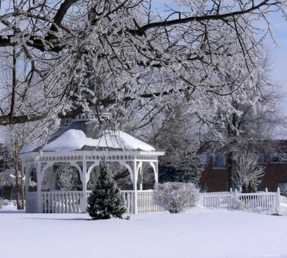
Now is the time to start thinking about where you want to spend this winter. At Westminster Village you can celebrate the season in a winter wonderland filled with life enrichment connections to enhance your mind, body and spirit. Just turn down the thermostat, pack a bag, and get ready to enjoy a safe and entertaining winter. For more information, call Tyler or Melody at 288-2155.

