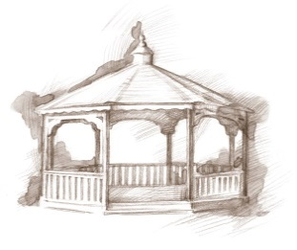
TheVillageVoice
November 2018
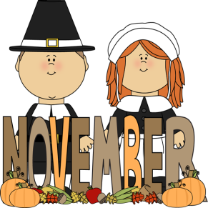
Around Westminster, the brilliant colors of fall are giving way as the leaves have begun falling to the ground. With the familiar smell of fall in the air, and leaves crunching under foot, one is reminded of the words to the Thanksgiving song, “Over the river and through the woods to Grandmother’s house we go!” Families will experience a special time with their parents and grandparents as they enjoy a delicious Thanksgiving dinner together as they bring in the Holiday Season at Westminster Village.

Presenting the Ball State Centennial Documentary
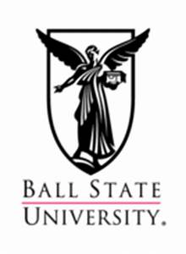
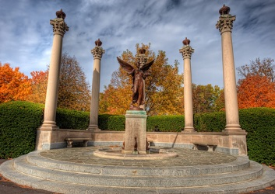
If you were not able to attend the Ball State Centennial Celebration and the premiere of the Centennial Documentary on September 6th, at Emens Auditorium, then you are in luck! On Wednesday, November 7th, at 6:30 pm, Chris Flook, with Delaware County Historical Society, will be at Westminster to talk about the history of Ball State and present the BSU student-produced documentary, “From Normal to Extraordinary: Ball State’s First Century.” If you would like to learn more about the history of Ball State, or just rekindle great memories, this program is one not to miss! The public is welcome to attend.

USO Dance at Westminster Village
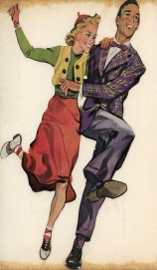
Do the sounds of Benny Goodman or the Dorsey Brothers take you back to another day and time? On Friday, November 9th, from 7:00 pm to 9:00 pm, Westminster Village will be hosting a USO Dance to commemorate our Veteran’s service. Come to Jitterbug or Swing the evening away as DJ, Matt Howell, plays the hits of the 1940’s. There will be door prizes and delicious
food. The public is invited to attend.

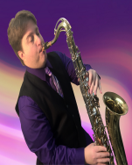
Rhatatat at Westminster
On Thursday, November 15th, at 2:00 pm, in Legacy Commons, Michael B. will present Rhatatat, a musical performance the whole family can enjoy, from golden oldies to popular hits of today. With a passion for music, Michael B. has been singing and playing the saxophone for over 30 years, and brings that passion to his performances. The public is welcome to attend.

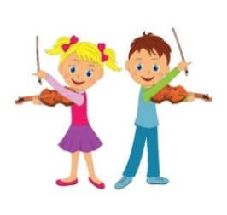
Tiffany Arnold Studio Violin Recital

The Legacy Commons, at Westminster Village, will be filled with the beautiful music of the Tiffany Arnold Studio and over twenty violin students, as they perform their violin recitals on Friday, November 16th. The program begins at 7:00 pm and the public is invited to attend what is sure to be a lovely evening of music!

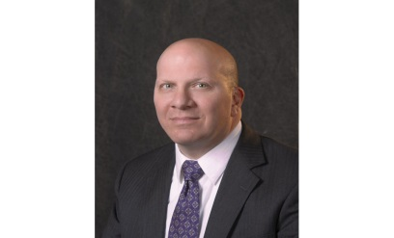
BSU’s Owsley Museum Director to Speak

On Tuesday, November 20th, at 2:00 pm, Dr. Robert LaFrance, the Director of Ball State University’s David Owsley Museum, will be at Westminster Village to talk about two of the exciting exhibits currently on display until December 21st. The exhibition of art, by celebrated American author and illustrator, Edward Gorey (1922-2000), entitled “Gorey’s World,” features the art he “consumed and collected.” Also on display, “The Power of Place: 100 Years of Architecture at Ball State University.” The public is welcome to attend.

Other Programs in Legacy Commons Event Hall

11/13 – 7:00 pm – Music by Jimmy Carter

11/19 – 7:00 pm – Americas Hometown Band- Clarinet Choir, will offer a
sampler of classical, show tunes, popular standards and
contemporary music.

11/23 – 2:00 pm – Robert McHenry (Oldies and Doo Wop) will perform
along with his furry friend, Snickers.

11/27 – 7:00 pm – 20th Street Band performing Southern Hymns and Gospel

11/29 – 7:00 pm – Music by Nola Nottingham – Singer & Pianist

Now that fall has arrived, your thoughts may turn to the many challenges of winter weather. This could be a good time to talk with Tyler or Melody, at 288-2155, about how you can enjoy being Safe and Warm at Westminster Village.
