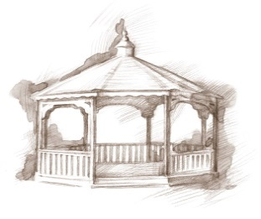 TheVillageVoice

**December 2018**



December, the month that most people wait all year for, is finally here! The weeks leading up to Christmas are a magical time with the sights and sounds of the holiday season. Around Westminster, the Christmas decorations abound. There are over thirty, beautifully decorated Christmas trees, throughout the building. Each Christmas

tree has been lovingly decorated with its own special theme. Outside

of Westminster, the building and trees have been strung with

Christmas lights.

**BSU *Wrecking Crew* *Trumpet Ensemble***

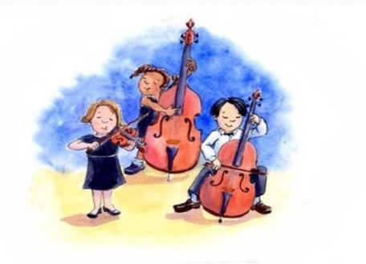

The Ball State University *Wrecking Crew Trumpet Ensemble* will be performing at Westminster Village, in Legacy Commons, on Wednesday, December 5th, at 7:00 pm. The Wrecking Crew consists of trumpet majors at BSU. They spend their time studying music, playing trumpet, and

playing in trumpet ensemble. They will be playing a variety of

notable Christmas songs to spread Christmas cheer!

**Youth Symphony Orchestra**

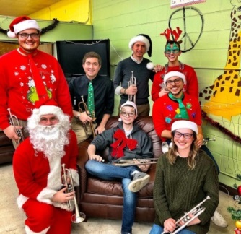

On Saturday, December 8th, at 2:00 pm, the Youth Symphony will be performing at Westminster Village in Legacy Commons. Founded in 1964, the Youth Symphony Orchestras of East Central Indiana, bring together young musicians from Delaware and surrounding counties to provide weekly orchestral experiences specifically tailored for students ages 5 to 18.

**The Bells Are Ringing at Westminster Village**

****The Holiday Chimers will bring their beautiful Christmas sounds to Westminster’s Legacy Commons on Sunday, December 9th, at 7:00 pm. The Holiday Chimers will certainly get everyone in the holiday spirit!

**Christmas Sing-Along with Molly and Shirley!**

On Monday, December 10th, at 2:00 pm, there will be a Christmas Sing-Along Concert with pianist, Shirley Robertson, and vocalist, Molly Huffman.

**“Friends of the Orchestra” MSO**

**Marimbas Ensemble Holiday Show**

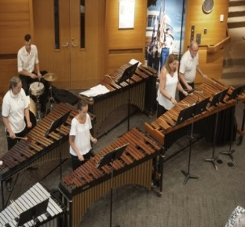

Five members of the MSO Percussion section will be at Westminster Village, to play the marimbas, on Tuesday, December 11th, at 7:00 pm. The ensemble will be playing a selection of Christmas songs such as Silver Bells, Parade of the Wooden Soldiers, The Christmas Song, and more. They will also be playing some carols that folks can

sing along to.

**Other December Events in Legacy Commons**

12/06–7pm – Evening with Distaff Group

12/17–7pm – Madison County Music Makers

**Enchanted Tree Celebration**

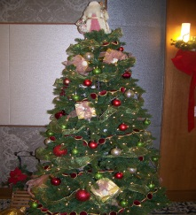

If you don’t have a chance to see all of the Christmas Trees that are on display throughout the holidays, then come to our *Enchanted Tree Celebration* on Thursday, January 3rd, from 3:00 pm – 7:00 pm. Westminster will have all of the Christmas trees on display in the Legacy Commons and the mall area so they can be viewed before they are packed away for another year. Come enjoy a cup of hot cocoa and cookies, as you stroll through a winter wonderland!

*\*All events listed are free and open to the public!*

***Safe and Warm For The Winter***

If staying alone in your home during the long, cold winter doesn’t sound like something you want to do this year; Westminster has an idea for you! Come and spend the winter in a comfortable furnished apartment. You can participate in any of our activities, exercise in the Wellness Center, do your banking, get your hair done in the Beauty Salon, and join in all the reindeer games! *“Safe & Warm for the Winter”* includes meals, cleaning, linen laundry, utilities and basic TV, with monthly rates beginning at $2,239. If you would like to schedule a tour or just ask a question, call Tyler or Melody at 765-288-2155.

