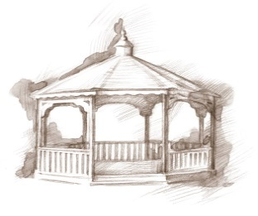
TheVillageVoice
January 2019

Here we are at the beginning of a shiny new year. At Westminster, the Christmas trees, lights and wreaths have all been lovingly packed away for another year. As the snow starts to fly around the outside of Westminster, our residents are all settled in for the long winter, knowing that no matter what winter throws at us, they are safe and warm within our walls. With so many activities available, along with the Village Shoppe, Beauty Shop, Wellness Center, First Merchants Bank branch, seven dining rooms and a Café, our residents don’t have to venture out unless they absolutely have to. Westminster Village is a village all unto itself!

20th Street Band
On Tuesday, January 8th, at 7:00 pm, the 20th Street Band will be preforming at Westminster in Legacy Commons. The band is made up of a small group of friends that come together for fellowship and good southern Gospel Music.

Presidential Second Acts
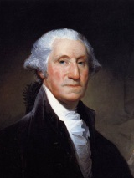
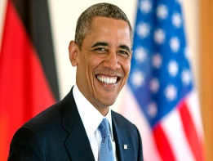
What do US Presidents do with their lives after their terms are up and they return home? On Wednesday, January 9th, at 2:00 pm, Richard Harris will present “Presidential Second Acts: What did our Presidents do in Retirement?” From Washington to Obama: some were very healthy and productive, while others…not so much. Richard is a retired BSU Administrator and who’s hobby in retirement has been sharing his love of American History with audiences. This program is presented by the E.B. Ball and Bertha C. Ball Center.

Westminster Village’s Next-To-New Shoppe Fashion Show
The Next-To-New Shoppe at Westminster Village is a great place where our residents shop for a huge variety of, slightly used, to new, clothes and household items. On Thursday, January 17th, at 2:00 pm, several of our residents will be modeling a selection of outfits from the shoppe. The public
is welcome to shop at the Next-to-New Shoppe if
accompanied by a resident.

Eastern Gate Quartet
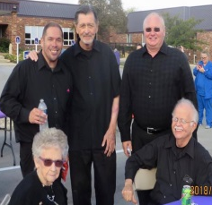
Westminster Village will host the Eastern Gate Quartet on Monday, January 21st, at 7:00 pm. Woody Noblitt, a well-known Pastor in the community, is part of this quartet.

Westminster Treasures
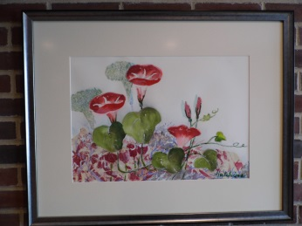
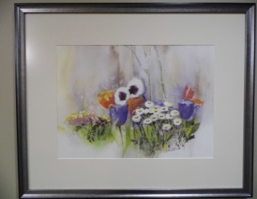
In 1979, Westminster Village was blessed when a tiny lady, with a big personality, moved into “The Village”. It didn’t take long for Betty Hutchins to become known as the “local artist”. Betty was schooled as an English teacher but when an art teacher position became available, she decided to spread her wings in a different direction. Betty was in her 50’s when she took a class in watercolor and fell in love with the medium. At Westminster she had her own studio where she painted her canvases. Her joy in painting was not for monetary gain, for she often gave away many of her paintings to employees and friends. When Betty passed, over 100 of her watercolor and oil paintings were purchased by Westminster Village. They are hanging in the Residential halls of “The Village” for everyone to enjoy!

Safe & Warm for the Winter
Winter has been kind to us so far. December has delivered warmer temperatures, making it safe to be outdoors. But, as we know, Indiana weather can change in the blink of an eye and the next two months are not likely to be so kind. It is not too late to book a winter vacation at Westminster Village where you may find yourself renewing an old friendship and making new ones. For more information, or to schedule a tour, call Tyler or Melody at 288-2155.

