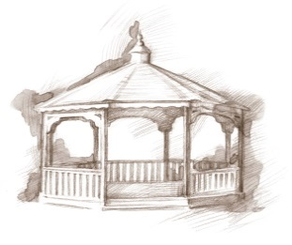
TheVillageVoice
March 2019
As we begin the month of March, it helps to know that spring is just around the corner. Westminster residents have many scheduled programs and activities that they enjoy during the long winter months. You can also find groups of residents spontaneously gathering together to play cards or other games. There are daytime and evening musical programs or our Expanding Your Horizons lecture series to enjoy. Our residents find plenty to do if they are staying inside where it is warm.

Friends of the Orchestra Series at Westminster
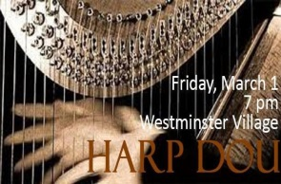
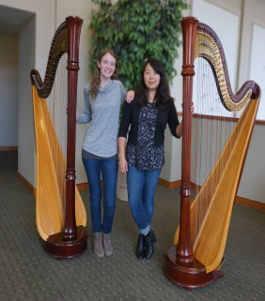
On Friday, March 1st, at 7:00 pm, Annie King and Lydia Wiseheart, of the Muncie Symphony Orchestra, will be at Westminster, as part of the Friends of the Orchestra Series, as they perform Harp duets including Irish folk song, Danny Boy, Panis Angelicus by Cesar Frank, and many more favorites. Annie is the Principal Harpist for the MSO; she has performed in many other orchestras, runs a teaching studio, and is currently working on her Doctor of Art degree at BSU. Lydia began playing the harp at the age of eight and she is currently a BSU student, working on her Bachelor’s degree in music performance. “This project is supported in part by the National Endowment for the Arts” visit www.arts.gov.” Join us for what is sure to be a beautiful concert.

Danny Russel Presents Abraham Lincoln
The February Expanding Your Horizons, “The Story of Abraham Lincoln” performed by Danny Russel has been rescheduled for Monday, March 11th, at 2:00 pm. Hilarity, heartbreak, humanity, and brilliant speeches abound as “Abraham Lincoln” traces his amazing journey from a log cabin to the White House. Please join us for this amazing performance.

20th Street Band
On Tuesday, March 12th, at 7:00 pm, the 20th Street Band will be preforming at Westminster in Legacy Commons. The band is made up of a small group of friends that come together for fellowship and good southern Gospel Music.

Signature Event – Dine & Discover!
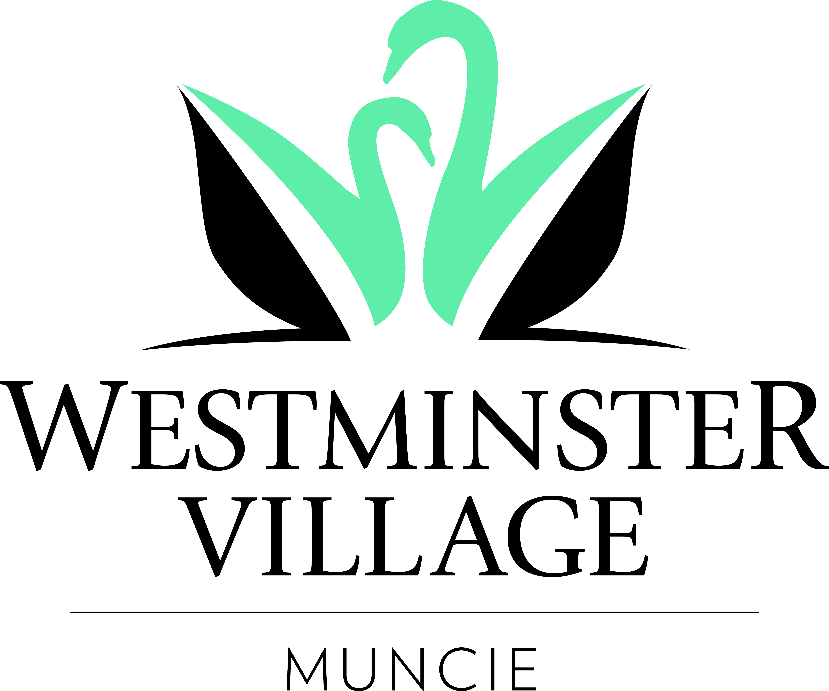
“The Ins and Outs of Living at Westminster Village”

Are you considering a move to Westminster Village but you have questions that you need answered? Please join us for a complimentary luncheon and bring your list of questions. Join us for the Q & A discussion on Wednesday, March 13th at 11:30am and learn what it’s really like to live at Westminster Village during our panel presentation, followed by tours. The panel consists of Dale Lindley, President, Mary Jo Crutcher, Vice President, Rev. Dr. Ron Naylor & Sherry Brown of Organize This, along with four of our residents to answer your questions from a resident’s perspective. Bring a friend, parent or loved one. Space is limited. RSVP by March 8, for this free event to Melody Scoble, at 765-288-2155.

Women in Aviation

E.B. and Bertha C. Ball Center presents “Women in Aviation” at Westminster Village. The program will be presented by Richard Kennison, Lt. Col. (Retired – USAF), on Thursday, March 14th, at 2:00 pm. Almost from the beginning of aviation, women have been superstars, earning the respect and admiration of all people who were fascinated with this new form of transportation. There was little to no discrimination, a good pilot was a good pilot, period. Mr. Kennison will talk about some of the most famous female fliers of those first exhilarating days of flight, fliers like Harriet Quimby, Kate Stinson, and Louise Thaden, to name a few.

Meet the Artist Luncheon at Westminster Village
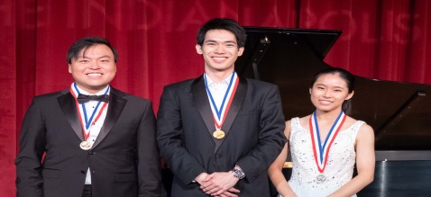
The Muncie Symphony Orchestra will host a Lunch with the Artist – Meet and Greet, at Westminster Village. Have lunch with MSO Artistic Director and Conductor, Douglas Droste and the three top medalists from the International Violin Competition of Indianapolis (IVCI), as well as Glen Kwok, IVCI Executive Director. Enjoy a delicious lunch with the artists, on Friday, March 22nd, at 11:30 am. Cost $15.00, RSVP no later than March 18th to MSO – 765-285-5531, cbradshaw@munciesymphony.org

Living a Life in Balance at Westminster Village
“I did four rehabs here and fell in love with the place. When it came time for us to move, Westminster Village was our only choice! I love Westminster Village because I feel like I belong and have something to contribute. Westminster Village gives me security, protection and people who look out for me! – Sandy Mixell, Westminster
Village Resident

