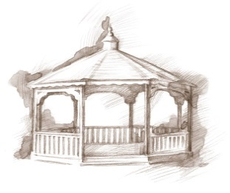 TheVillageVoice

**April 2019**

**Westminster Village Resident Spotlight**

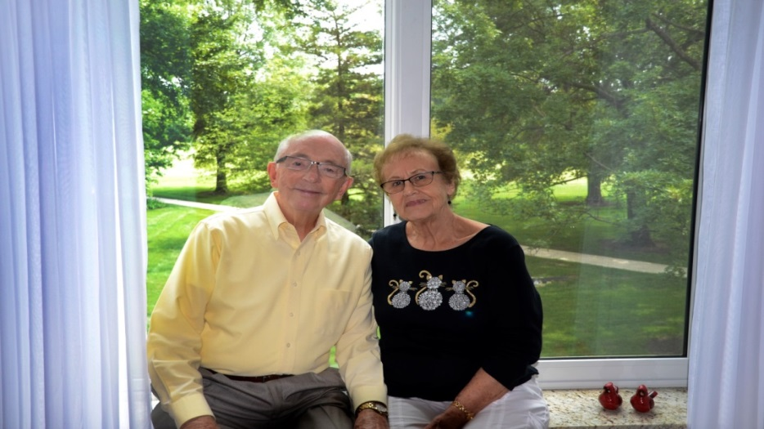

*“We love living here with so many friends and colleagues we’ve known through our church and Ball State, and we’ve met so many new friends. After taking care of our parents’ homes in other cities and states, we didn’t want to put that burden on our girls, since they all live away from Muncie. Westminster Village was the perfect solution for us!”* –Norm and Joyce Beck, Residents of Westminster Village. Norm received his B.S, M.S, and Ph.D. from Ball State, and began his career there. He retired in 2004 as an Associate V.P. of Human Resources and Auxiliary Services at BSU. He is currently Secretary of the George and Frances Ball Foundation and an Elder at First Presbyterian Church. Before retiring, Joyce was an Executive Secretary with the Ball Associates – Ball Foundation.

**CCRC Living – Fact vs Myth**



**Myth**: *“It costs so much money;*

*I could never afford to live there.”*

**Fact**: When families are considering a retirement community, they don’t take into consideration the costs to live in their homes, such as; utilities, taxes, an emergency response system, maintenance, security, housekeeping, food, and maybe a membership to the Fitness Center. Actually, folks need to weigh the intangibles as well, such as access to health care, socialization of living in a community and sharing interests with friends and neighbors, and the accessibility of a caring staff. At a Continuing Care Retirement Community, such as Westminster Village, these costs are all included in the monthly fee. With all that is included, it may not be as “expensive” as many people think!

**Screening of MSO Performance Featuring *Hey Mavis***



The American Group, *Hey Mavis*, recently performed with The Muncie Symphony at Emens Auditorium.  The concert features *Hey Mavis’* newest work of original songs and illustrations from their book/CD based on stories of the Ohio and Erie Canal. You will be tapping your toes as you delve into the heart of their music and stories of the Midwest with great symphonic accompaniment. Steve Perry Productions filmed this concert and has invited Westminster Village to screen it for our residents and the public.  The screening will be in Legacy Commons on Monday, April 1st at 2:00pm.

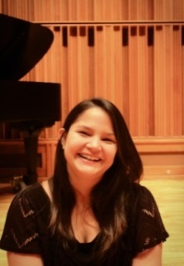**Pianists to Perform at Westminster Village**

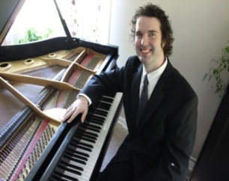

Please join us on Tuesday, April 2nd, at 7:30 pm for a piano concert. Costa Rican pianist, Gabriela Calderon Cornejo and Peter Douglas will feature works by Spanish Composer, Enrique Granados and Latin American Composers, Aurora Roman Casares and Maria Mendoza d´ Baratta.

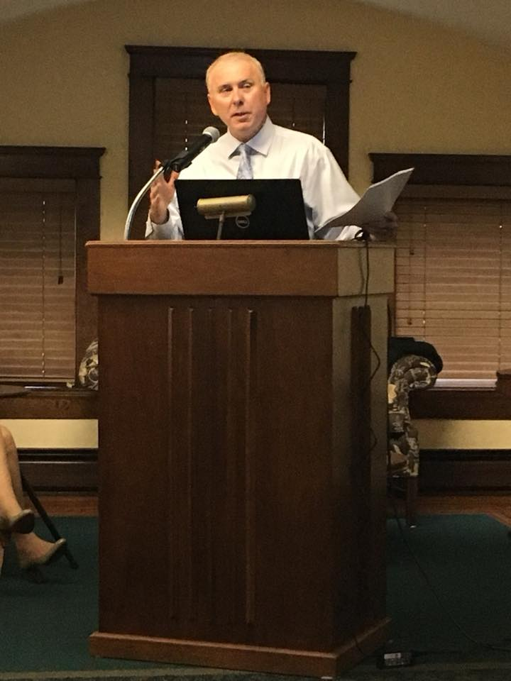***Exploring the Lives of Hamer and Phyllis Shafer***

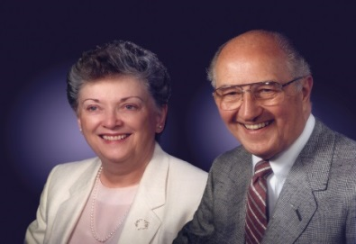E.B. and Bertha C. Ball Center presents *Exploring the Lives of* *Hamer and Phyllis Shafer,* on Wednesday, April 3rd, at 2:00 pm. Mr. Dane Starbuck, author, musician and attorney-at-law, will talk about the Shafers, who were both Muncie natives. They were well-known for their philanthropic efforts during their lifetime and thereafter. You can still see the effects of their generosity today at BSU, the Youth Opportunity Center, Shafer Leadership Academy and many more. Join us and learn more about this special couple.

**East Central Indiana Chamber Orchestra**

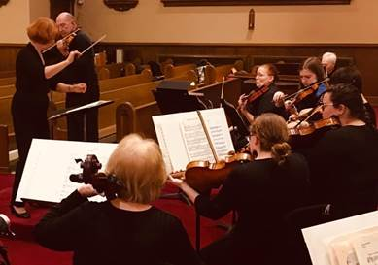

On Sunday, April 7th, at 7:00 pm, at Westminster Village, the ECICO will present a concert *“Under Their Spell...the Magical Music of American Composers*. They will also feature piano soloist, Dr. Cooley, playing Gershwin’s Classical Jazz piece, *The Piano Concerto in F*.

*All events in Legacy Commons are free and open to the public. No reservations required! Visit wvmuncie.com for a complete listing of events.

If you wish to opt out of this newsletter, please call Melody at 765-288-2155, [mscoble@wvmuncie.com](mailto:mscoble@wvmuncie.com).

