Westminster Village Resident Spotlight
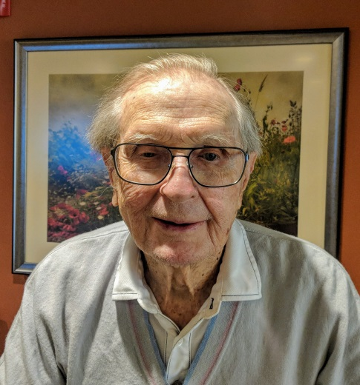
“I enjoy working out in the Wellness Center on a daily basis and attending as many of the activities as I can. The food is delicious, the best I’ve had in the 15 years since my wife passed. I enjoy renewing old friendships.” – Don Bell was born in Evansville, Indiana. He graduated from Indiana University in 1941. He married in 1953 and they moved to Muncie in 1955. Don was employed by Ball Corporation for 37 years. He and his wife had three sons. Don exercises daily and loved to play golf in his younger years. Horses have been an important part of Don’s life for over 60 years and for many years hosted a wonderful horse show here at Westminster Village. He has attended the Presbyterian Church his entire life.

CCRC Living – Fact vs Myth

Myth: “I don’t want to leave my family – and they can take care of me if my health changes.”
Fact: Some of our residents say the exact opposite – they tell us that they made the choice to move to a CCRC, like Westminster Village, so that their family does not have to worry about them as their health needs change. While children (and their parents) may have good intentions, adult children often have work and family obligations in addition to the added aspect of having parents living in their home. As parents age, their needs cannot always be met by their family – no matter how loving or well-intentioned. For many older parents, they actually feel isolated when they live with their children, because their network of friends may not be close by. Many of our residents have made the decision to move to Westminster because they wanted to take the burden off of their children by choosing a retirement community that includes access to good health care so that their future health care needs are always met.

You are invited to our complimentary events for you, your family and friends:
Lunch and Breakfast Presentations.

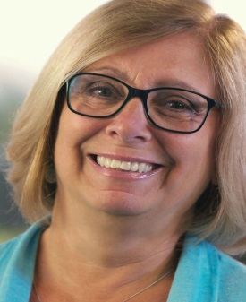
Featured Presenter, Jackie Stone has over 30 years of experience in the retirement living field, helping people make informed choices for their next stage of life. She is a featured speaker at many national senior living conferences, leads workshops and research projects, and has a keen understanding of all aspects of the senior living decision.

“What are you Waiting For?”

Dispelling the Myths of Retirement Living. Learn the hazards of waiting and the benefits of planning ahead for the next stage of life.

Wed., 7/31: Lunch 11:30-1:30
Thur., 8/01: Breakfast 8:30 – 10:30

“Live a Full Life”

Living a full life isn’t about the size of your home, car, or wallet. It is about making room for experiences. We will share ten key points to living a full and enriching life.

Wed., 8/21: Lunch 11:30 – 1:30
Thur., 8/22: Breakfast 8:30-10:30

“The Path to Healthy Aging and Achieving Wellness”

Aging can be a time of personal growth and fulfillment. Learn about the seven dimensions of wellness, and opportunities to nurture the mind, body and spirit.

Wed., 9/11: Lunch 11:30-1:30
Thur., 9/12: Breakfast 8:30-10:30

Free lunch & breakfast events, you don’t want to miss! Take charge of your future. Space is limited, please RSVP to any of these events at any time.

There are many options for Senior Living in Muncie, and surrounding communities, so before you make a choice please take the time to tour Westminster Village as you may be able to live for less in safe & secure surroundings. Call 765-288-2155 to schedule a tour with Tyler or Melody.

If you would like to opt out of this newsletter, please call Melody.

