Westminster Village Resident Spotlight

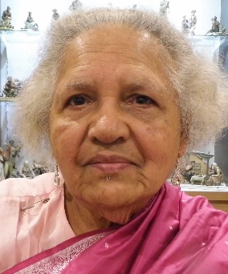
I came to Westminster Village over three years ago, with impaired health. Thanks to the excellent care provided by Westminster towards my convalescence, I was able to move to one of their independent-living apartments and I am happy to say that I am still there. The physical, intellectual, cultural, emotional, and spiritual well-being of the residents is of paramount concern to Westminster. The mind boggling variety of events and activities presented by Westminster bears ample testimony to this. There is never a dull moment at Westminster. One of the best features about Westminster is the total removal of the heavy responsibility associated with caring for your home and automobile. Everyone is nice and friendly and makes you feel at home. And your children have the peace of mind that you are in an excellent place. – Padmini Joshi received her B.A. (honors) and M.A., in math, from Bombay University, India, and another M.A. in math from Bryon Mawr, PA. She received her Ph.D. in math from the University of Illinois, Urbana-Champaign (UIUC). She taught for nine years in India and 42 years in the US, both as student assistant and instructor at UIUC, at Butler University (1968-1969) and at Ball State (1969-1993), as a full time regular faculty member and part time thereafter until December 2005. Ball State gave her the Outstanding Faculty Teacher Award in 1979. Padmini continues to stay active in her love of math, working on several math projects.

CCRC Living – Fact vs Myth
Myth: “CCRCs are just social Clubs for retirees.”
Fact: Along with many fun things to do and be involved in, including volunteering and helping others, there are opportunities for learning, enrichment and service. New friends and neighbors (and staff) become like an extended family. The social aspect is one of the most important benefits of living at a CCRC. Instead of living alone in your home, in a neighborhood where your friends have moved or passed away,
you can live in a beautiful community, such as Westminster Village, where you have access to not only health care and the security of never being alone, but also having access to friends and social, cultural and spiritual activities right outside your door.
You are invited to our complimentary events for you, your family and friends:
Lunch and Breakfast Presentations.

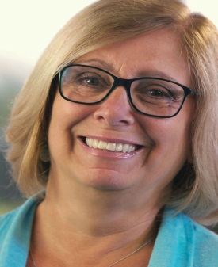
Featured Presenter, Jackie Stone has over 30 years of experience in the retirement living field, helping people make informed choices for their next stage of life. She is a featured speaker at many national senior living conferences, leads workshops and research projects, and has a keen understanding of all aspects of the senior living decision.

“What are you Waiting For?”

Dispelling the Myths of Retirement Living. Learn the hazards of waiting and the benefits of planning ahead for the next stage of life.

Wed., 7/31: Lunch 11:30-1:30
Thur., 8/01: Breakfast 8:30 – 10:30

“Live a Full Life”

Living a full life isn’t about the size of your home, car, or wallet. It is about making room for experiences. We will share ten key points to living a full and enriching life.

Wed., 8/21: Lunch 11:30 – 1:30
Thur., 8/22: Breakfast 8:30-10:30

“The Path to Healthy Aging and Achieving Wellness”

Aging can be a time of personal growth and fulfillment. Learn about the seven dimensions of wellness, and opportunities to nurture the mind, body and spirit.

Wed., 9/11: Lunch 11:30-1:30
Thur., 9/12: Breakfast 8:30-10:30

Free lunch & breakfast events, you don’t want to miss! Take charge of your future. Space is limited, please RSVP to any of these events at any time.
For details on each presentation, and other upcoming July events at Westminster Village, visit our website wvmuncie.com.

There are many options for Senior Living in Muncie, and surrounding communities, so before you make a choice please take the time to tour Westminster Village as you may be able to live for less in safe & secure surroundings. Call 765-288-2155 to schedule a tour with Tyler or Melody.

