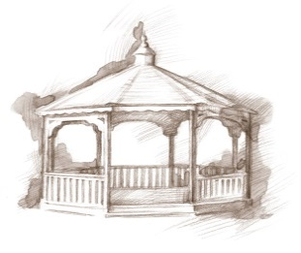
TheVillageVoice
August 2019

Westminster Village Resident Spotlight
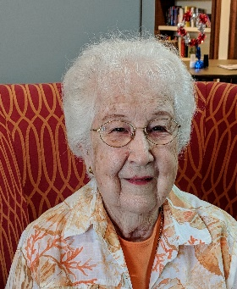
“Anyone choosing to come to Westminster Village has so many opportunities. I think, kind and caring employees, with “respect” for you, rates first. Opportunities for almost anything you would desire; such as friends, alone time, games, movies, entertainment, Bible studies, Vespers, Lunch Bunch outings, shopping trips, exercise, crafts, and the list goes on. Your loved ones know you are being cared for and happy. I love Westminster Village because I feel loved and secure here. I have opportunities to do things here that I would not have if I lived alone. I have friends here that are like family to me. – Norma Rozelle has lived in Muncie all of her life. After graduating from Royerton High School, she worked at Old National Bank for 10 years and met her husband, Zack, there. They adopted their son and twin daughters, then she gave birth to another daughter. Zack and Norma enjoyed traveling the U.S after Zack’s retirement. They were blessed with 54 years of marriage and a wonderful family.
_____________________________________________________________________________________________________________________
CCRC Living – Fact vs Myth
Myth: “People at CCRCs just sit around in rocking chairs and play bingo.”
Fact: On the contrary, there is a broad spectrum of interesting things to do. Many of WV our residents say they are busier than before they retired, but now they are doing what they enjoy, and often are pursuing interests that they always wanted to try but never had the chance. When choosing a retirement community, it is important to think ahead. Are there engaging retirement living activities available if your health declines? At Westminster Village, our continuum of care offers you exactly that. Cozy up in our common areas to leisurely enjoy a book or to savor conversation with friends. Or pack your calendar with offerings such as card games, fitness classes, Bible studies, guest speakers, evening music programs and more. Our residents don’t have enough time in their days to participate in all the activities offered here! (But if you want to sit and rock for a while – that’s fine too!)

You are invited to our complimentary events for you, your family and friends:
Lunch Presentations.

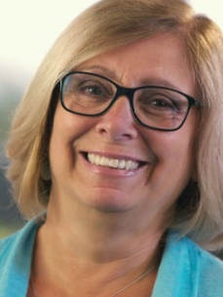
Featured Presenter, Jackie Stone, has over 30 years of experience in the retirement living field, helping people make informed choices for their next stage of life. She is a featured speaker at many national senior living conferences, leads workshops and research projects, and has a keen understanding of all aspects of the senior living decision.

“Live a Full Life”

Living a full life isn’t about the size of your home, car, or wallet. It is about making room for experiences. We will share ten key points to living a full and enriching life.

Wed., 8/21: Lunch 11:30-1:30

“The Path to Healthy Aging and Achieving Wellness”

Aging can be a time of personal growth and fulfillment. Learn about the seven dimensions of wellness, and opportunities to nurture the mind, body and spirit.
Wed., 9/11: Lunch 11:30-1:30
Free lunch & breakfast events, you don’t want to miss! Take charge of your future. Space is limited, please RSVP to any of these events at any time.

For details on each presentation, and other upcoming August events at Westminster Village, visit our website wvmuncie.com.

Remembering John W. Fisher

The E.B. and Bertha C. Ball Center presents Remembering John W. Fisher on Thursday, August 1, 2:00 pm. Dane Starbuck, author, musician, and attorney-at-law, will be at Westminster to discuss John W. Fisher, II, who married Janice Kelsey Ball.

National Model Airplane
History Month

Michael Smith, of the Academy of Model Aeronautics, will be at Westminster on August 14th, at 2:00 pm, to speak about their museum and about August being the National Model Airplane History Month.

If you would like to schedule a tour of Westminster Village, call Melody or Tyler at 288-2155. To opt out of this newsletter, please call Melody.

