Westminster Village Resident Spotlight
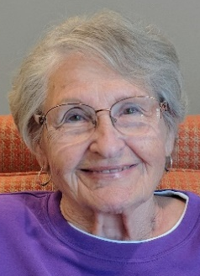
“I came to Westminster Village in April 2019. After all of the downsizing and unpacking, a sigh of relief seeing my new apartment with my things around me. I’m ok! Because I am a follower of Jesus Christ, I know he cares for me, leads and guides me, so where ever I am, I am full of joy. There are many opportunities at Westminster Village for body and soul. The exercise classes, music, interesting speakers, outings, are all organized by a loving staff. Our Maintenance men and Housekeepers are all very caring. The Symphony came with their string instruments and told a story about a stolen violin that was returned after many years, was my favorite program so far. Children also came with their instruments, many singers too, keep our memories intact. Whatever your choice is up to you. I have said many times, that Westminster Village is a safe place for me to be and my children’s peace of mind.” –Billie Cruea was born in Portland, Indiana. She says that she was sort of a “country girl” because she and her husband raised chickens, and had a large garden. Billie was a stay at home mother, raising four children and supporting her husband.

CCRC Living – Fact vs Myth

Myth: “I will lose my independence.”
Fact: Many older adults won’t even consider living in a CCRC because they believe these communities will rob them of their independence. However, this couldn’t be further from the truth. Communities like Westminster Village are designed to give you more variety and diversity in what you’re able to do or accomplish. From fitness classes, educational programs, wonderful events and social opportunities, you will be doing things you never thought possible. Also, your apartment is your own. Although it is
part of the Westminster Village community, you can make your accommodations reflect your individual personality. Apartments include a kitchen or kitchenette, living areas and bedrooms. We will take care of the mowing and snow shoveling, so you can spend your time doing things you actually enjoy.
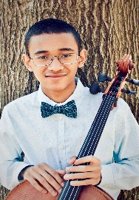
“No Questions Off-Limits!

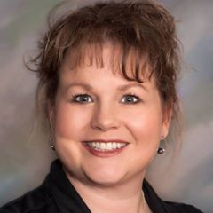
Have you been considering a move to Westminster Village but you still have questions to ask? Come to our FREE Panel Discussion on Wednesday, 10/2, at 2:00-3:30 pm. No questions will be off-limits! The panel will be made up of Resident Ambassadors, Administrators, our Chaplain, and Professional Organizer Sherry Brown, who will give a short presentation on her downsizing services. There will be hors d′oeuvres & refreshments served. RSVP to Melody.

The Psychology of
German Fairy Tales

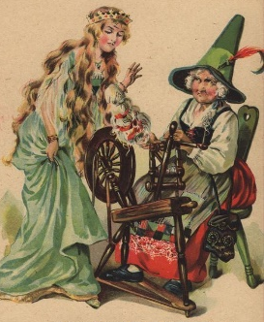
Tom Schwartz, a retired high school German teacher, will be at Westminster on Monday, 10/7, at 2:00 pm, to take you on a behind-the-scenes look at popular fairy tales, many of which have been altered to fit the psychology of various countries, their traditions, morals, etc. He will also discuss the effect that Disney has had on these tales.

MSO “Lunch with the Artist”

On Friday, 10/11, at 11:30 am, Westminster, in partnership with the MSO, will be hosting a “Lunch with the artist,” and also enjoy a short concert with the two of the 2019 MSO Young Artist Competition winners. Muncie Native, Maya Kilburn, a sixteen year old violinist, and is the Steve Dingledine Senior Division Winner. Fourteen year old cellist, Ethan Murphy, is the Ladonna Dingledine Junior Division Winner. The cost for the luncheon is $15.00 per person. To make reservations, please call Carol at the MSO office at 765-285-5531, CBradshaw@MuncieSymphony.org. Reservations will be taken no later than Friday, 10/4.

Food, Fun, & Fitness

As a retired professor of Health-Nutrition-Fitness at Clearwater Christian College, Coach Mike Walker will be at Westminster on Monday, 10/14, at 2:00 pm to present “Food, Fun, & Fitness for Seniors.”

Safe & Warm Seminar

Does spending another winter at home alone concern you? Come enjoy a stress-free winter with our “Safe & Warm” trial stay! Choose one of our comfortably furnished apartments and enjoy the winter at Westminster Village. Wondering where you start? You are invited to attend our Complimentary Safe & Warm Lunch Seminar on Tuesday, 10/29, at 11:30 am, to learn more about our program. RSVP, call Melody or Tyler, at 288-2155.

