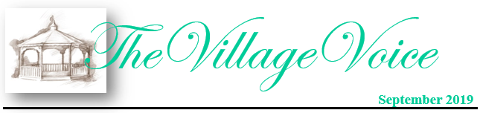

Westminster Village Resident Spotlight

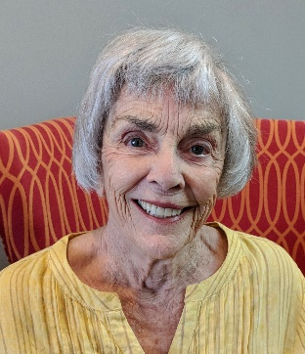 *“My first momentous moment occurred when I told my friend that I was moving into the apartment near her. She exclaimed, “Wonderful, now you can eat with the third floor girls!” My favorite performances are any of the ones from Ball State. I would tell people that life here is very different from your own home, so be sure to check everything out. I love Westminster because of the setting, the beautiful grounds and the companionships. I have lived at Westminster for two years and it is important to me as a safe haven.”* – Barbara Cossaart was born in Omaha, Nebraska and moved to Frankfort, Indiana, after her father passed away. She attended Butler University, earning a degree in Kindergarten/Elementary Education. She taught in the Indianapolis City Schools and was an assistant in the first Montessori School in Muncie. She has four children and for many years her family lived on Bethel, across the street from a woods filled with daffodils. She loves biking and took five trips to Europe with her bike. She also enjoys flower gardening.

CCRC Living – Fact vs Myth

**Myth:** *“I’m not ready yet – I’m not moving until I have to!”*

[](https://www.bing.com/images/search?view=detailV2&ccid=4x4jilWU&id=983A8CB20494F1B7541ACCC4B59D1B0C9A848C1B&thid=OIP.4x4jilWUADFntChqcUZqkwHaE8&mediaurl=http://www.charlesgate.net/wp-content/uploads/sites/218/2017/07/GettyImages-529426058-1600x1067.jpg&exph=1067&expw=1600&q=seniors+being+active&simid=608037200591588031&selectedIndex=128)**Fact:** Waiting too long can be a mistake. So many times we hear our residents say they wish they had made the move to Westminster Village sooner. If you wait too long it may get to the point that the decision is made for you and then you are placed somewhere that possibly wouldn’t have been your first or even the best choice. Don’t wait too long! Your future is YOUR choice. You want to move to a Continuing Care Retirement Community while you can enjoy all of the benefits that it has to offer, and knowing that your future needs will also be met. So, what are you waiting for?

**You are invited to our complimentary events for you, your family and friends.**

“The Path to Healthy Aging

and Achieving Wellness”

Rather than being a process of steady decline, aging can be a time of personal growth and fulfillment if we focus on wellness in its various dimensions. Learn about the seven dimensions of wellness: physical, intellectual, emotional, spiritual, occupational, social, and environmental. Opportunities to nurture the mind, body and spirit to live a more enriched life.

**Wed., 9/11: Lunch 11:30am-1:30pm**

This is a free lunch event that **you don’t want to miss!** Take charge of your future. Space is limited, so please RSVP to this event by calling Tyler or Melody at 288-2155.

“No Questions Off-Limits!”

Wed., 10/2: 2:00 – 3:30pm

(hors d′oeuvres & refreshments)

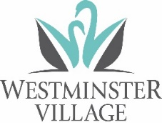There will be a panel including Dale Lindley, *President*, Mary Jo Crutcher, *Vice President,* Rev. Dr. Ron Naylor, *Westminster Chaplain*, and featuring Sherry Brown, of *Organize This!* Resident Ambassadors Pat Bennett, Norm Beck, and Emma Lee Slagle, will also be available to answer your questions.

Sign up today to meet our panel and learn *“The Ins and Outs”* of what it’s like to live at Westminster Village.

**Westminster Village**

**45th Anniversary Celebration**

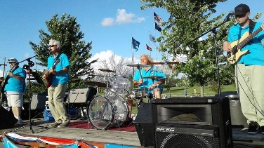You are invited to join us on Friday, September 6th to celebrate our 45th Anniversary, with the ***Reminisce Band*** and a ***Classic Car Review***, in our Front Parking Lot. Come to view the cool cars and enjoy the music. The Car Review begins at 3:30-5:30 pm and the band will start at 5:30- 8:30 pm. Starting at 5:15 pm, enjoy a FREE hot dog, chips, cookie, & a drink, while it lasts. Bring your lawn chairs and come celebrate with Westminster Village!

**Muncie Churches and**

**Civic Life**

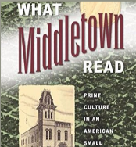During 2016 and 2017, the Center for Middletown Studies completed the *Muncie Churches and Civic Engagement Project*. Wed., September 25th, at 2:00 pm, Dr. James Connolly, Dir. of the Center, will be at Westminster to review the project’s key findings and consider their implication for civic affairs in Muncie.

**BSU BINGO NIGHT**

**At Westminster Village!**

**Join us for a night of FREE Bingo fun at Westminster Village with Charlie Cardinal, Spirit Cheer and Code Red on September 24th, at 6:30 pm., and a chance to win some BSU swag prizes!