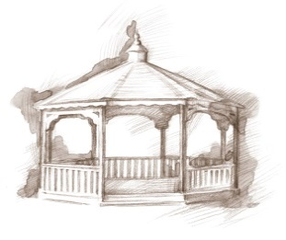
TheVillageVoice
November 2019

Westminster Village Resident Spotlight

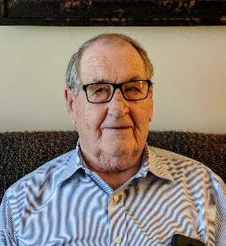
My wife, Twila, and I moved to Westminster Village five years ago, November. After some checking around, we thought Westminster seemed to offer many things, like church services and other amenities, such as the bank, beauty shop, etc., that we were used to when we lived at home. Westminster has room for family gatherings and many wonderful programs in Legacy Commons. There is a Bible Study each week and Sunday services. Each of us are going to eventually need these services and it seems that Westminster has them all, plus many not mentioned here. – Max Rawlings and his wife, Twila, owned a manufacturing company with a metal stamping press, many small presses and a large press with a 10 ft. hydraulic bed. Before they sold their business to a company from Flint, Michigan, they had 60 employees. The Rawlings had a home in Lake Wales, Florida, where they wintered for 24 years, and another in Modoc, Indiana.

Red Carpet Event
Featuring Lori Borgman

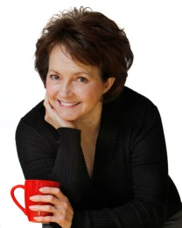
Westminster Village is pleased to announce that author/humorist Lori Borgman has been invited back for a special Red Carpet Event. Lori is a nationally-syndicated columnist, author and speaker, addressing family matters from a humorous point of view. While on her book tour, she will be at Westminster on Monday, November 4th, at 7:00 pm, in Legacy Commons to talk about her newest book, “What Happens at Grandmas Stays at Grandmas.” Please join us for this delightful evening. Following her presentation, Lori will be doing a book signing. Refreshments served!

Prohibition: The Noble Experiment That Went Wrong!

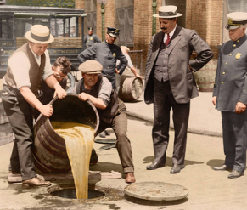
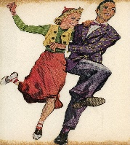
E. B. and Bertha C. Ball Center presents Prohibition: The Noble Experiment That Went Wrong, on Wednesday, November 6th, at 2:00 at Westminster. Mr. Rich Harris, Director Emeritus, Disability Services, BSU, will discuss Prohibition as our country’s attempt to address the severe problems of alcoholism.

Arnold Violin Studio
Fall Student Recital

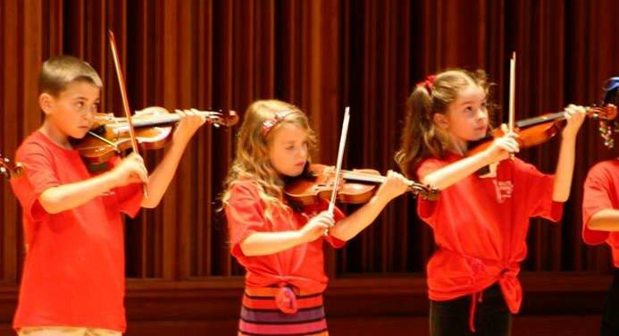
On Friday, November 8th, at 7:00 pm, Legacy Commons at Westminster will be filled with the beautiful violin music of the Arnold Violin Studio, which is comprised of the private violin students of Tiffany Janney Arnold.
Students performing in this Fall Recital range in ages from 7 to 19, and have been studying the violin from 1-10 years. Cookies and punch served!

USO Dance at
Westminster Village

Do the sounds of Benny Goodman or the Dorsey Brothers take you back to another day and time? On Friday, November 15th, from 7:00 pm to 9:00 pm, Westminster Village will be hosting a USO Dance to commemorate our Veteran’s service. Come to Jitterbug or Swing the evening away as DJ Matt Howell, plays the hits of the 1940’s. There will be door prizes and delicious refreshments!

Mountain Laurel Bluegrass

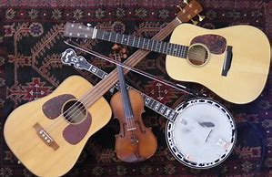
On Thursday, November 21st, at 7:00 pm, Westminster will host the Mountain Laurel Bluegrass Music. Join us for a fun, toe tapping evening.

America’s Hometown
Band Clarinet Choir

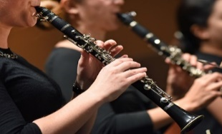
The Clarinet Choir will be at Westminster Village on Monday, November 25th, at 7:00 pm. The Clarinet Choir will be playing such favorites as, “You May Remember” and many more.

*All programs and events FREE in Legacy Commons. Public invited.

Schedule a tour with Tyler or Melody, have lunch on us and receive a FREE gift. Call today at 288-2155.

