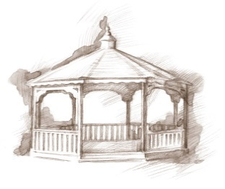TheVillageVoice

**December 2019**

The Holiday Season is upon us with the lovely sights and sounds of Christmas. Here at Westminster Village, it is going to be a virtual Winter Wonderland, with over 30 beautifully decorated trees throughout the entire building and wreaths adorning many doors. Christmas goes beyond the inside walls as the trees and building outside are draped in lights and wreaths. At Westminster, it is tradition that the Friday following Thanksgiving, our Christmas decorations begin to be assembled. Everyone can feel the excitement in the air!

Minnetrista to Present

*A Christmas Carol*

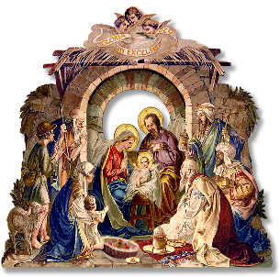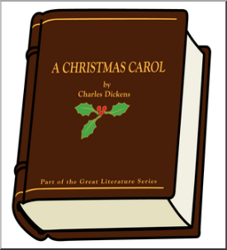In 1925, Ball Brothers Company had an edition of *A Christmas Carol* designed and printed as a gift for friends, family, and employees. Minnetrista’s Theatre Preserves will perform the Dicken’s Christmas classic, with their own spin on the story in a 30 minute version, on Monday, December 2nd, at 10:00 am.

BSU Wrecking Crew Trumpet Ensemble to Perform at Westminster

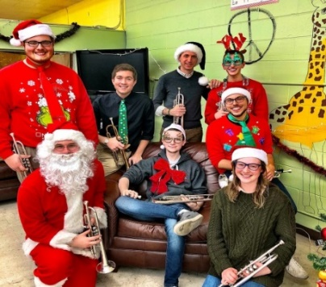*The* *BSU Wrecking Crew Trumpet Ensemble* will be performing, on Wednesday, December 3rd, at 7:00 pm. *The Wrecking Crew* consists of trumpet majors at BSU and they will be playing a variety of notable Christmas songs to spread Christmas Cheer!

German Christmas

Traditions in America

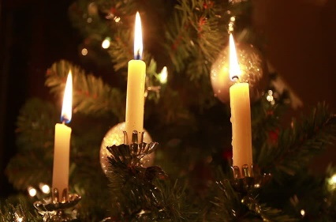Did you know that Marzipan cookies, candles on the Christmas tree, and the first crèche scene, were German traditions? On Wednesday, December 4th, at 2:00 pm, *Tom Schwartz,* will trace the history of our Christmas traditions that came from Germany.

Muncie Ballet Studio to

Dance *The Nutcracker*

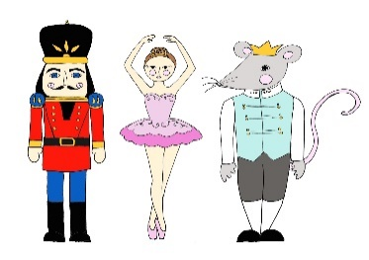On Monday, December 7th, at 2:00 pm, the Muncie Ballet Studio will perform a 30 minute version of *The Nutcracker.* The dancers will range from two years old and up.

The Distaffs

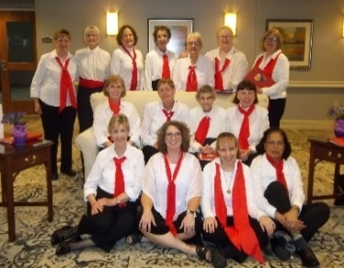*The Distaffs Chorus* is an interest group of the Ball State University Women’s Club. Since 1968, these “ladies in red” have enjoyed the fellowship of singing together and sharing their music with the community. *The Distaffs* will perform, on Friday, December 13th, at 7:00 pm, to sing songs of peace, joy, hope, faith, love and friendship, offering a positive balance to the challenges of life.

MSO Marimba

Percussion Ensemble

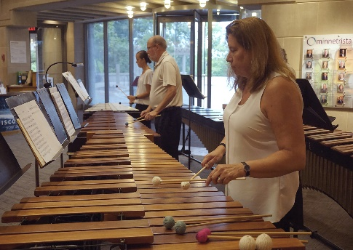You will not want to miss the *Muncie Symphony Orchestra Marimba’s* as they fill the Legacy Commons with their beautiful sounds of Christmas as they perform at Westminster, on Monday, December 16th at 7:00 pm.

Repricing a Limited Number of Residential Apartments!

Westminster Village is repricing a limited number of *Residential Independent studios*, and *one bedroom/kitchenette* *apartments* for immediate move-in. These apartments enjoy all of the same amenities as all of our kitchenette apartments.

Be Safe & Warm

This Winter!

If staying alone in your home during the long, cold winter doesn’t sound like something you want to do this year, Westminster has an idea for you! Come and spend the winter in a comfortable, furnished apartment. You can participate in any of the activities, exercise in the Wellness Center, do your banking, get your hair done in the Beauty Salon, and join in all the reindeer games!

For information on events, apartments, or to schedule a tour, please call Tyler or Melody at 765-288-2155. Visit our website wvmuncie.com for details.