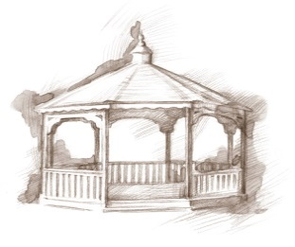TheVillageVoice

**January 2020**

*Westminster Village Resident Spotlight*

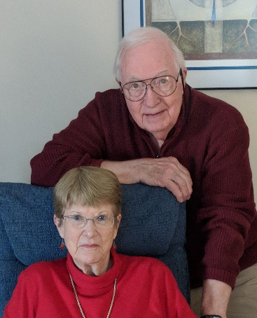 *“When my wife Pat, and I designed and oversaw the construction of our house in 1970, we knew, because of its size and 4 floor levels, that at some point it would not be safe or easy for us to stay there. Then, 46 years later, in 2016, because of its size, and the cost of utilities, maintenance, and care, we decided that it was time for us to begin the process of moving. Moving to where it would be safe for both of us, all maintenance and care would be provided, and a place where progressive medical care was available, within minutes. We also wanted a place where we could continue to enjoy independent living, more freedom, and access to all the locations and events we had been attending for decades.*

*We contacted Westminster Village to be placed on their waiting list for the apartment size that we wanted and soon, we were notified that an apartment would be available. That began our plans to get ready to leave our home. So that our children did not have to clean it out and sell our home as we had to do for both of our mothers, we contacted Sherry Brown, who owns “Organize This” and who works with Westminster, to help us get rid of items we did not need and our children did not want.*

*Yes, there are several other locations in Muncie that we could have moved to, but, in our opinion, none of them have the experience, the resources, the location, the safety, the events we can attend, or the friendliness of Westminster Village. Every night, when we go to dinner, we can sit with both old and new friends, where we exchange stories from our past lives, from today, and find as much as possible to share that, in many cases, causes everyone to laugh. Another thing we enjoy at Westminster is to help others, living or working here, if we can, and to, without getting ourselves into trouble, make them laugh!”* – Ben Bennett, and his wife Pat, were both born in Ohio. After graduating from high school, they both decided to attend the University of Cincinnati where they met. Ben graduated in 1958 with a BS in Industrial Management. Pat graduated in 1960 with a BS in Nursing. They were married in December of 1958. Ben went on to work on a Masters in Journalism. Pat went on to earn a MS in Nursing and later a PHD in Nursing. Ben worked at Maxon Corporation here in Muncie for 34 years and Pat at Anderson University School of Nursing for almost 30 years.

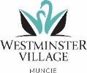

Westminster Village • 5801 W. Bethel Ave, Muncie, IN 47304 • 765-288-2155 • wvmuncie.com

The History and Celebration

of Epiphany

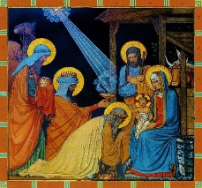On Monday, January 6th, at 2:00 pm, we will share fun facts and King Cake to acknowledge the start of *Epiphany*. *Epiphany* is a Christian feast day that celebrates the revelation of God incarnate as Jesus Christ. In Western Christianity, the feast commemorates principally the visit of the Magi to the Christ Child.

Enchanted Tree Celebration

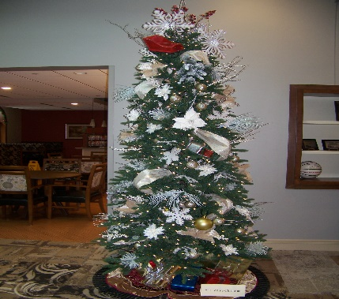If you didn’t get a chance to see all of the beautifully decorated Christmas trees that were throughout Westminster during the holidays, then come to our *Enchanted Tree Celebration* on Tuesday, January 7th, 3:00 pm – 7:00 pm. You will be able to view all the tress in Legacy Commons and the mall area before they are packed away for another year. Sip on hot cocoa and cookies as you stroll through our Winter Wonderland!

*“Living As An*

*American in China”*

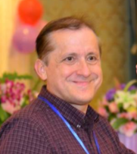On Wednesday, January 15th, at 2:00 pm, David Lambert, who worked in finance and lived in China for 11 years, will share his unique experiences and observations of the Chinese Culture.

MSO Marimba

Percussion Ensemble

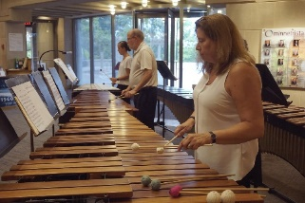You will not want to miss the *Muncie Symphony Orchestra Marimba’s* as they fill the Legacy Commons with their beautiful sounds, as they perform at Westminster, on Wednesday, January 15th, at 7:00 pm.

Dr. Martin Luther King, Jr.

Documentary

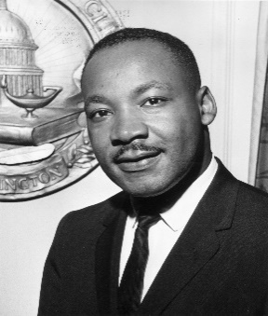Come to Westminster to mark the birthday of Dr. Martin Luther King, Jr., as we present a documentary on the life and death of Dr. King, on Monday, January 20th, at 2:00 pm.

Safe & Warm at

Westminster Village

If winter is proving to be more than you want to deal with, there are still some apartments available for our Safe & Warms. Come and enjoy life where you have nothing to worry about except to decide what to have for dinner or whether you want to attend a nightly program. To schedule a tour, call Tyler or Melody at 765-288-2155.