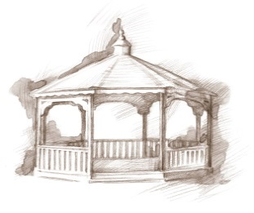TheVillageVoice

**February 2020**

Westminster Village Resident Spotlight

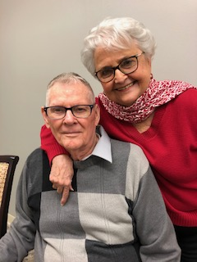

*Joe and I both had family members that lived at Westminster Village. They enjoyed the different neighborhoods and activities and at times they were so busy that we had to make a*

*appointment for a visit. So when we decided to make the move here, we were already aware of all of the things that Westminster offers. We wanted to enjoy Westminster while we could and so far it has been one of our best decisions. We know it is a huge move but please, don’t be afraid, because it is very rewarding. We know many adult ladies who will not leave their homes and all their precious things. It’s hard but worth the effort, and we have found great peace after we moved to Westminster. We truly believe our lives are blessed being able to live here. All we have to do is enjoy our new home, and when one of us passes, the one left will be taken care of. Living here we are safe and secure. Amazing!* Joe and Elaine Markins were both raised on working farms and met at the Gaston Skating Rink. Joe worked at Westinghouse-ABB and after he retired he returned for several more years as a Consultant/Inspector in Quality Control. As a Westinghouse Consultant, Joe flew all over the United States. Elaine began her career in 1955 as a beautician at Ambers Beauty Salon for eighteen years. She then worked for Star Bank, in many different capacities, for nineteen years. Their daughter, Cheryl, a teacher for thirty eight years, lives in South Carolina, and has given Joe and Elaine have grandchildren. The Markins have been married for sixty three wonderful years.

____________________________________________________________________________________________________________________________

CCRC Living – Fact vs Myth

**Myth**: *“It would be easy to get any care I might need at home.”*

**Fact**: Care at home can be difficult and costly, while continuing care retirement communities offer seamless solution for most care needs that may arise in later life.

History of the

Lucius Ball Home

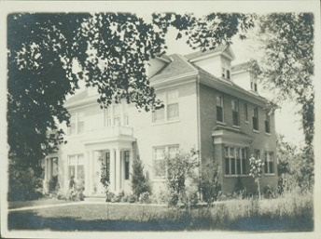Dr. Lucius Lorenzo Ball, the eldest of the Ball Brothers, received his medical degree from the University of Buffalo in 1889, at the age of forty. Unlike his brothers, who built new homes along Minnetrista Boulevard, Lucius purchased an existing home along the Boulevard. On Wednesday, February 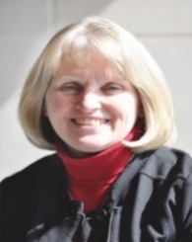5th, at 2:00 pm, Karen Vincent, *Director of Special Projects* *at Minnetrista*, will be here to share some interesting facts and fallacies about this home.

Danny Russel Presents

*Abraham Lincoln*

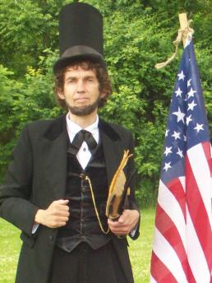[](https://www.google.com/url?url=https://www.yellowriverfestival.com/abraham-lincoln.html&rct=j&frm=1&q=&esrc=s&sa=U&ved=0ahUKEwjp3PXo-M_NAhVsxoMKHVbVCkgQwW4IHDAD&usg=AFQjCNH6SWxVvPyGN7AcDHPldHlarbJMvA)*Expanding Your Horizons* in February will be the story of *Abraham Lincoln*, as performed by Danny Russel. Hilarity, heartbreak, humanity, and brilliant speeches abound as “Abraham Lincoln” traces his amazing journey from a log cabin to the White House. Danny’s performance includes stirring renditions of “A House Divided”, the “Gettysburg Address” and portions of Lincoln’s Second Inaugural Speech. We encourage you to join us on Monday, February 17th at 3:00 pm.

“Behind every great man…

is his mother!”

[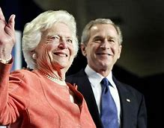](https://www.bing.com/images/search?view=detailV2&ccid=aIAp0%2fnn&id=8F88721A99BBF3FF68798C97D8CF33C990EEC7A1&thid=OIP.aIAp0_nnkPAbEquLcMGLMAHaEQ&mediaurl=https%3a%2f%2fcdn.aarp.net%2fcontent%2fdam%2faarp%2fpolitics%2fevents-and-history%2f2016%2f04%2f1140-presidential-mothers-barbara-bush.imgcache.rev5b87454d304a3ba350e3c9d40fec75c4.web.jpg&exph=655&expw=1140&q=presidential+mothers&simid=608039649097091453&selectedIndex=114)E.B. and Bertha C. Ball Center presents Rich Harris, Director Emeritus of Disability Services at Ball State as he discusses *US President’s Mothers.* On Wednesday, February 19th, at 2:00 pm, Rich will introduce you to the intelligent, hard, working mothers who felt their sons had the right stuff!

Sweetheart Ball

In Celebration of *The Month of Love*, Westminster Village invites you to attend a *Sweetheart Ball* on Friday, February 28th, 7:00 pm – 9:00 pm. Matt Howell will be the DJ, playing romantic tunes from the 1940’s through the 60’s. Join us as you spin your favorite sweetheart around the dance floor, or just come to listen. Senior couples and singles are welcome to attend this free event!

All feature events are free and open to the public, and held in our Legacy Commons Event Hall. Enjoy refreshments at all of the events.

We are still in the midst of winter and if you would like to come for our *Safe & Warm* trial stay, we would love to have you. Move into one of our lovely, furnished apartments, enjoy eating in the dining rooms, and attending all the great activities. Your new friends are waiting to meet you! Call 765-288-2155 today for a tour. Ask for Tyler or Melody.

If you wish to opt out of this newsletter, please call Melody at 765-288-2155, [mscoble@wvmuncie.com](mailto:mscoble@wvmuncie.com)