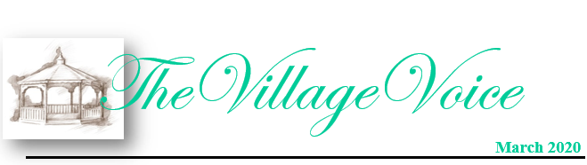
Westminster Village Resident Spotlight

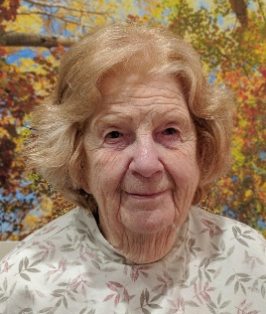
Life at Westminster is what you make it. If you want to stay in your apartment and read, watch television, or just sit, you may, but there is so much more available to you. There is a wonderful variety of music programs, speakers on various topics, excursions to civic and sporting events. There are also many social events held here, such as a picnic at the gazebo during the summer. The grounds are extensive and walking the trails is good exercise. The staff is patient and friendly, and the residents become like family. – Betty Arthur was born five miles from the present location of Westminster Village and has lived in Indiana her entire life. She has been in all 50 states, visited extensively in Western Europe, and has traveled to Australia. She went to work at the Grace Maring Library the day after graduating from Muncie Central, worked at the Ball State Library first as a student, then staff and finally as a member of the faculty. She has three degrees from Ball State and retired as an Assistant Professor and Head Cataloger. Betty was married to Francis Arthur for over 64 years and has two children. She now has four grandchildren and four great-grandchildren. Betty is the Chairman of the Westminster Library Committee and a Librarian of Westminster’s Mary Garr Library.
_____________________________________________________________________________________________________________________

CCRC Living – Fact vs Myth

Myth: “It isn’t any different from staying in my house.”
Fact: The many on-site services, amenities and conveniences you gain at a senior living community make life easier. For example, the amenities at Westminster Village include a bank, beauty salon, Village Shoppe, library, various dining options, transportation, on-site nurses, scheduled events, dances, and more. Also, you gain more time to enjoy the things you love to do when you move to a maintenance-free apartment in a senior living community. Downsizing to an independent apartment can relieve you of the stress and burden that comes with maintaining a home, especially a home where you don’t use the majority of the space anymore.

Friends of the Orchestra

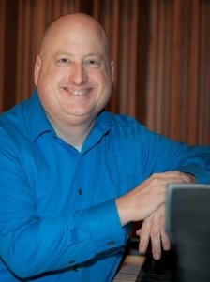
Sunday, March 1st, 7:00 pm, Westminster Village and the MSO present the second concert of our “Friends of the Orchestra” series, a memorable performance featuring Noelle Tretick Gosling, violinist and MSO Concertmaster, and Jim Rhinehart, MSO Principal Pianist. Noelle lives and works in Indianapolis and has toured with many celebrities such as Stevie Wonder, Josh Gorban, Harry Connick Jr, and many more. Jim is a pianist, composer and teacher at BSU. He received his doctorate in Theory and Composition from Ball State. In addition to music, Jim enjoys walking, sausage-making and cooking.

Eastern Gate Quartet

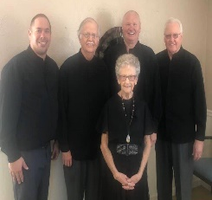
Westminster Village will host the Eastern Gate Quartet, a Southern Gospel Quarter, proclaiming the Good News on our Lord and Savior Jesus Christ. The concert will be Thursday, March 5th, at 7:00 pm.

History of Social Services
in Muncie

On Monday, March 9th, at 2:00 pm, Dr. James Connolly and Dr. Warren Vander Hill, will be here to present the, “History of Social Services in Muncie.” Dr. Connolly is the George and Frances Ball Distinguished Professor of History, Director of the Center for Middletown Studies and co-director of Digital Scholarship Lab. Dr. Hill is the Provost Emeritus, Ball State University. In 2019, the Center for Middletown Studies completed the Nonprofit Social Studies in Muncie Oral History Project.

“The Real St. Patrick”

What was St. Patrick’s birth name? Was he born in Ireland? To find out the answers to these questions and the true story of Saint Patrick, join us for this presentation, “The Real St. Patrick”, presented Dr. Frederick Suppe, an Associate Professor of History at Ball State and a Medieval Historian, on Tuesday, March 17th, at 2:00 pm.

All feature events are FREE and open to the public, and held in our Legacy Commons Event Hall. Enjoy refreshments at all of the events.

Thinking of a spring move to Westminster Village? We have apartments in many different floor plans, sure to be the right fit for you! To schedule a tour to see our lovely models apartments, please call Tyler Ewing or Melody Scoble at 765-288-2155. Have lunch and receive a free gift!

If you wish to opt out of this newsletter, please call Melody at 765-288-2155, mscoble@wvmuncie.com.

