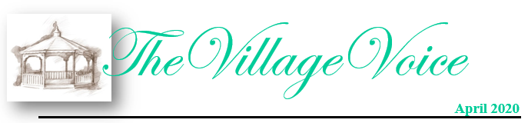

Westminster Village Resident Spotlight

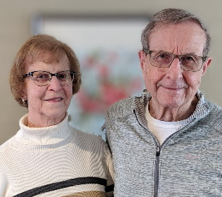
We moved to Westminster Village on June 6th, 2018 and it has been a very positive experience. Free movies and popcorn on Friday – what more could you ask for?! We have made many new friends and renewed old friendships. You can choose to keep to yourself, or participate in many activities. Transportation is available for Ball State activities, community events, and shopping. Our daughter and son both live in California and are greatly relieved to know we are “Safe and Warm.” We feel like this is the place for us to be at this time. – Dick McKee was a Ball State faculty member and Administrator for thirty seven years. He served as Executive Assistant to six Ball State Presidents. Joan McKee was Executive Director of the Muncie Symphony Orchestra for sixteen years. Dick and Joan appreciate the continued partnership Westminster has with the MSO and Ball State.
____________________________________________________________________________________________________________________________

CCRC Living Myth vs Fact

Myth: “It’s going to be depressing.”
Fact: This is the number-one fear that most people have about independent or adult living, experts say. Some people have bad memories of dark, disinfectant-smelling nursing homes; others remember cramped quarters in overcrowded apartment towers. Happily, none of these fits the description of the modern independent living community, which is just as likely to resemble a tightly known small town or a high-end spa resort. And the cure for the misconception is easy, simply visit a few independent living communities near you. Talk to residents, spend an evening in a group activity, such as a lecture, concert, or a dance, and schedule a tour of the communities. On a warm afternoon, come walk the grounds and enjoy The “Mike Dobbs Nature Trail.” Relax in the gazebo as you watch the swans gliding around the pond. This is all it takes, experts say, to put this myth to rest.

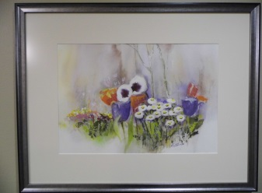
Westminster Implements Policy to Protect Residents

Westminster Village has implemented policies in an effort to protect our residents from coming in contact with the Coronavirus (COVID-19). As of March 13, 2020, Westminster has restricted visitations. We remind everyone that this is only temporary. Residents are encouraged to talk to their friends and family members by phone or computer. Our Westminster residents are considered “high risk” for infection of the virus, therefore, we are dedicated to providing a healthy & safe environment.
To all of our friends who enjoy attending our programs and events, we have temporarily suspended them, but we promise to reschedule the wonderful programs we had planned, in months to come.
Also, we will not be giving tours during this time but we can certainly answer any questions by phone.

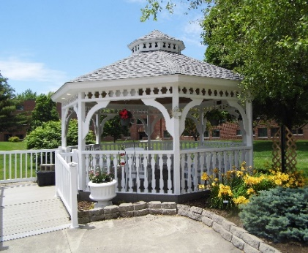
Westminster Treasures

In 1979, Westminster was blessed when a tiny lady, with a big personality, moved into The Village. It didn’t take long for Betty Hutchins to become known as the “local artist”. Betty was schooled as an English teacher but when an art teacher position became available, she decided to spread her wings in a different direction. Betty was in her 50’s when she took a class in watercolor and fell in love with the medium. At Westminster she had her own studio, in her apartment, where she painted her canvases. Her joy in painting was not for monetary gain for she often gave away many of her paintings to employees and friends. Today, over 70 watercolors have been re-matted and reframed, and they are displayed for everyone’s enjoyment. Each painting was placed with love and care in just the perfect spot, complementing the different wall color of each floor in The Village.

The Mike Bailey Gazebo

Mike Bailey was employed as a carpenter and began his career at Westminster in January of 1978. Mike had many skills but woodworking was his first love. He also loved the challenge of planning and executing special projects, so Mike designed and built the two gazebos at Westminster. Mike worked at Westminster for 37 years, until 2015, when he retired. The largest gazebo, near the pond, was dedicated, in his memory, in 2017.

5801 W. Bethel Avenue, Muncie IN 47304
For any questions, please call Tyler Ewing or Melody Scoble at (765) 288-2155
Check our website at wvmuncie.com

