TheVillageVoice

**May 2020**

Westminster Village Resident Spotlight

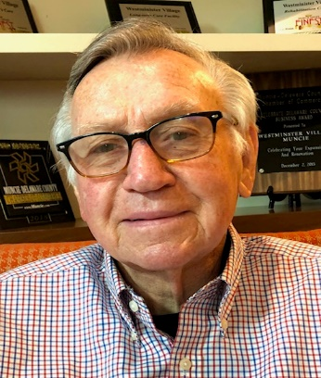*I am privileged and blessed to be a resident at Westminster, especially during this very difficult and critical time in my life. Westminster is not just a place to exist; it was, and is, a concept of a wonderful, ever-developing place to consider for comfort, continued education, and programs for physical, mental, and spiritual well-being. At the top of the list for me is to be aware that it is perfectly alright to be spiritually grounded at Westminster.*

*Until this current COVID-19 national Pandemic, the Activities Department had scheduled events that included gospel singing groups, local performers, speakers from government, organizations, historical lecturers, and many resourceful representatives from Ball State.*

*My dear wife, Anne, passed peacefully a few days before Christmas 2019. My family knew that I would need to immediately look at possibilities and opportunities for a quick move. They arranged a meeting for us with Gay Nation, the Marketing Director. We had a discussion about me and what Westminster had to offer. We were also invited to eat in their wonderful dining room, so I could sample a meal. We toured with Tyler Ewing, Sales Consultant, who informed us that there was an apartment all ready for me to move in to. Many of my family members went into action and they were able to move me in almost immediately. I would be remiss in not mentioning the supportive care nursing services that are available to all residents like me and a major factor with my family’s strong interest in my coming to Westminster. Residents voice regularly about the personal attention they get from the nurses and staff. My family and I are most appreciative!*

Earl Muterspaugh graduated from Middletown High School, and earning a B.S and M.S. from Ball State College. Earl taught at Yorktown Elementary School. He was a teacher and Principal at Royerton and DeSoto Elementary schools. Earl worked for Food Brokerages in Indianapolis, as a Retail and Account Executive. Earl is an Army Veteran. He married Anne Sawyer Clark and they had three daughters.

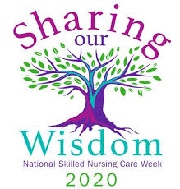

CCRC Living – Fact vs Myth

**Myth:** “I will lose control of the daily activities of my life.”

**Fact:** Moving anywhere new is a big transition, especially if you are coming from a place where you had an established routine and set of friends. Letting go of long-held habits can be difficult and may require a major adjustment. However, at Westminster Village, we provide ample opportunities for you to meet new people and form new bonds. Even though it may take time, our compassionate staff is available to help in any way we can. We believe living in a CCRC will give you an added sense of security, as you are surrounded by those committed to your care. At the same time, we want to ensure you have the independence and privacy you deserve.

National Nurses Week

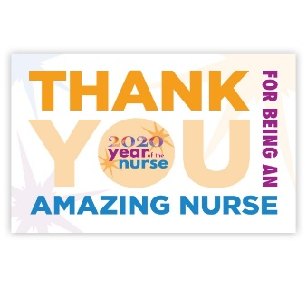During the month of May, we will be recognizing our entire nursing staff during National Nurses Week, 5/6-5/12. This date is celebrated in honor of Florence Nightingale’s birthday. She was born May 12, 1820. Our nurses strive to have the highest quality of care for our residents. Nurses, we applaud you! We will also be honoring our entire Westminster staff during National Skilled Nursing Care Week, 5/12-5/18. Westminster would like to express our gratitude and appreciation to our staff for their loyalty and dedication to our residents. As a special recognition, we will publish six full page ads, three per week. Be sure to check out these special ads in the StarPress.

Westminster Offers Virtual Tours on our Website

During this time of the COVID-19, for the safety of our residents and staff, Westminster will not be giving tours in person, but please visit our website; wvmuncie.com, and take our 360° Virtual Tours. The Marketing Team would be happy to schedule a time to also “walk through” the Virtual Tour with you. Call Tyler or Melody at 765-288-2155 to schedule a virtual tour. It is almost like being here in person!

If you would like to opt out of this newsletter, please call Melody at 765-288-2155.

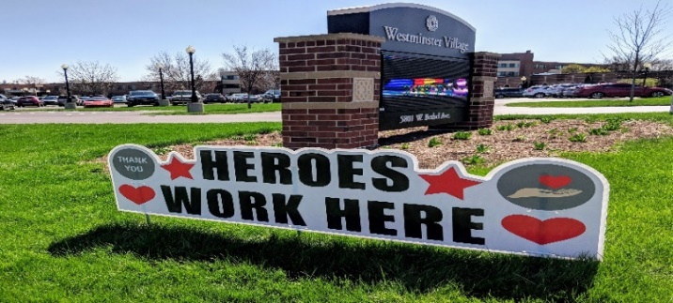

5801 W. Bethel Ave., Muncie, IN 47304