Westminster Village Resident Spotlight

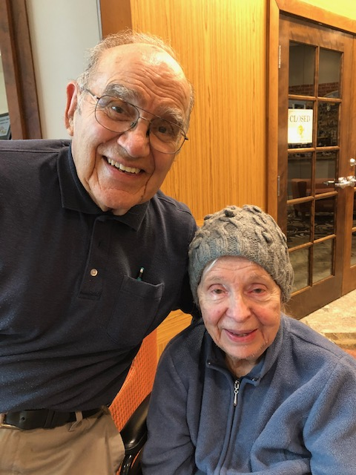*After fifty years in the same house on University, we decided it was time to down size. It was very easy to pick Westminster Village since we knew several people who were residents and we had visited them on many occasions. Our children took over the logistics of moving and before we knew it, we had a two bedroom apartment. Our family moved our furniture over and had it all furnished for us, all we had to do was to move in. We would advise anyone interested in Westminster Village to visit with residents who have lived here awhile. You can’t do better than talking to the people who actually live here. Then, to get all your questions answered and have a tour, schedule an appointment with Melody and Tyler, Westminster’s Marketing Team.*

**Vivian and Ramon Avila** have lived at Westminster Village for one and half years. Vivian was born on a farm near Decatur, Indiana. After high school, she entered nurses training, and received her degree, at St. Joseph’s Hospital in Fort Wayne. She was a nurse at Longfellow elementary for twelve years before retiring in 1998.

Ramon was born in Fort Wayne, Indiana. After high school, he was in the Air Force, then completed college, receiving his PH.D in Mathematics from the University of Michigan. Ramon taught high school for five years and at Ball State University for thirty four years, retiring in 1996. Ramon and Vivian have been married for sixty-six years. They have four children, fifteen grandchildren, and eleven great grandchildren.

_______________________________________________________________________________________________________



CCRC Living – Fact vs Myth

**Myth**: *“It costs so much money; I could never afford to live there.”*

**Fact**: When families are considering a retirement community, they don’t take into consideration the costs to live in their homes, such as; utilities, taxes,

an emergency response system,

maintenance, housekeeping security, food, and maybe a membership to a Fitness Center. Actually, folks need to weigh the intangibles as well, such as access to health care, socialization of living in a community and sharing interests [](https://images.search.yahoo.com/images/view;_ylt=AwrEzNwRoxlfFFgA8DCJzbkF;_ylu=X3oDMTIyaTdub3ZsBHNlYwNzcgRzbGsDaW1nBG9pZAM2NzE2YzI3NDQwZDdkNDQ3ODY2NTkxYzczMjFjNjA3ZgRncG9zAzIEaXQDYmluZw--?back=https%3A%2F%2Fimages.search.yahoo.com%2Fsearch%2Fimages%3Fp%3Dsenior%2Badults%2Bexercising%2Bphotos%26fr%3Dyfp-t%26tab%3Dorganic%26ri%3D2&w=1254&h=836&imgurl=davidyorkhomehealthcare.com%2Fwp-content%2Fuploads%2F2017%2F12%2Fseniors-exercising.jpg&rurl=https%3A%2F%2Fdavidyorkhomehealthcare.com%2Flow-impact-exercises-active-seniors%2F&size=449.4KB&p=senior+adults+exercising+photos&oid=6716c27440d7d447866591c7321c607f&fr2=&fr=yfp-t&tt=5+low-impact+exercises+for+active+seniors&b=0&ni=144&no=2&ts=&tab=organic&sigr=znzJThS7xu43&sigb=eGBzlYGjrM5B&sigi=V63QH5CbzF18&sigt=oQgWcEHePyNb&.crumb=sffDEFkoCpn&fr=yfp-t)with friends and neighbors, and the accessibility of a caring staff. At a Continuing Care Retirement Community, such as Westminster Village, these costs are all included in the monthly fee. With all that is included, it may not be as “expensive” as many people think!

Westminster’s Resident Woodworker

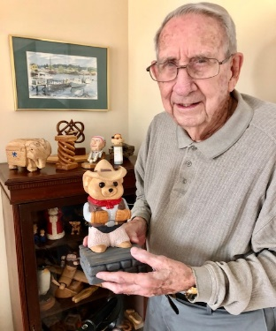Don Alexander, a Westminster resident, makes the most wonderful wood carvings, from animals to a beautiful necklace that he made for his lovely wife, Helen. As a young man of 12, Don joined the Boy Scouts and then as an Eagle Scout, he helped campers at Camp Redwing. It was at Camp Redwing where he started to carve neckerchief slides. With college, marriage, and then WWII, he put aside his love of carving until many years later when he decided to carve a fisherman, and he was hooked! We have displayed many of Don’s carvings in our Art Gallery for others to view. His latest carving project is a cowboy with fancy boots and we can’t wait to see how that turns out!

What’s New at Westminster?

As we navigate this new way of life, the last four months have certainly been trying, but we appreciate the fact that everyone has been so patient.

Our beauty salons are now open, which has made many of our residents want to dance a jig! Family and friends may have unlimited outside visits and with limited hours and times, they may visit with residents in their apartments. We ask that masks must always be worn, social distancing is a must inside or outside, there can be no traveling to other areas in our building and visitors must only use the two main elevators. We will be sanitizing after the visiting hours are over. With everyone’s diligence and cooperation, Westminster hopes to remain COVID-19 free! Check wvmuncie.com for daily updates.

Limited tours may now be scheduled with Tyler or Melody during the Visitation Hours between 9 –11 am.

and 6 – 8 pm. , or check out our 360° Virtual Tours on wvmuncie.com

If you would like to opt out of this newsletter, please call Melody.

Westminster Village

5801 W. Bethel Avenue

765-288-2155

wvmuncie.com